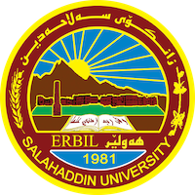
Academic Curriculum Vitae
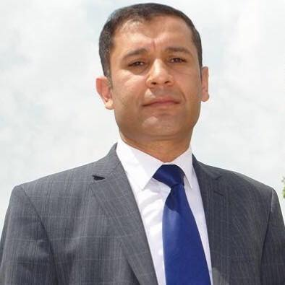
Personal Information:
Full Name: Sarbast Qadir Husen
Academic Title: Teacher
Email: (sarbast.husen@su.edu.krd)
Mobile:07504520892 )

Education:
-Bachelor's degree: Law
Graduation year: 2009
Faculty of Law – Evening study
Salahaddin University
Rank: First in his class
- Master: Private Law, 2014
Salahaddin University
Rank: First in his class
-PhD students in civil law.

Employment:
- Arabic language teacher - General Directorate of Erbil Education - Mercosur Education
Date of first employment: 17/9/2002.
- Teaching assistant in the Department of Law - College of Law and Politics - Salahaddin University، In September of 2009.

Qualifications
-Assistant teacher since 2014.
- Teacher since 2019.
- IT qualifications: Proficient in Word and Excel program.
- I participated in several English language courses، Including the courses of the English Language Teaching Center affiliated to Salahaddin University.
- I have IELTS certificate.

Teaching experience:
-Taught students: personal status law - the third stage, civil contracts - the third stage, obligations - the second stage, the entrance to the study of law - the first stage, the pleadings law - the fifth stage, the law of evidence - the fifth stage, and the commercial law - the second stage.

Research and publications
-The contract is the law of the contracting parties and its exceptions.
-The civil liability of the translator.
-Anti-competitive agreements in the telecommunications sector.
And a book entitled: (Anti-competitive practices in the telecommunications sector - a
comparative study)

Conferences and courses attended
-I attended several conferences and courses inside the Kurdistan Region

- Give details of any conferences you have attended, and those at which you have presented delivered poster presentations.

Funding and academic awards
- List any bursaries, scholarships, travel grants or other sources of funding that you were awarded for research projects or to attend meetings or conferences.

Professional memberships
- List any membership you hold of any professional body or learned society relevant to your research or other life activities.
-Member of the Kurdistan Teachers Union
- Member of the Kurdistan Jurist Union

Professional Social Network Accounts:

- List your profile links of ReserchGate, LinkedIn, etc.
- https://www.researchgate.net/profile/Sarbast-Qader
- https://www.linkedin.com/feed/
- https://www.facebook.com/sarbastq
- https://scholar.google.com/citations?user=iKMy64UAAAAJ&hl=en

It is also recommended to create an academic cover letter for your CV, for further information about the cover letter, please visit below link:
https://career-advice.jobs.ac.uk/cv-and-cover-letter-advice/academic-cover-letter/

