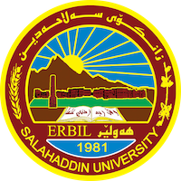
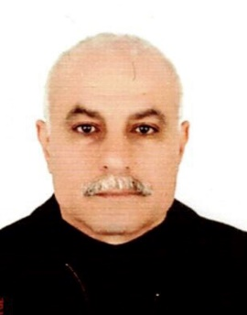
Academic Curriculum Vitae

Personal Information:
Full Name: Sardar Suwar Zewar
Academic Title: Lecturer
Email: sardar.alsaidahmad@su.edu.krd
Mobile: +9647501356650

Education:
- 1977. High School Certificate (Baccalaureate), scientific department, Al Ukhwa, Erbil-Iraq
- 1978-1984.Master’s degree in Architecture and planning /Ion Mincu University of Architecture and Urbanism, Romania.
- 1984-1988.PHD in Architecture/ Faculty of Architecture and Systematization/ Ion Mincu University of Architecture and Urbanism, Romania.

Employment:
- 1992-1994. Employed at Salahaddin University /College of Engineering/Department of civil Engineering.
- 1994-current : Employed at Salahaddin University /College of Engineering/Department of Architecture.
- 2001-2022: member in the municipality of Erbil.

Qualifications
Teaching qualification
- Course of training for teacher professional development at Salahaddin University -Erbil.
IT qualification:
- AutoCAD , Microsoft office
Language qualifications:
- Arabic
- Kurdish
- Romanian
- English

Teaching experience:
Employed in university of Salahadin since 1992. The fields that I taught include the following:
- Descriptive Geometry/ theoretical
- Architectural thesis/ Theoretical and practical
- Architectural design of grade five / Theoretical and Practical
- Architectural design of grade four/ theoretical and practical
- Architectural design of grade two / Theoretical and practical
- Working drawing/ Theoretical and practical
- Theory of Architecture / Theoretical and practical
- Building construction/ theoretical
- Landscape design / Practical
- Vernacular architecture/ theoretical
- Material of construction (finishing)
- Supervision of students for thesis of architecture design for over 10 years

Research and publications
- Amin, A. B. H., Mustafa, F. A., & Swar, S. (2019). School design daylighting Analysis A study of Foundation schools in Erbil Governorate. Sulaimania Journal for Engineering Sciences, 6(2).‏ https://www.iasj.net/iasj/article/187924
- Swar, S., & Bayz, A. (2016). Foundation schools design efficiency at Erbil governorate. (A study of usable area ratios). ResearchGate. https://www.researchgate.net/publication/333429481_Foundation_schools_design_efficiency_at_Erbil_governorate_A_study_of_usable_area_ratios

Conferences and courses attended

Participating in seminars at Salahaddin University.

Holding seminars at Salahaddin University.
Professional memberships
- IRAQI Engineers Union /Baghdad
- Kurdistan Teachers Union/ Erbil- ID. No. 15304
- Kurdistan Engineers Union/Erbil - ID .No. 02840
Professional Social Network Accounts:
- https://www.researchgate.net/profile/Sardar-Swar
- https://scholar.google.com/citations?user=r-A2ffoAAAAJ&hl=en
- https://iq.linkedin.com/in/sardar-swar-a859b9110
- https://twitter.com/swar_sardar
- https://orcid.org/0009-0000-8009-0517

