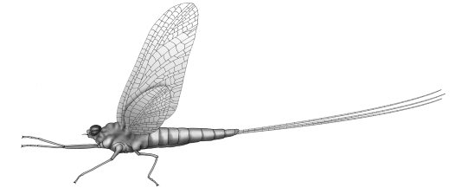
University of Salahaddin
Department of Biology
3rd Class Year
ENTOMOLOGY
Entomology
Lab: 1
Insect Relatives-Arthropoda

Characteristics of Arthropods
- The Arthropoda (from the Greek Arthron, joint and podus, foot) are the largest group of organisms and they occur in all environments on earth.
- The group includes: spiders, ticks, mites, centipedes, millipedes, crustaceans, insects and others.
- The segmented bodies are arranged into regions, called tagmata (e.g., head, thorax, abdomen). Some have a cephalothorax (head and thorax are fused together).
- The paired appendages (e.g., legs, antennae) are jointed.
- They possess a chitinous exoskeletons for support and protection ,that must be shed during growth.
- They have bilateral symmetry.
- Arthropods use gills, tracheal tubes, or book lungs for gas exchange.
- Arthropods use either coxal or green gland and malpighian tube for excretion.
- Acute senses include simple and compound eyes, brains, and many ganglia.
- They have open circulatory systems, complete digestive system.
- Muscular system is complex and muscles attach to the exoskeleton.
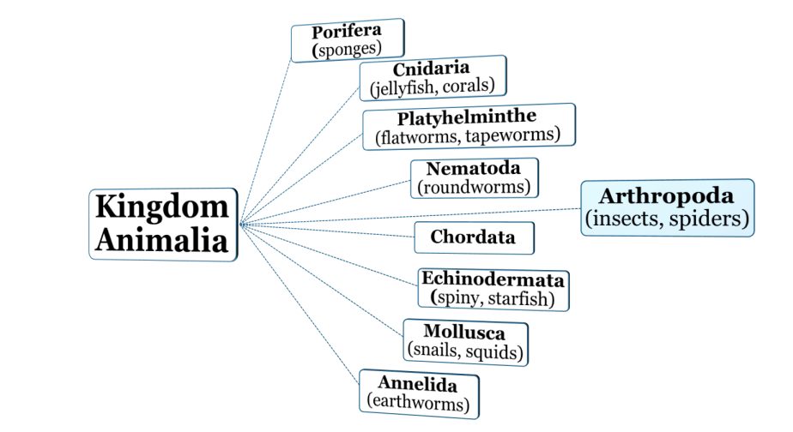
- Arthropods reproduce sexually, but some exhibit parthenogenesis.
Classes of Arthropods
- Class: Arachnida
- Class: Crustacea
- Class: Myriapoda (Chilopoda and Diplopoda)
- Class: Insecta (hexapoda)

Class Arachnida
- Spiders, scorpions and mites belong to this class.
- Spiders are the largest group of arachnids.
- Most arachnids have only 2 body regions- a cephalothorax and the abdomen.
- Most arachnids have 4 pairs of legs.
- Arachnids have 2 chelicerae for poisoning prey and 2 pedipalps for sensing and handling food.
- 4 remaining appendages aid in locomotion.
- no Antennae
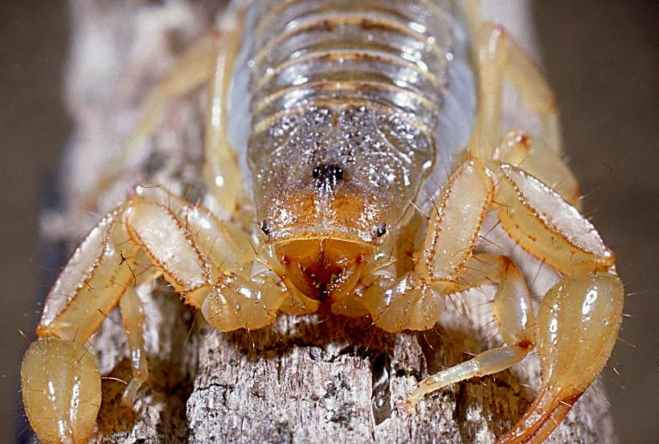
chelicerae
eyes
pedipalp

Class Crustacea
- Most crustaceans are aquatic and use gills for gas exchange.
- 2 pairs of antennae for sensing.
- Mandibles for crushing food that moves side to side.
- Many have five pairs of walking legs used for seizing prey and cleaning other appendages.
- First pair is often modified into strong claws.
- Crabs, lobster, shrimp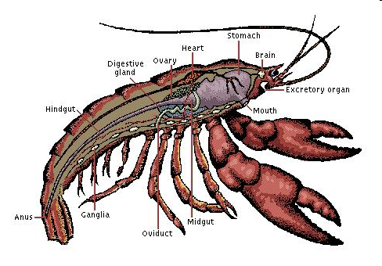

Class Chilopoda and Diplopoda
- Centipedes belong to class Chilopoda and millipedes belong to class Diplopoda.
- Centipedes are carnivorous and eat soil arthropods, snails, slugs, and worms.
- Centipedes have one pair of legs per visible segments
- Centipede bites are painful to humans (poisonous glands).
- Both have Malpighian tubes for waste excretion.
- Both have tracheal tubes for gas exchange.
- Millipedes eat mostly plants and dead material.
- Millipede have two pairs of legs per visible segments
- Millipedes also have stink glands for scaring predators (irritation).
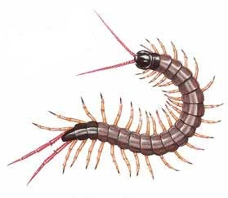
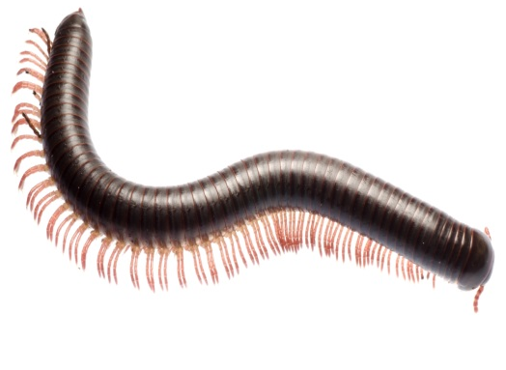
Centipedes
Millipedes

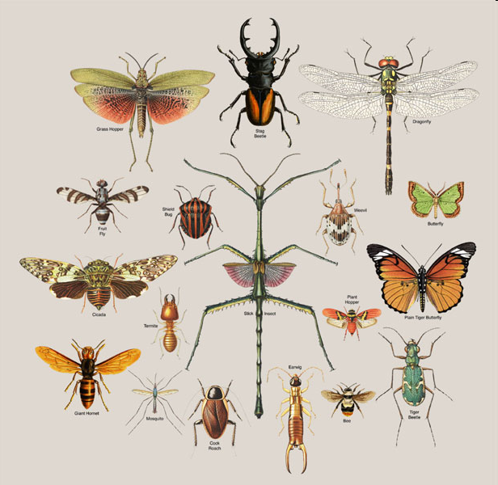
Class Insecta (hexapoda)
- 3 body parts: head, thorax, abdomen
- 3 pairs of legs on the thorax
- 1 or 2 pairs of wings on the thorax
- 1 pair of antennae
- Life cycle has either incomplete or complete metamorphosis

