University of Salahaddin Entomology
Department of Biology
3rd Class Year Lab2

External Morphology
Head Capsule
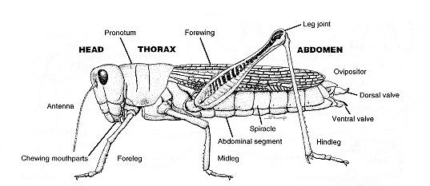

The Head
- The head, being the anterior tagma, bears the major sense organs and the mouthparts.
- The head of an insect is composed of a series of segments (6 segments), which are specialized for:
  - food gathering and manipulation,
  - sensory perception, and
  - neural integration.
- Considerable controversy still surrounds the problem of segmentation of the insect head.
- There are three preoral and three postoral segments.
- The first preoral segment is preantennal; it is called the protocerebralor clypeolabralsegment. The segment itself has disappeared but its appendages remain as the clypeolabrum.

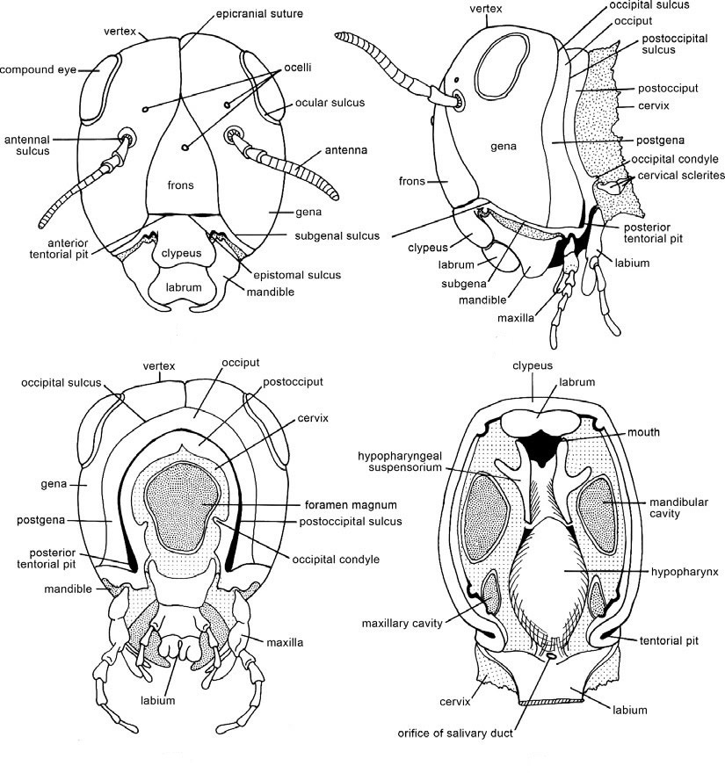
A- Anterior
B- Lateral
C- Posterior
D- Ventral
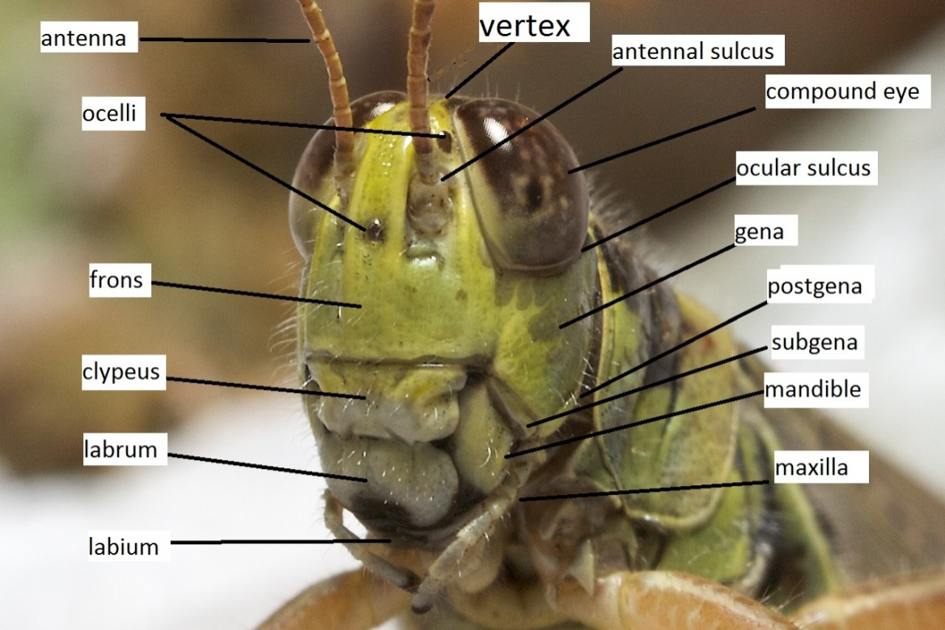

AXIAL POSITION
- The posture or orientation of the head in its resting position relative to the long axis of the body can be important in providing definitions of the anatomical features of the head.
- Axial position in insects typically falls into three basic categories:
- prognathous.
- hypognathous.
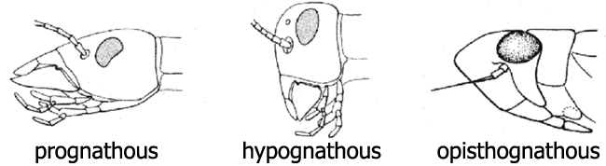
- opisthognathous.

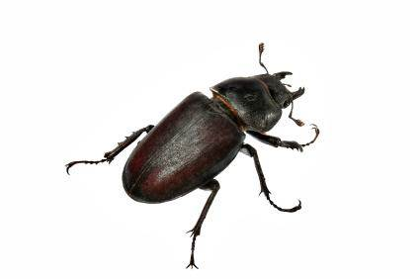
- Some predaceous insects, such as carabid beetles and earwigs, display the prognathous. Condition in which the mouthparts are directed anteriorly.

- Hypognathous refers to insects with the head vertically oriented and the mouth directed ventral.
The hypognathous position is evident in most major groups of insects and can be seen in the grasshopper, house fly, and honey bee. Other conditions are probably derived from ancestors with a hypognathous head
- The opisthognathouscondition is characterized by posteroventral position of the mouthparts
The opisthognathous condition is displayed in many fluid-feeding Hemiptera, including true bugs, leafhoppers, whiteflies, and aphids.
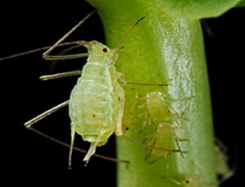
aphid

