University of Salahaddin Entomology
Department of Biology Lab 3
3rd Class Year

The Antennae

The antennae are a pair of sense organs located near the front of an insect's head capsule (except in order: Protura where antennae and eyes are absent).

Although antennae vary widely in shape and function, all of them can be divided into three basic parts:

scape -- the basal segment that articulates with the head capsule

pedicel -- the second antennal segment

flagellum -- all the remaining "segments" (individually called flagellomeres).

Functions of Antennae

Functionally the antennae are organs of specials sense. Antenna is an organ of smell and touch. It is useful to detect chemicals including food and pheromones. Also perceives humidity changes, variation in temperature, vibration, wind velocity and direction. It is useful for hearing in mosquitoes and communication in ants. Occasionally useful to clasp the mate (e.g. flea) and grasp the prey.

In a few exceptional cases they are modified for other uses thus in the larvae of Chaborus and its allies they are adapted for seizing the prey ,while those of the male of Meloe and several other insects are used for holding the female.
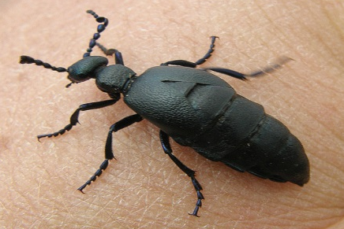
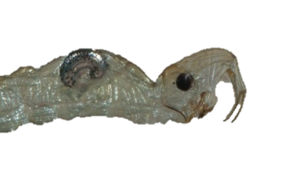

Meloe male
Chaborus larvae (Phantom midges)

Types of antennae

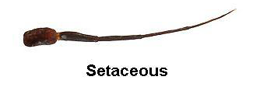
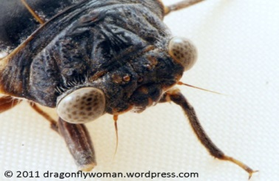
Setaceous -- bristle-like (hair-like) e.g. Dragonflies and damselflies (order Odonata) and Cockroaches. .

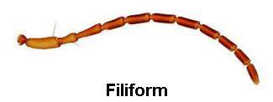
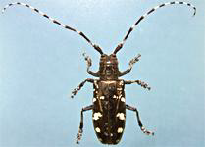
Filiform – (individual segments similar in size) thread-like e.g. Ground beetles

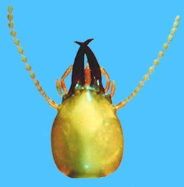
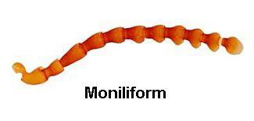
Moniliform - Moniliform have a beadlike shape. e.g. termites.

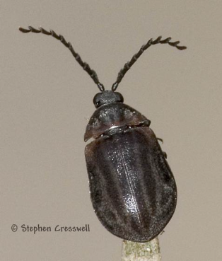
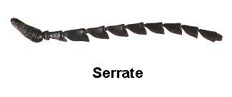
Serrate - the segments are angled on one side giving the appearance of a saw edge e.g. click beetles.

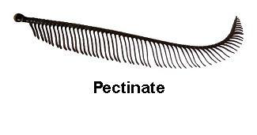
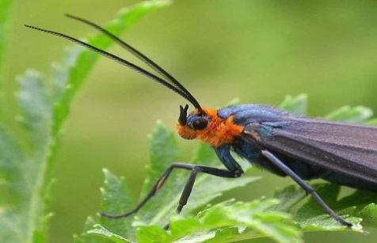
Unipectinate (Comb-like): - The segments are longer on one side. This gives the appearance of a comb e.g. Sawflies (related to wasps) and Fire-colored beetles.

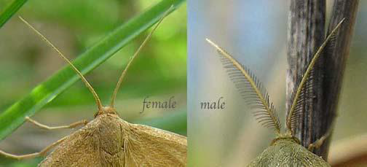
Bipectinate - The segments are longer on two sides. This gives the appearance of a comb e.g silk worm moth.
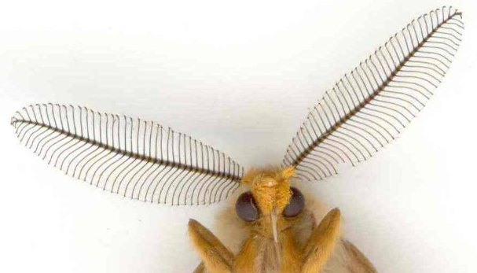

Stylate:-in some flies the flagellomeres are consolidated and the last one is called the style e.g.Tabanus.
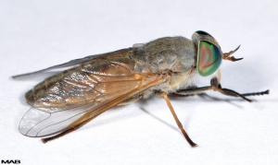
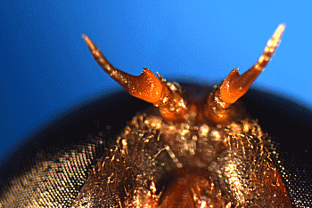
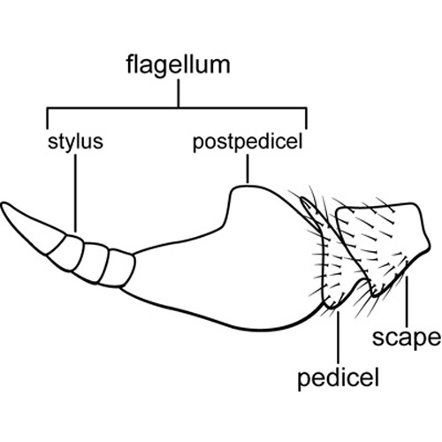

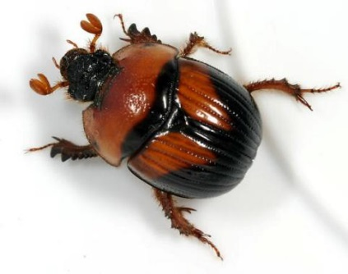
Lamellate - the segments towards the end are flattened and plate-like. This gives the appearance of a fan e.g. scarabid beetle.
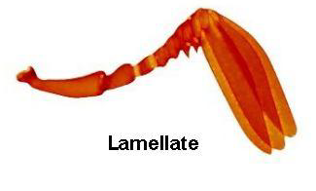

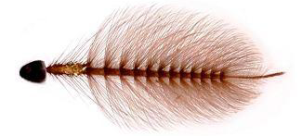
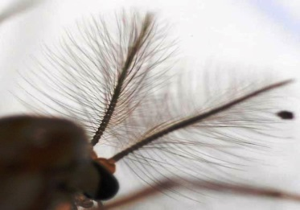
Plumose: brush-like e.g. male mosquitoes.

Pilose: (covered with usually soft hair) e.g. female mosquitoes.
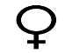

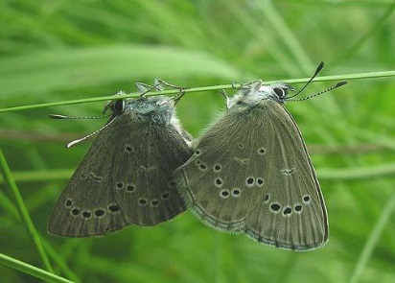
Clavate -- gradually clubbed e.g. Butterflies

Capitate -- abruptly clubbed e.g. Carrion beetles

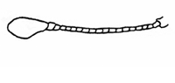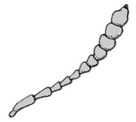
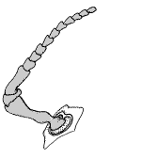

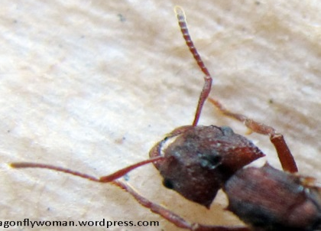
Geniculate – elbowed e.g. Weevils and Ants.

Aristate -- pouch-like with lateral bristle e.g. House flies.

