University of Salahaddin **Entomology**   
Department of Biology  
3rd Class Year **Lab4**

# **External Morphology**

# **Mouthparts (1)**

## The mouthparts of insects are structures surrounding the mouth that are involved in the mechanics of feeding and processing and manipulating the food so that it can be ingested.

## Although functionally equivalent to the jaws of vertebrates, they lie outside the mouth, not within a buccal cavity.

# **Basic Structure**

Mouthparts of insects generally consist of:

* Labrum
* Mandibles
* Maxillae
* Labium
* Hypopharynx

***Chewing mouthparts:***

**The labrum** is a simple fused sclerite, often called the upper lip, and moves longitudinally. It is hinged to the clypeus which helps to pull food into the mouth. The inner surface of labrum is the epipharynx. Epipharynx bears mechano- and chemosensilla.

# **Mandibles**

## The mandibles, one on each side, are hinged to the head capsule by one or two condyles.

## Used to chew, cut, and tear food, to carry things, to fight, and to mold wax.

## The mandibles are opened and closed by a pair of muscles; one inserted on either side of the axis of mandibular attachment at the condyles.The opener muscle is called the **abductor**, whereas the closer is the **adductor**.

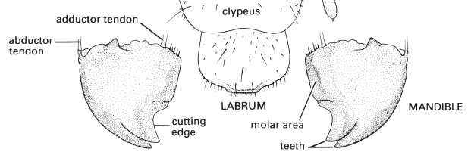

# **Maxillae**

## Behind the mandibles are the maxillae, one on each side of the head.

## Each maxilla articulates with the head capsule by a single condyle so that it is extremely mobile.

## This high degree of movement allows the maxillae to manipulate food between the mandibles and move it toward the mouth.

## Each maxillae consisting of a basal part composed of the proximal **cardo** and the more distal **stipes**

## Two lobes attached to the stipes; the mesallacinia and the lateral galea – and a lateral, segmented maxillary palp.

## **Functionally**, the maxillae assist the mandibles in processing food; the pointed and sclerotized lacinae hold and macerate the food, whereas the galeae and palps bear sensory setae (mechanoreceptors) and chemoreceptors which sample items before ingestion.

## The maxillary palps are leg-like structures often with three to five segments and they have an important sensory function.

## 

# **Labium**

## Labium is a fused structure that moves longitudinally and possesses a pair of segmented palps equivalent to lower lip.

## They function to close the mouth below.

## There are two main parts to the labium:

## The proximal **postmentum**, closely connected to the posteroventral surface of the head and sometimes subdivided into a submentum and mentum.

## The free distal (apical) **prementum**, near the base of the prementum is the palpiger which carry the labial palps which are antenna-like pieces consisting of 1 to 4 segments and functioning as sensory organs. The glossae and paraglossae, including sometimes the distal part of the prementum to which they attach, are known collectively as the **ligula.**

## 

## **Hypopharynx**

## There is tongue-like structure called hypopharynx

## Arising as a median lobe from the floor of the head capsule and extending ventrally into the preoral cavity

## It is frequently fused to the labium.

## Hypopharynx is mainly membranous, and the salivary glands open through it.

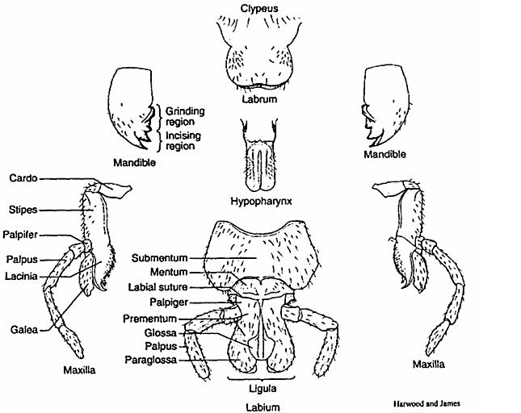

# 

# **Chewing mouth parts**

# ***Chewing and lapping type:***

## The chewing lapping mouthparts occur in the honey-bees and bumble-bees. These consist of a long tongue which is formed from the **glossae** of the labium, ending in a spoon shaped labellum or flabellum.

## The galeae of the maxillae form blade-like structures and the maxillary palps are very small.

## A temporary food channel is formed by the proboscis, **galeae** and **labial palps** fitting together. Through this food channel the liquid food flows up, assisted by the pumping action of the pharynx.

## The normal mandibles are used for wax and pollen manipulation.

# 