Entomology3rd Class Lab 9

External Morphology

Abdomen and Abdominal Appendages

Insect abdomen is the third functional region of insect body. The number of abdominal segments varies. Most insects have 10 or 11 abdominal segments, but several of these are reduced.

There are various types of appendages arise from the abdomen.

Abdominal segments from 1 to 7 are pre-genital segments, 8th and 9th are known as genital segments as they form genital appendages, e.g. ovipositor in females and aedeagus or penis in males

10th and 11th segments are known as post-genital segments.

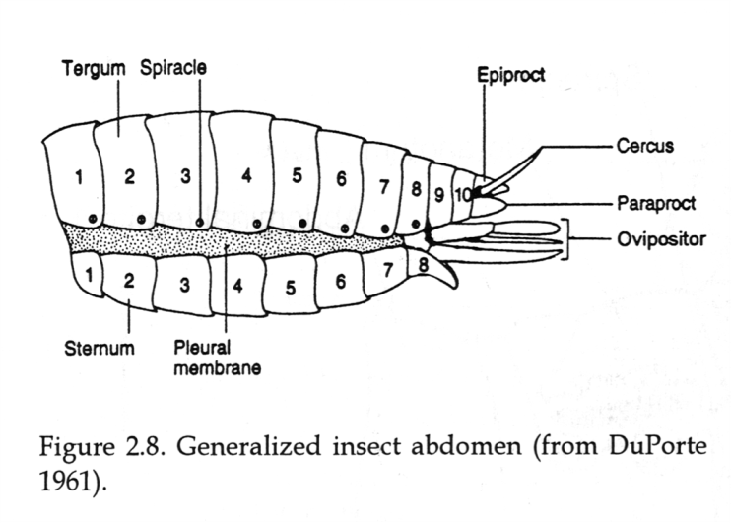

Abdomen segments in Hymenoptera

The 1st abdominal segment gets fused to metathorax forming propodium.

The 2nd abdominal segment forms a narrow pedicel or petiole followed by enlrgedgaster (rest of the abdominal segments) in Hymenoptera.
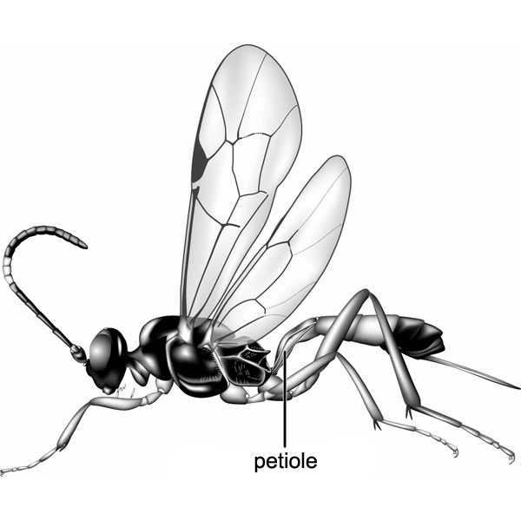
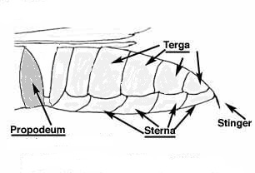
gaster
Petiole
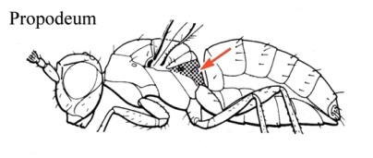

Abdominal appendages

Non reproductive appendages

Order Collembola (Springtails) are the only order of hexapods with a collophore, a structure found on the ventral side of the first abdominal segment used for water uptake and excretion.They jump using a furcula, an elongate forked appendage which arises from the ventral side of the 4th abdominal segment. When bent beneath the body the furcula is held by the retinaculum which is located on the ventral side of the 3rd abdominal segment.

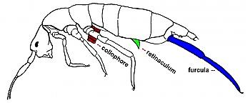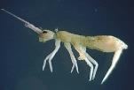

Larval abdominal appendages

A pair of leg-like outgrowth of the body wall on segments 3, 4, 5, 6 and 10, known as prolegs (false legs)., are common in caterpillar (Butterfly larvae).
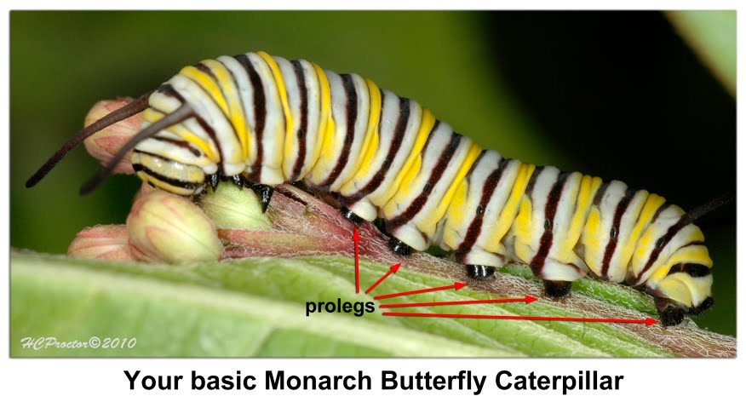
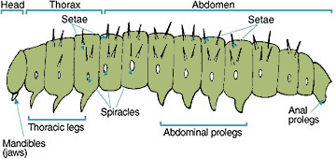

Anal cerci

Cerci are paired appendages on the 11th segment of abdomen of many species of insect. Typically, they are elongate multisegmented structures that function as sense organs .They may be considerably modified:

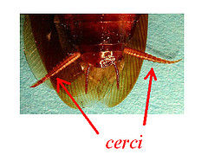
The cerci maybe simple, unsegmented as in Orthoptera, or multi segmented as in Blattodea.
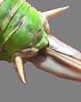

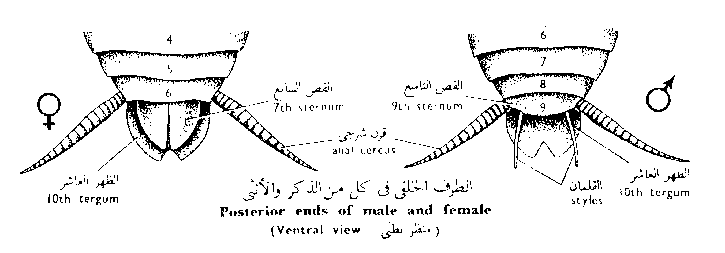

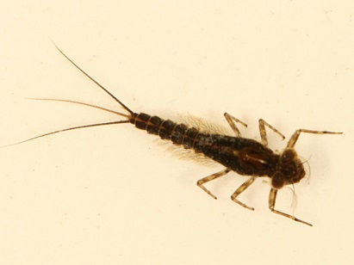
They maybe long ,multi segmented and the median caudal filament arising between the cerci, as in Thysanura (silverfish) and Ephemeroptera (mayfly) larvae.
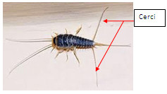

Sometimes the cerci differ in the two sexes of a species, e.g. Earwigs the cerci form powerful forceps which usually straight and unarmed in female, but is curved and toothed in male.
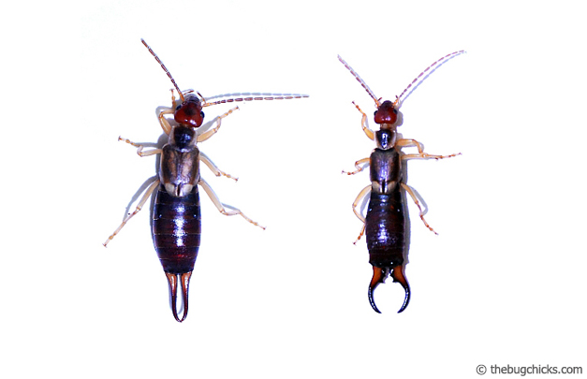
Female
Male

Cerci - modified as caudal gills, e.g. Odonata (Damsel fly Larvae)
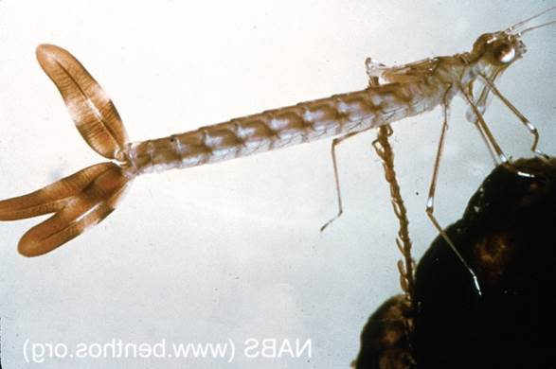
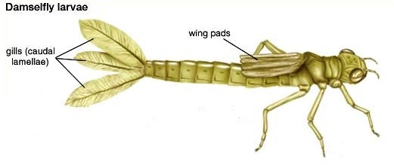

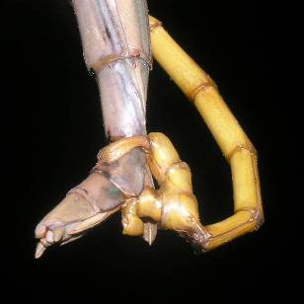
Cerci - modified as claspers, e.g. Male Odonata and male Phasmid(stick insects)
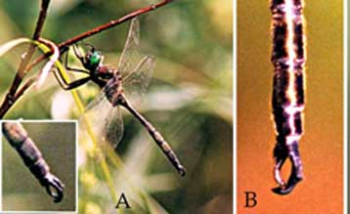
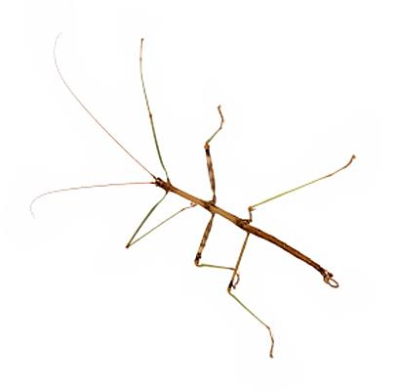

Reproductive appendages

The organs concerned specifically with mating and the deposition of eggs are known collectively as the external genitalia.

Female External Genitalia

Ovipositors are used for oviposition and it is formed by the modification of 8-9 abdominal segments. Thysanura, Orthoptera, Thysanoptera and some Hymenoptera insects contain true ovipositors.
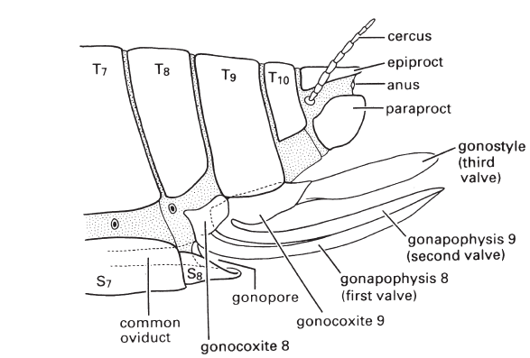
Ovipositor

Male genitalia

Modification of 9th abdominal segment makes the copulatory organ of males which is consist of aedeagus and pair of lateral claspers to grasp and hold the abdomen of the female during mating.
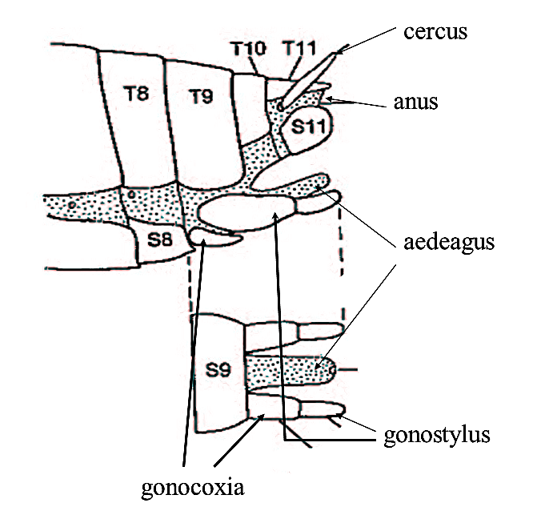

Sting apparatus

The ovipositor of Hymenoptera may be considerably modified for boring, piercing, sawing, and stinging. Only when modified for stinging it isn’t participate in egg laying.

Only females (workers and the queen) possess a sting. Part of female apparatus is modified into a sting, connected to two poison glands.

The sting composed of:

A stylet: resulting from the fusion of the genital pieces of the 9th segment enlarged at the base and possessing two grooves internally.

2 lancets: genital pieces of the 8th segment rectilinear and denticulate in workers, they slide on the stylet rail. The venom is situated between the 2 lancets. The sting of the queen is curved and smooth.

2 poison glands: the dorsal acid gland “y” shaped is the only one really venomous. It is linked to a bulky reservoir by a long canal. An alkaline gland with a non-toxic secretion serves to lubricate the lancets and to increase the pH of the venom, enhancing its toxicity.
