University of Salahaddin **Entomology**   
Department of Biology   
3rd Class Year

**Lab 12**

**Study Techniques of Collecting, Pinning and Preservation of Insects**

Collection of insects will help in obtaining first-hand information about the different aspects of insect life such as the host plant, mode of egg laying, feeding, growing and nature of inflicting damage etc. A well identified & classified collection will serve as a valuable reference material of the representative insect fauna of the locality.

**Collecting Insects**

You can collect insects from almost anywhere. You can find many insects on plants, especially on flowers and leaves. Also examine bark, stems, and branches. Insects are common in and around buildings and under objects like rocks and logs. Aquatic insects can be found in ponds, lakes, streams, rivers, and bogs and on nearby plants. Watch for insects at different times of the year. Insects are most common during summer, although they can be found outdoors from early spring to late fall. Some may be out only at certain times of the year.

**Equipment**

1. insect net
2. killing jar
3. forceps
4. relaxing jar
5. spreading board and pinning block
6. insect pins and labels
7. storage box

**Collecting Nets**

Collecting nets come in three basic forms: Aerial, sweeping, and aquatic. The first is designed especially for collecting butterflies and other flying insects. Both the bag and handle are relatively lightweight. The sweeping net is similar to the aerial net but is stronger and has a more durable bag to withstand being dragged through dense vegetation. Aquatic nets are used for gathering insects from water and are usually made of metal screening or heavy scrim with a canvas band affixed to a metal rim

* 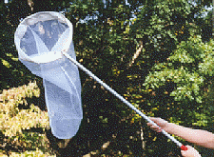**Arial** **net**

Used for catching select insects that may be flying through the air or perched on something (such as dragonflies, butterflies, bees)

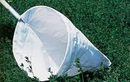

* **Sweep** **net**

Sweep nets are used to sweep through vegetation to collect random insects not easily seen

**Aspirators (pooters)**

A pooter uses suction to collect small insects without harming them

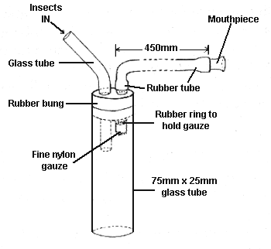

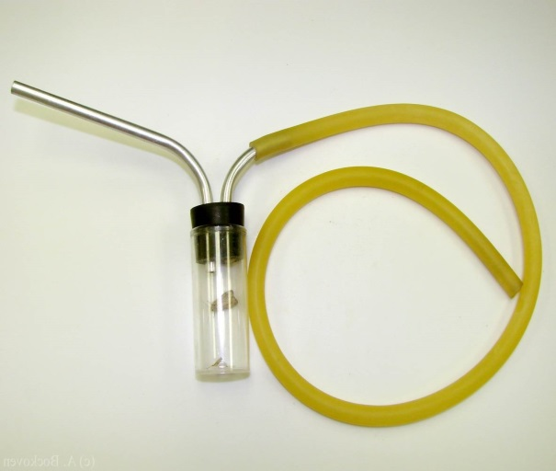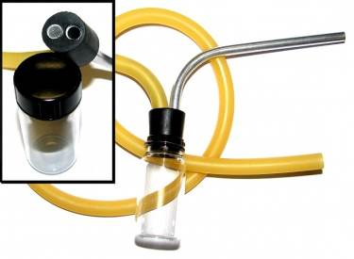

**Light Traps**

Light traps are a very effective way to collect insects at night

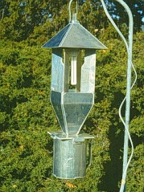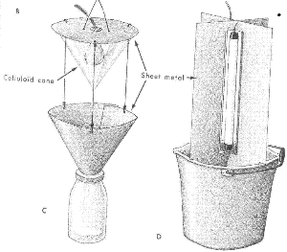

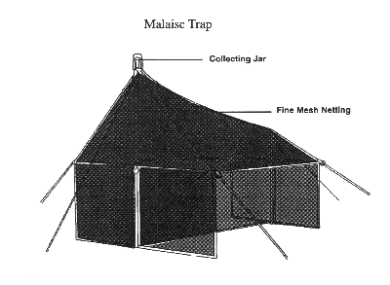**Malaise Traps**

This trap is a tent-like structure made of netting with a collecting chamber at the top. Insects entering the trap eventually fly or crawl upward while attempting to escape. Instead of escaping, they become trapped in a killing jar or a container of ethanol.

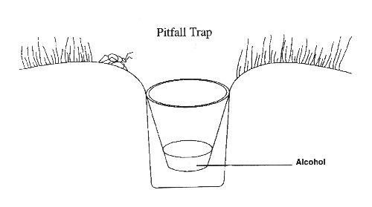**Pitfall Traps**

Insects that crawl about on the ground can be captured in a pitfall trap. The simplest trap can be constructed easily by placing a can or plastic container in the ground. Add enough killing agent (such as alcohol) to cover the bottom of the container. To keep rainwater out of these traps, a board can be propped up over the opening.

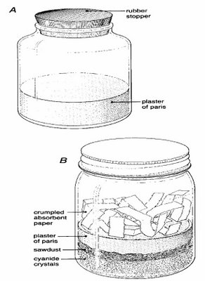

**Killing Bottle**

The collected insects are required to be killed quickly for preservation For this purpose killing bottles are used, Ca, K or sodium cyanide or ethyl acetate or chloroform or 70% alcohol are some of the killing agents used in killing bottles. Potassium cyanide is most toxic killing agent.

**Preserving Insects**

* **Soft-Bodied Insects** - Many types of insects, including aphids, springtails, mayflies or silverfish, are soft-bodied and cannot be pinned successfully. The same is true of many immature insects such as caterpillars, beetle and wasp larvae and others. If placed on pins, most soft-bodied insects will shrivel or decompose. Such insects must be preserved in liquids in rubber-stoppered glass vials.
* For the long term, insects are preserved in ethyl alcohol, usually of about 70 percent concentration (70% alcohol, 30% water). Isopropyl alcohol can also be used, but with less success.
* **Hard-Bodied Insects** - Since insects have a hard shell or exoskeleton and all of the soft parts are on the inside, they tend to keep rather well after drying, even for long periods of time. Only a small amount of maintenance is necessary to keep them in good condition.

**Mounting the Specimen**

**1- Relaxing**

**2- Pinning**

**3- Setting**

**4- Labelling**

**5- Insect Boxes**

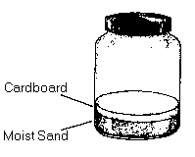**The Relaxing Jar**

* While insects should be pinned on the same day they were collected, this is not always possible. So before pinning these specimens left in the killing jar too long, to restore their flexibility, it is necessary to "relax" them. By placing them in a relaxing jar at high humidity for a few days we can restore their flexibility enough to allow pinning without damage to the specimens.
* A relaxing jar is easy to make. Simply use another baby food or larger jar as the relaxer. Place some absorbent material such as newspaper, sand or cotton in the bottom and cut a blotting paper disk to fit tightly inside. Moisten the material with water and add a drop or two of ethyl acetate, phenol, to prevent mold. Place insects on the paper, close the jar tightly and let it sit for about 2-3 days. Check the jar. If the insects are flexible, mount them immediately.

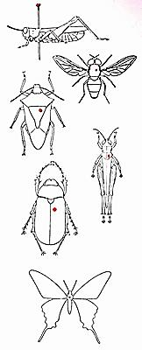**Pinning**

* The pinning is the best method for preserving hard bodied insects. The pinning facilitates convenient handling of the specimens for study as well as helps for safe and secure storing. The special rust proof steel pins are used for this purpose, which are generally longer and thinner. As a rule the pins are inserted vertically through the line. The bugs are pinned through the scutellum, grasshoppers through pronotum and beetles through the right elytra. It is desirable to keep 3/4th portion of the pin below and 1/4th portion above the insect body.

**Insect Pins**

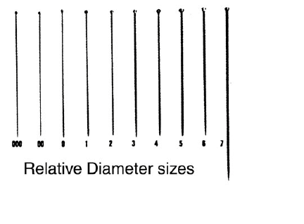Special pins are needed to pin insects. These pins are longer, stronger, and thinner than an average pin. They come in several sizes from 00 through 7, the size of the pin increasing with each number (2's and 3's are most useful). Insect pins are purchased from biological supply houses and some hobby stores, in packs of 100. Never use common pins.

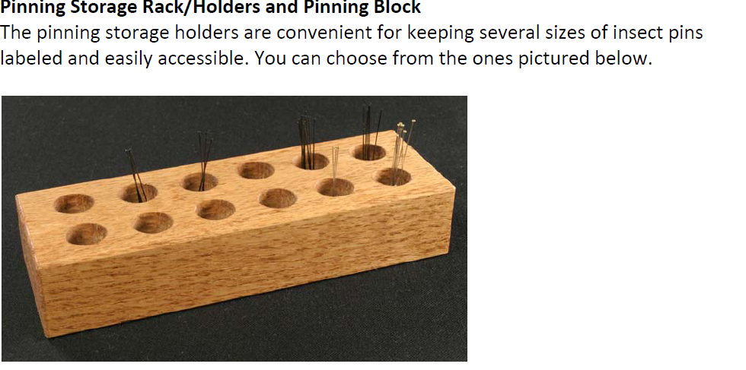



**Pinning block**

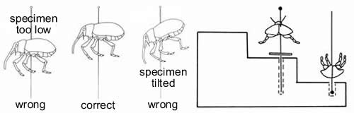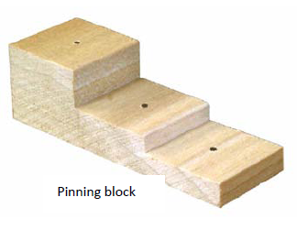Pinning block will result in an attractive collection with the insect, collection and identification labels in uniform position. For insects too small to pin, points are used. Points are simply slender triangles of thick paper to which an insect is glued to the thin end and a pin is inserted through the wide end. Different types of glue may be used, but I mainly use the common white glue. An alternative to mounting small insects on points is the double mount. This can be used for most insects, especially micro *Lepidoptera*. A very small Minuten pin should be inserted in the specimen, which is then inserted in a small block of cork. A standard insect pin should then be inserted in the opposite end of the cork block

**Spreading Board**

* 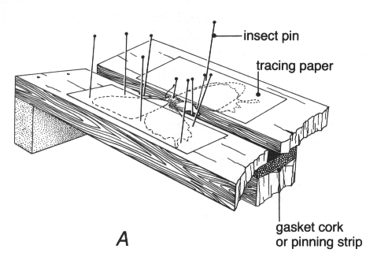Mounting butterflies and moths is a special technique that requires a spreading board to do an attractive job. The spreading board is usually made of soft pine with a piece of balsa or cork underneath the center groove to receive insect pins.
* When pinning and spreading a butterfly or moth, before you begin to work, cut several thin strips of paper about 1/4 inch wide and 8-10 inches long. Once these are ready, pick up the insect by the thorax and carefully push a pin through the middle of the thorax. Adjust the position of the butterfly on the pin and make sure that it is level, both on the sides and in both front and back.

**Labelling**

* All specimens should be clearly labelled with the locality where it was collected, the collector's name and the date when it was collected. The locality should be a well-known place name.
* Other information such as habitat, method of collection, time of day or the host plant may also be valuable information to record on your label.
* 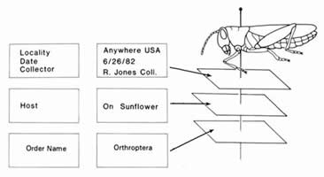A second label is used to write the classification or name of the insect

**Storage**

* 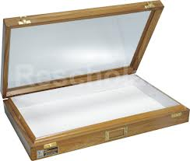**Insect Boxes:** The pinned insects must be stored in insect boxes for preserving them safely for a longer period. The bottom is covered with cork sheet and prepared for easy pinning. Add some naphthalene to the storage container to prevent insect damage. Preferably, insect collections should be kept in air tight containers in an air-conditioned room. This prevents insect attack and evaporation of the naphthalene.

