University of Salahaddin Entomology
Department of Biology
3rd Class Year Lab5

External Morphology

Mouthparts (2)

Siphoning type:

Butterflies and moths (lepidoptera) are adapted for feeding on nectar like the bees, but in their mouthparts the maxillae form the main proboscis and not the labium. The mandibles and labium are much reduced, the maxillary palps are rudimentary and the labium forms a triangular plate forming a labial palps. The galeae are much elongated and coiled, each forming a half tube, which makes complete tube when both are locked together. When not in use the proboscis is coiled into position beneath the head and when the insect wants to feed, it becomes uncoiled to reach the nectary. It is the rise in blood pressure which uncoils the proboscis.

The food canal is formed between the maxillary galeae in Lepidoptera. Lepidopterans have no salivary canal in the tongue because the nectar on which they feed does not require digestion before being ingested.
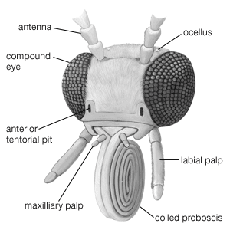
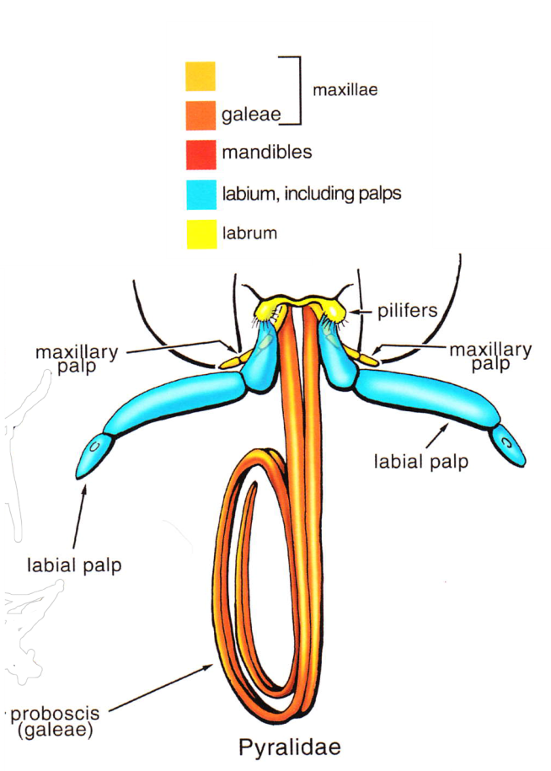
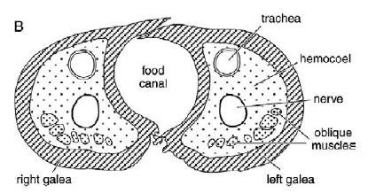

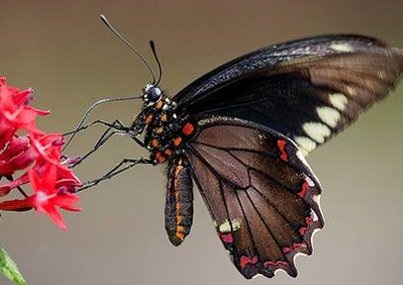
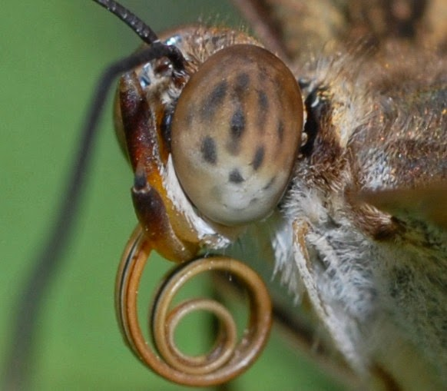

In use
At rest

Piercing-sucking mouthparts

The piercing-sucking mouthparts are found in blood sucking insects like the mosquitoes, the bugs such as bedbug and kissing bug, and the herbivorous insects such as aphids, which feed on plant juices. In this type the mandibles and maxillae resemble fine needles.

In female mosquito, the mouthparts consist of a long proboscis or beak, which is composed of the:

Labium, forming an elongate, fleshy and mid-dorsally grooved tube.

It encloses the needle-like stylets formed by the modifications of the mandibles, maxillae (have serrated tip keep the wound open) and hypo pharynx.

The needle-like labrum is fused with the epipharynx and forms the long covering of the open groove of proboscis.

The proboscis bears at its tip, two small labellae, which used as feelers and enable the mosquito to select the appropriate part of its victim to attack. These mouthparts are well developed in female mosquitoes as they feed on blood.

Food canal is formed between labrumepipharynx and hypo pharynxwhile salivary canal formed within hypopharynx.

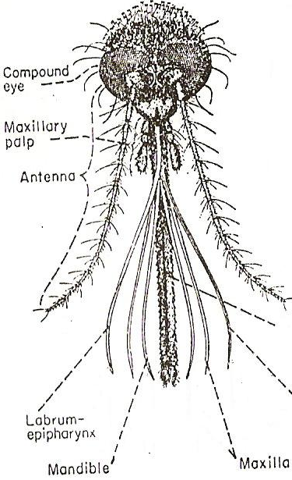
Labium
Hypopharynx
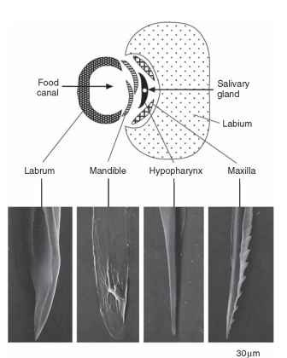

In male the mouth parts is sucking types ,are suitable for sucking plant juices only .labrum-epipharynx& the labium are the same as in the female, but the mandibles & maxillae are very short & functionless & the hypopharynx is fused with the labium.

Piercing-sucking mouthparts In Hemiptera (true bugs and aphids):

In Hemiptera (true bugs and aphids), the mandibular stylets which are usually serrated at the apex are the main piercing structures.

The relatively thick labium does not enter the wound, but folds up beneath the insect as the mandibles and maxillae penetrate deeper into the host tissues.

Both canals (food and salivary) are formed between the styliform maxillae, which interlock by a tongue-and-groove mechanism that permits them to slide lengthwise with respect to each other but prevents them from coming apart.

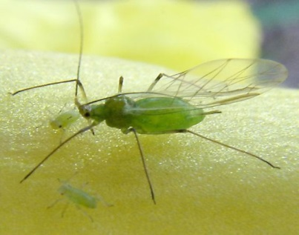
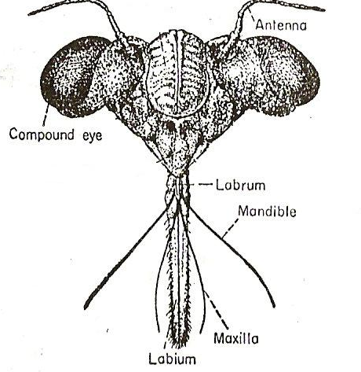

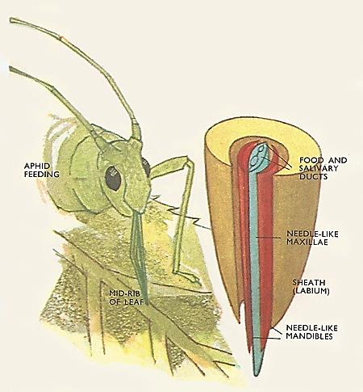

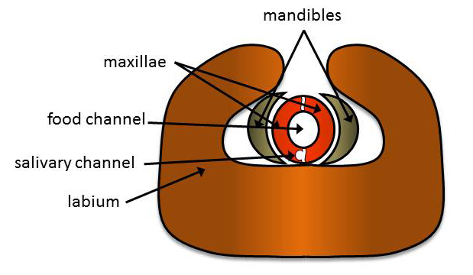

Sponging Mouthparts:

Sponging Mouthparts are used to sponge and suck liquids. Found in Housefly.

The mouthparts modified to proboscis that is typically a sponging or lapping organ, the proboscis is subdivided into a basal rostrum, central haustellum, and distal labella. The mandibles are absent and the maxillae are represented only by stipes maxillarypalps.

The proboscis is a composite structure containing parts of the labrum, hypopharynx, and labium, as well as the clypeus.

The labellum is a large sponge-like organ that transverse by a series of minute capillary channels called (pseudotracheae) through which the liquid food sucked up by capillary attraction.
