**Entomology** 3rd Class **Lab 6**

# **External Morphology**

# **Mouthparts (3)**

* **Cutting and sucking mouth parts:**

Cutting and sucking mouth part in stable fly like the lapping Muscidae. However, the haustellum is elongated and rigid, and the distal labellar labes are small and bear rows of prestomal teeth on their inner walls.

The labrum and labium interlock to form the food canal within which lies the hypopharynx enclosing the salivary duct.

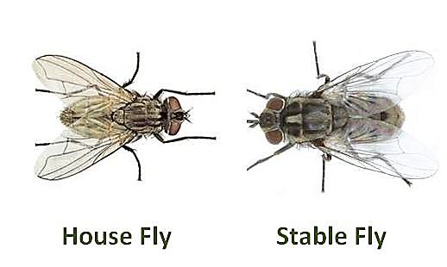

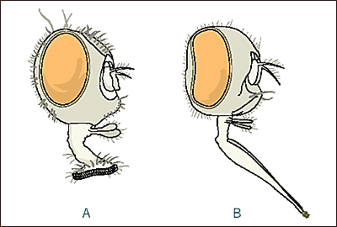

* **Cutting lapping mouth parts**

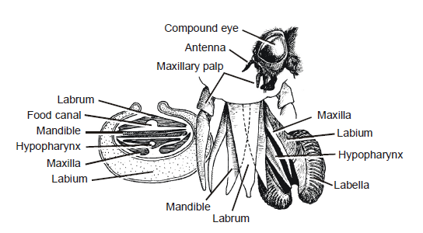mouth parts in horse fly is cutting-lapping type. In these flies all of the ancestral outhparts are still present and the horseflies use them in a very different way. The mandibles and maxilla resemble scissor blades and when the feeds it opens and closes these two sets of scissors cutting the skin surface. Blood pools inside the ragged wound and the fleshy labellum, with this sponging tip, sucks up the pooling blood.

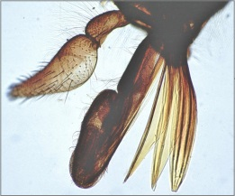

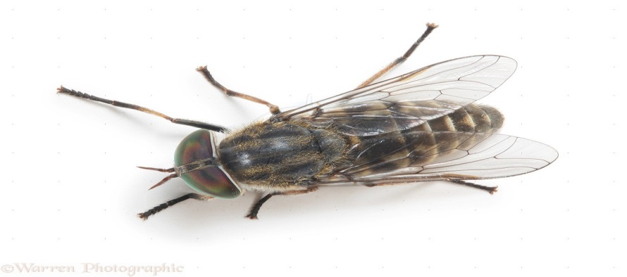

* **Suctorial Mouthparts of Larvae Predaceous sucking mouthpart**

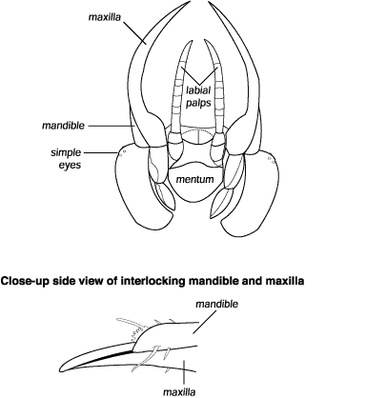Some predaceous larvae that feed on the body fluids of their hosts are mandibulate, with mandibles resembling those of insects feeding on solid food. These are larvae of lacewings and ant lions (Neuroptera), glowworms (Lampyridae), and dytiscid beetles. In all of them, the mandibles are sickle shaped with a groove along the inner edge. These insects can pump the fluid contents of their prey into the foregut through the tubes.

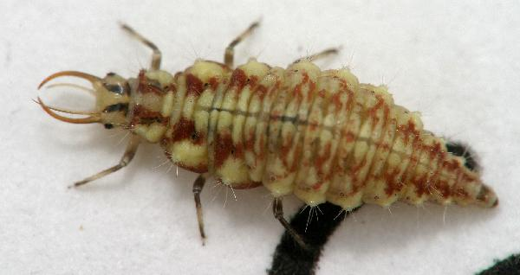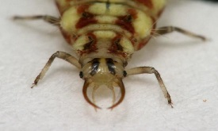

Lacewings larvae

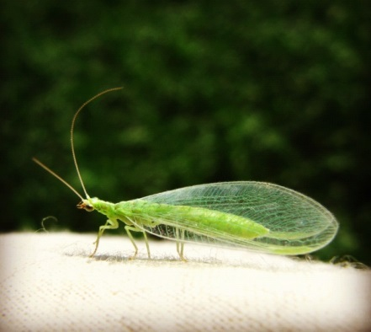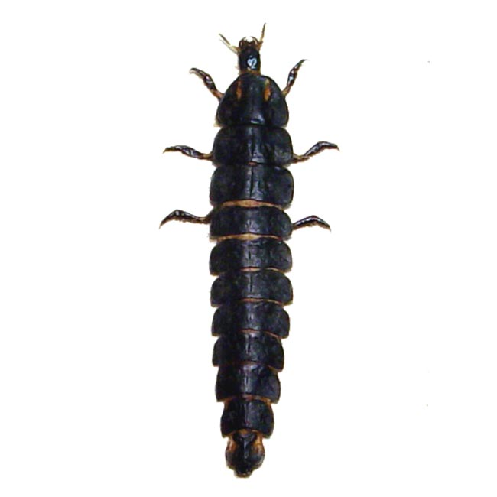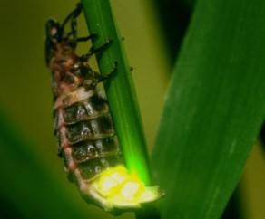

Glowworm larvae

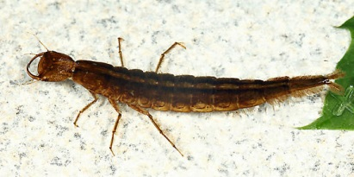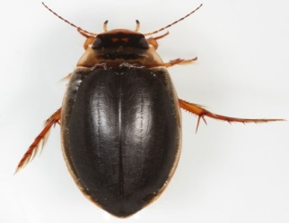

dytiscid beetle larvae

* **Predaceous chewing mouth parts**

 the mouth parts in dragon fly nymph is Predaceous chewing type .in this type the labium modified to form an elongate, prehensile structure known as the *mask* This structure is hinged in the middle and bears a pair of terminal claws. The whole arrangement is called the mask because when not in use and folded back under the head, it conceals the rest of the mouthparts. When food is sighted, the mask is thrown forward and the prey is impaled on the claws.

