**Lab 17**

**Insect Taxonomy**

Taxonomic categories (obligatory categories are shown in **bold**):

|  |  |  |
| --- | --- | --- |
| Taxon category | Standard suffix | example |
| Order |  | Hymenoptera |
| Suborder |  | Apocrita |
| Superfamily | -oidea | Apoidea |
| Family | -idae | Apidae |
| Subfamily | -inae | Apinae |
| Tribe | -ini | Apini |
| Genus |  | *Apis* |
| Subgenus |  |  |
| Species |  | *A. mellifera* |
| subspecies |  | *A. m. mellifera* |

**The class insecta is divieded in to two subclasses Apterygota and Pterygota.**

**Sub Class: Apterygota**

These are primitive wingless insects with pregenital abdominal appendages with no or slight metamorphosis. Mandibles articulate with head capsule at a single point.

The malpighian tubules are rudimentary. There is no pleural suture in the thoraccic region.

**Sub class 1. Apterygota**

Order 1: Thysanura (Bristle tails, Silverfish )

Order 2: Diplura (Diplurans)

Order 3: Protura (Telson tails)

Order 4: Collembola (Spring tails)

**Sub class pterygota:**

These are insects with developed wings and showing definite metamorphosis. The pregenital appendages are absent in these insects. A pleural suture divides the thoracic pleura in to episternum and epimeron. The mandibles articulate at two points with the head capsule. This sub class divided into two **Division**

**1: Exopterygota (Hemimetabola). Metamorphosis simple, wings develop**

externally. Immature stages (nymphs) usually resemble adults in structure and habits

**2: Endopterygota (Holometabola). Metamorphosis complex accompanied** by a pupal instar, wings develop internally. Immature stages (larvae) differ from adult in structure and habit.

**Exopterygota (Insects having simple metamorphosis)**

Order 5: Ephemeroptera (May flies)

Order 6: Odonata (Dragon flies & damsel flies)

Order 7: Plecoptera (Stone flies)

Order 8: Grylloblattodea (Grylloblattids)

Order 9: Orthoptera (Locusts and grasshoppers)

Order 10: Phasmida (Walking sticks, leaf insects & stick insects)

Order 11: Dermaptera (Ear wigs)

Order 12: Embioptera (Web spinners)

Order 13: Dictyoptera –Blattoda-(Cockroaches and mantids)

Order 14: Isoptera (White ants or termites)

Order 15: Zoraptera (Zorapterans)

Order 16: Psocoptera (Psocids, book lice)

Order 17: Mallophaga (Bird lice)

Order 18: Siphunculata or Anoplura (sucking lice)

Order 19: Hemiptera (Plant bugs)

Order 20: Thysanoptera (Thrips)

**Endopterygota (Insects having complex metamorphosis)**

Order 21: Neuroptera (Ant lions and lace wings)

Order 22: Coleoptera (Beetles, weevils)

Order 23: Strepsiptera (Stylopids)

Order 24: Mecoptera (Scorpion flies)

Order 25: Siphonoptera (Fleas)

Order 26: Diptera (Flies, midges, mosquitoes)

Order 27: Lepidoptera (Moths and butterflies)

Order 28: Trichoptera (Caddis flies)

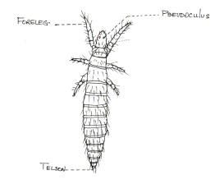Order 29: Hymenoptera (Ants, bees, wasps)

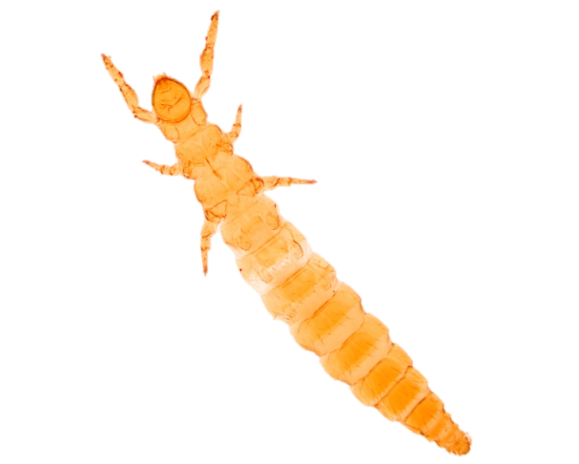

**Sub Class: Apterygota**

**1- ORDER: Protura (telson tails)**

**BODY CHARACTERISTICS**: Small, whitish

**MOUTH PARTS**: Entognatha, sucking

**EYES & OCELLI**: absent

**ANTENNAE**: None

**WINGS**: None

**LEGS**: First pair elevated like “antennae,” tarsi one segmented

**ABDOMEN**: 12 segments, no cerci

: No tracheae, malpighian tubules small

Metamorphosis .absent (simple)

**HABITAT**: Soil, leaf litter, moist conditions, worldwide

**FOOD**: Decaying organic matter

**Family:** Acerentomidae

Eg***. Acerentomon*** sp.

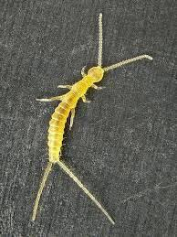2- ORDER: Diplura (two-pronged bristletailsEntognatha)

**BODY CHARACTERISTICS**: Small or minute, whitish

**MOUTH PARTS**: Entognathad, chewing

**EYES & OCELLI**: None

**ANTENNA**: Long, filiform

**WINGS**: None

**LEGS**: Tarsi one segmented

**ABDOMEN**: 10 segments, cerci forceps like or long caudal filaments, Trachaea present, malpigian tubules vestigial or absent

**HABITAT**: Soil and leaf litter, caves, under bark in moist conditions worldwide

**FOOD**: Decaying organic matter

**Family:** Japyidae

eg***. Japyx*** sp.

**3-ORDER: Collembola (spring tails)**

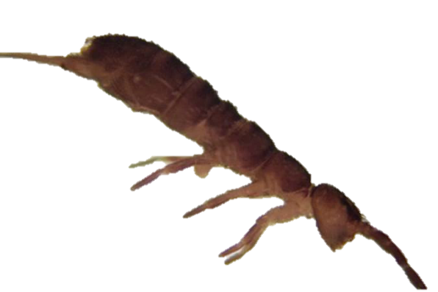**BODY CHARACTERISTICS**: Minute,tubular

**MOUTH PARTS:** entognathous, chewing Compound eyes absent.

**ANTENNA:** Short, 4 segmented

**WINGS**: None

**LEGS:** Pair of claws at end of tibia

**ABDOMEN:** 6 segments, usually with three pairs of appendages:-

1. Collophore it is located on the Venter of the first abdominal segment .it might serve as an organ of adhesion .
2. forked structure (furcula) on 4th segment,
3. retenaculum on 3rd segment.

Furcula directed anteriorly and secured by tenaculum. Springing occurs when furcula releases.

**Metamorphosis** is absent (simple).egg-yong-adult

**Tracheael systemis** usually absent .

No malpighian tubules..

**HABITAT:** Moist environments

**FOOD**: Decaying organic matter

1. 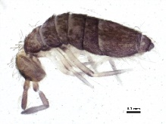**Suborder:-**  Arthropleona.

1- body elongate

2-abdomen wuth 6 distinct segment.

Family :Entomobryidae

eg. *Entomobrya* sp.

**B. Suborder:-** Symphypleona

1-body oval or globular

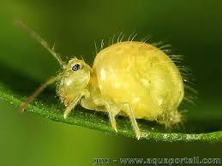2-abdomen with 4 segments fused and segments 5 and 6 forming asmall apical papilla

Family:Smithuridae

Eg.*Sminthuru*s

**4-ORDER: Thysanura(Bristle tails, Silverfish)**

**BODY CHARACTERISTICS:** Small, usuallycovered with scales

**MOUTH PARTS**: Ectognatha, chewing

**EYES & OCELLI**: Compound eyes usually present, 0-3 ocelli

**ANTENNAE:** Filiform, long

**WINGS**: None

**LEGS**: Tarsi 2-4 segmented

**ABDOMEN**: Styli on venter of several segments, female with long, jointed ovipositor, cerci long, median caudal filament present tracheae present, malpighian tubules present.

***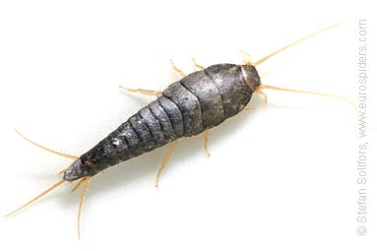*Metamorphis** is absent (simple)

**HABITAT**: Soil, rotting wood, leaf litter, worldwide

**FOOD:** Can feed on book bindings, cloth

**1- Family:** Lepismatidae

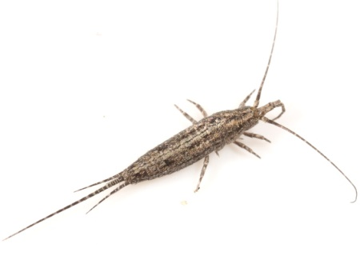Eg. ***Lepisma saccharina***

Eg. ***Thermobia domestica***

**2- Family:** machilidae.

Eg***.Machilis***