Lab 19
Insect Taxonomy 3
Endopterygota (Insects having complex metamorphosis)
- Order: Coleoptera (beetles)
Ordinal Characteristics:
- Chewing mouthparts
- Complete metamorphosis
- Two pairs of wings, the first pair hardened (elytra), the second pair membranous.
Order Coleoptera:
- Suborder: Adephaga
- Suborder: Polyphaga

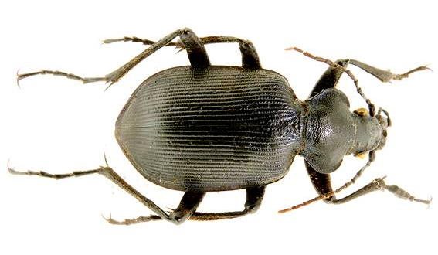
- Suborder: Adephaga
Family: Carabidae (Ground beetle).
Calosoma spp
- head near eye narrower than pronotum
- antennae threadlike
- the color black and shiny and sometime metallic or colorful
- most nocturnal (coming out at night)

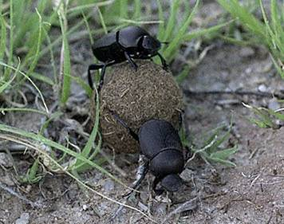
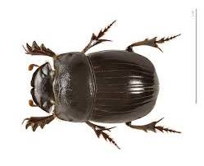
- Suborder: Polyphaga
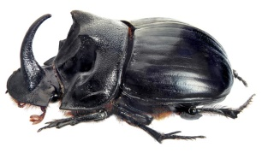
Family: Scarabaeidae (Dung beetle)
- Food: dung
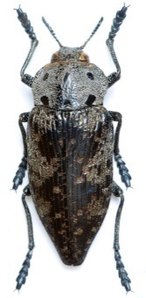
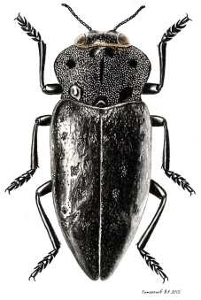
- Copris spp
Family: Buprestidae (Metallic wood borer)
- Food: Foliage, nectar
- Capnodis miliaris
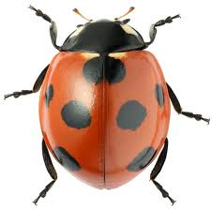
Family: Coccinellidae (Lady beetle)
- Food: Insects
- Coccinella sptempunctata (seven-spot ladybird)

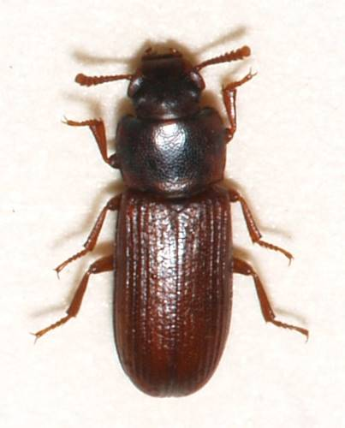
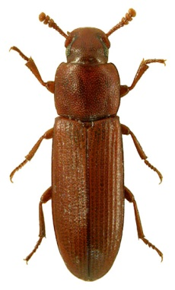
Family: Tenebronidae (flour beetles)
Tribolium confusum (clavate antenna) Tribolium castaneum (capitate antenna)

- Order: Lepidoptera (Butterflies and moths)
- BODY CHARACTERISTICS: Small to very large, covered with scales
- MOUTH PARTS: siphoning proboscis, vestigial in some species; Chewing in larvae
- ANTENNAE: Variable in form e.g. (bipectinate, unipectinarte. Clavate)
- WINGS: Two pairs, membranous, covered with scales (scaly wings).
- LEGS: Tarsi 5 segmented
- ABDOMEN: Cerci lacking

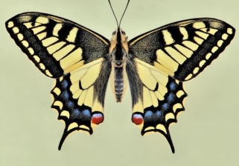
Lipidoptera grouped into two suborders Ditrysia and Monotrysia
Suborder: Ditrysia
1-Family: Papilionidae (tail on hind wings)
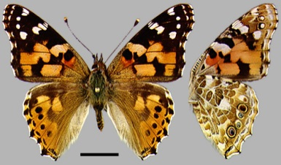
e.g. papilio machaon

2-Family: Nymphalidae
e.g. Vanessa cardui

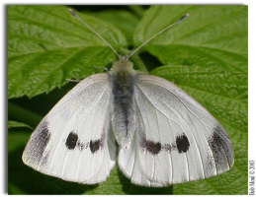
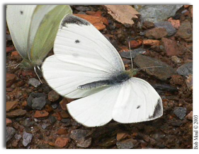
Female

3-Family: Pieridae
e.g. Pieris rapae
Male

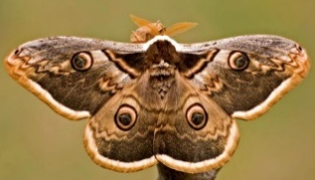
4-Family: Saturniidae
e.g. Saturnia pyri
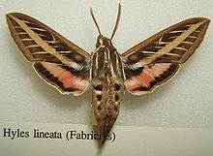

5-Family: Sphingidae
e.g. Hyles lineata
3- Order: Diptera: Flies and mosquitoes (two winged insects or true flies)
- Antennae mostly 3 segmented (except in Nematocera ) stylate and aristate.
- Mouth parts sucking type usually forming a proboscis. In many they are piercing and sucking and in others they are sponging (lapping) with labium distally expanded in to a pair of fleshy lobes.
- Mesothorax large supporting the functional wings, pro and metathoracic segments small and fused with mesothorax
- Wings only front pair of wings present. Hind pair modified into halters which act as
- balancers
- Legs well developed, tarsus usually 5 segmented pulvilli and an empodium Usually present
- Metamorphosis is complete
- Larvae eruciform and apodous known as maggots
- Pupa either free or enclosed in the hardened larval cuticle known as puparium, (coarctate pupa) and some have active pupa.

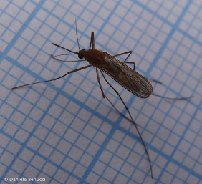
- This order is sub divided into several suborders:

1-Suborder: Nematocera (thread horn)
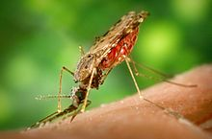
Family: Culicidae
Eg. Culex pipiens ,
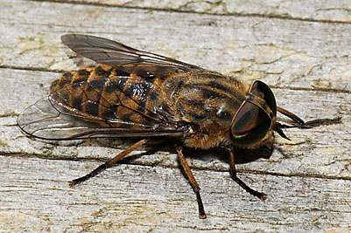
Anopheles albimanus
2- Suborder: Brachycera (short horn)
Family: Tabanidae (Horse flies)
Eg. Tabanus bromius
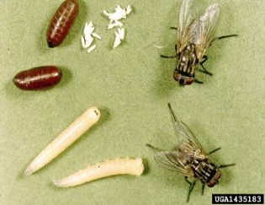
3-Suborder: Cyclorrhapha (circular crack)
Family: Muscidae
Eg. Musca domestica
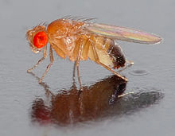
4-Suborder: Brachycera
Family: Drosophilidae
Drosophila melanogaster

