SAROOD TALIB MOHAMMED TAHER
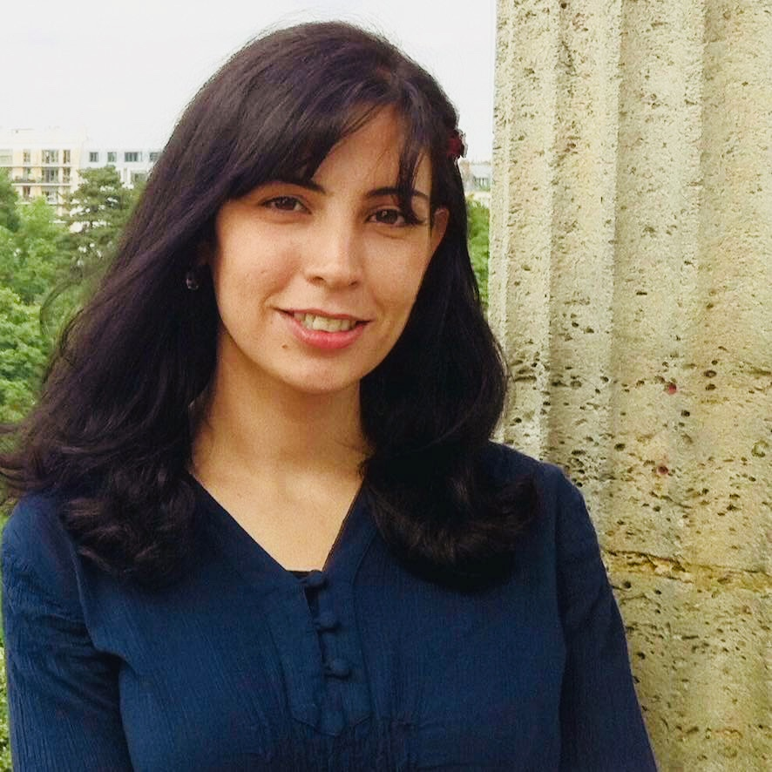
01/01/1984 Kirkuk - Irak
sroodb@yahoo.com
009647518289178

Educations
2017 PhD History of Antiquity (Sumerian Epigraphy)
Paris - France Université Paris 1- La Sorbonne
Thesis title : (The economic activities of women in Mesopotamia in the third millennium BC)
2013 Master 2 History of Antiquity (Sumerian Epigraphy)
Paris - France Université Paris 1- La Sorbonne
Thesis title : (The Technical Vocabulary of Shipping in Umma Documents of the Third Dynasty of UR (2012-2004 BC)
2009 Master Archeology (Sumerian Epigraphy)
Erbil – Irak Salahaddin University
Thesis title : (A study of a collection of unpublished cuneiform texts from the Third Dynasty of Ur period (2012-2004 BC) at Sulaymaniyah Museum)
2006 Bachelor Archeology (Antiquity)
Erbil – Irak Salahaddin University

Professional Experiences
Since July 2010 Erbil-Iraq
Lecturer, University of Salahaddin Department of Archeology - Faculty of Arts.
Since September 2017 Nanterre-France
Member as Associate Researcher, HAROC team (History and Archeology of the Cuneiform Orient) within the CNRS ArScAn laboratory (UMR 7041)

Archaeological Field Works
November 2009 Archaeological excavations in Catvera (Spain), a Pleistocene Superior site. A mission by the Institute of Human Paleoecologia I Evolucion Social (IPHES) - Tarragona Spain.
May 2010 Archaeological excavations at Moli de Salt (Spain), a Paleolithic Superior site. A mission by the Institute of Human Paleoecologia I Evolucion Social (IPHES) -Tarragona-Spain.
October 2010 Archaeological excavations at the Assyrian Vaulted tomb in Arab District, A cooperation mission : The Directorate of Antiquities of Erbil and the German Archaeological Institute. Erbil-Irak.

Publications in English
- Texts Relating to the Archive of Turam-ili in The Sulaimaniah museum, JCS 62, 2010, p/25-27.
- The Technical vocabulary of boat-building in the Texts of Umma from the third Dynasty of Ur, Sumer 62, 2016.

LANGUAGES
Kurdish (Native), Arabic: (Fluent as kurdish), French (V. good), English(V. good), Spanish (Basic /A1).

