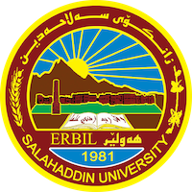
Academic Curriculum Vitae
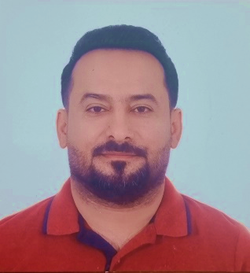
Personal Information:
Full Name: Sarwar Nawzad Jafar
Academic Title: Lecturer
Email: Sarwar.jaaffar@su.edu.krd
Mobile:0750 4654287

Education:
- Ph.D. Degree in Animal physiology (Clinical), Department of Biology College of Education, University of Salahaddin–Erbil. Iraq.
Title of Dissertation
“Hepatoprotective Activity of Some Medicinal Plants Against Thioacetamide Induced Hepatotoxicity in Albino Rats”
Date of attainment July 27, 2020.
- M. Sc. Degree in Animal physiology (Clinical), Department of Biology College of Education, University of Salahaddin – Erbil. Iraq.
Title of thesis “Evaluation of HbA1c and Oxidation Status in Diabetic Patients (Type 2) in Erbil Governorate”
Date of attainment July 11, 2012.
- B. Sc. Degree General Biology, Department of Biology, College of
Education, University of Salahaddin–Erbil. Iraq.
Title of Research Project “Survey of Plant Species in Nazanin Village/Erbil city”
Date of attainment July 25, 2005
Employment:
- April 7, 2007 Demonstrator. At Biology Dept., Education College, Salahaddin University – Erbil, Iraq.
- April 21, 2014 Assist. Lecturer.
- August 3, 2020 Lecturer
Qualifications
- Teaching qualifications

- An excellent user of office programs and internet surfing and emailing
- Latest exam of IELTS I scored 6.5
- Any professional qualification
- You could put any professional courses you have attended

Teaching experience:
- I taught the following courses so far in public and private universities:
  - Animal physiology (practical + theory)
  - Histology (practical and theory)
  - Human anatomy(theory)
  - Comparative anatomy of chordates

Research and publications
- State all researches, publication you made.

Conferences and courses attended
- Give details of any conferences you have attended, and those at which you have presented delivered poster presentations.

Funding and academic awards
- List any bursaries, scholarships, travel grants or other sources of funding that you were awarded for research projects or to attend meetings or conferences.

Professional memberships
- Member of Kurdistan Biologists Syndicate
- Member of

Professional Social Network Accounts:

- ORCID Link : https://orcid.org/0000-0002-9990-1065
- Google Scholar Citation (GSC) Link : https://scholar.google.com/citations?user=LE8EdJ8AAAAJ&hl=en&authuser=3
- ResearchGate Link : https://www.researchgate.net/profile/Sarwar-Jafar

