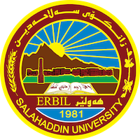
Academic Curriculum Vitae
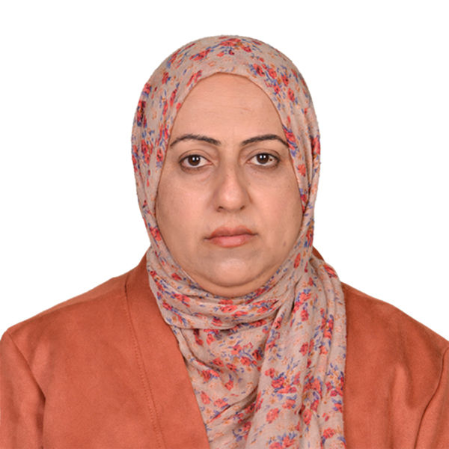
Personal Information:

Full Name: Sarween Omer Taha

Education: Graduated from shoresh secondary School-Erbil
• Obtained B.Sc. in Biology/Microbiology from college Science/ Sulaymani University-Sulaymania in 2001-2002.
• Obtained M.Sc. in Biology/ Microbiology from college Education/ Salahaddin University-Erbil in 2009-2010.
• Obtained Ph.D. in Biology/Molecular Microbiology from college Education/ Salahaddin University-Erbil in 2019-2020.

Employment:
In 2003 employ in salahaddin university .

Qualifications
Im finished in Language center / salahaddin university/ advanced level, and examined IELTS (5 degree).
Teaching experience:
- I stating undergraduate as a lab supervision, microbiology labrotary.

Research and publications
Ihave some of research published :
1.Application of silver oxide nanoparticles as antibiofilm and detection of beta lactamase gene in E.coli isolated from Diabetes mellitus patients.
2.Iron oxide nanoparticles reduced biofilm formation and detection of lmb genes in S.agalactiae isolated from patients of Diabetes mellitus.
3.Reducing biofilm formation through several nanoparticles.
4. synthesic and antimicrobial activity of chlorobenzyloxy pyrazoline on E.coli in mice.

Conferences and courses attended
- Give details of any conferences you have attended, and those at which you have presented delivered poster presentations.

Funding and academic awards
- List any bursaries, scholarships, travel grants or other sources of funding that you were awarded for research projects or to attend meetings or conferences.

Professional memberships
Biology

Professional Social Network Accounts:
Facebook (Dr. sarween omer).

