Subject: Practical Organic Chemistry Mr. Salar Ali Ahmed
Dept.: Food Technology Class: 2nd / Exp. : 3

Extraction by active organic solvents
Aim: To extract a compound that is present in very small amounts in a solvent with the help of another solvent in which that compound is highly soluble.
Principle: This method is based on the relative solubility of the compounds in organic solvents versus aqueous medium. The organic liquid in which the compound is more soluble is generally called as (solvent).
Extraction: is one of mains oldest chemical operation, used for purification compounds between two immiscible solvents such as ether and water by using separation funnel.
The solvent chosen should satisfy the following conditions:
- The solvent should be immiscible with water.
- The compound initially present in aqueous solution should be highly soluble in solvent.
Organic solvents used as separating solvent:
- Ether: used for separating hydrocarbons compounds. The advantage of this solvent is its lower boiling point (34.6°C) (rapid volatile). In the industrial ether is not good solvent for using due to some disadvantage like:
A- Combustible (Flammable).
B- Can not be re-extracted.
C- Rapid oxidizing by air forming peroxide bond.
2- Petroleum ether, benzene, CCl₄, CHCL₃, butanol …. etc.
3- Chlorinated hydrocarbons are non combust solvent, its heaver than water, and high cost.
The distribution ratio (partition coefficient) (D):
Is equal to the molar concentration of solute in the organic phase [S] _{org} divided by molar concentration in the aqueous phase [S] _{aq}. Depending on the system, the distribution ratio can be a function of temperature, concentration of chemical species in the system, and large number of other parameters.
Partition coefficient (D) = [S] _{org} / [S] _{aq}
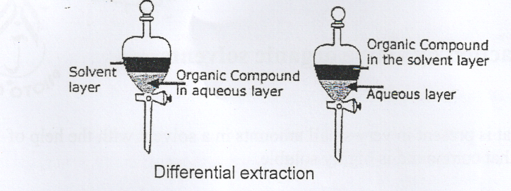
Note: the heavier solvent (higher density) forming the lower layer, and the upper layer formed by the solvent with lower density.

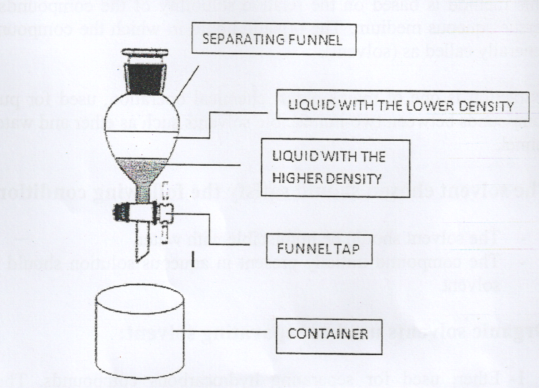

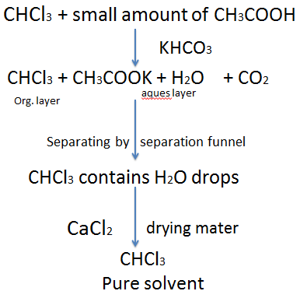
Procedure:
Pourer (20 ml) of non-pure chloroform solution (contain a little amount of Acetic acids impurity substance) in a separating funnel.
And add (10 ml) of potassium bicarbonate solution KHCO₃ (10 % conc.).
The stopper is placed on the separating funnel and the mixture is shaken well and put it at invert state to remove CO₂ gas, repeat this process several time until the CO₂ gas product is stopped completely and put the separating funnel at normal state then allowed to stand for (15 min) the mixture in the flask separate in to two layers. The separating funnel which contain the CHCL₃ solvent (higher density) in the bottom and a quasar layer in the top (lower density) dissolve salt (potassium acetate CH₃CO₂K). Collect the organic layer (CHCL₃) which may be contain small amount of water for remove water add one of these salts (CaCL₂, MgSO₄ and Na₂SO₄) with shaking about (15 min) and filter to obtain pure and dry chloroform.

