Subject: Practical Biochemistry MSc.Sawen M.Ezzalddin
Class: 2nd / Exp. : 1

CARBOHYDRATES
Carbohydrates are defined as carbon compound that contains hydrogen and oxygen in the ration 2:1 as in water the general formula of many of the simpler carbohydrates is (CH₂O)_{n}. carbohydrates are either, hydrolytic products are either polyhydroxy aldehydes or polyhydroxy ketons. Meaning to say that each carbohydrate molecule contains many hydroxyl groups and one or more aldehyde or keton group.
Carbohydrates are made in the plant by reaction of photosynthesis. Many plants contain quantities of carbohydrates as a food reserve and these are useful source of carbohydrate in the diet for human and other animals. After ingestions they are broken down to their constituent mono saccharides which can then be oxidized to carbon dioxide and water with the release of energy or stored in the form of the polysaccharide glycogen in the liver and muscle of animals.
Medical importance of carbohydrates:
Glucose is the most important carbohydrate. It forms the bulk of dietary carbohydrate absorbed in to the blood stream. Glucose is major fuel of the tissues of mammals.
Diseases associated with carbohydrates metabolism include:
1- Diabetes mellitus.
2- Galactosemia.
3- Glycogen storage disease and lactose intolerance.

Carbohydrates can be divided into:
1-Mono-saccharides or simple sugars: (such as glucose and fructose C₆H₁₂O₆). They function as energy source in cells during cellular respiration and are also used to build cell structures and other organic molecules within the cells.
2- Disaccharides: are composed of two mono saccharides joined together. Sucrose (table sugar) is a disaccharide composed of one glucose and one fructose molecule , maltose composed of two glucose molecule and lactose composed of one glucose and one galactose molecule.
3- Poly saccharides: are long chains of mono saccharides bond together(3-12) mono saccharide units. such as starch a polysaccharide composed of long chains of glucose. Starches can be found in potatoes, wheat, rice, corn, lentils.....ets. Animals and humans store excess glucose in the form of glycogen in the liver and muscles. Between meals the liver breaks down glycogen to glucose and releases it in to the blood stream to supply glucose to cells in need. Other important polysacchardies are cellulose and chitin. Cellulose makes up the cell wall of plants.
Monosaccharide characteristics (simple sugars):
1. Can have different number of carbon atoms.
2. Have free aldehyde or keto groups.
3. Can be combined to form disaccharides and polysaccharides.
4. Some can have a linear or ring structure.

Three Carbon Sugars
ALDOSES | KETOSES
Triose Sugars ( C₃H₆O₃ )
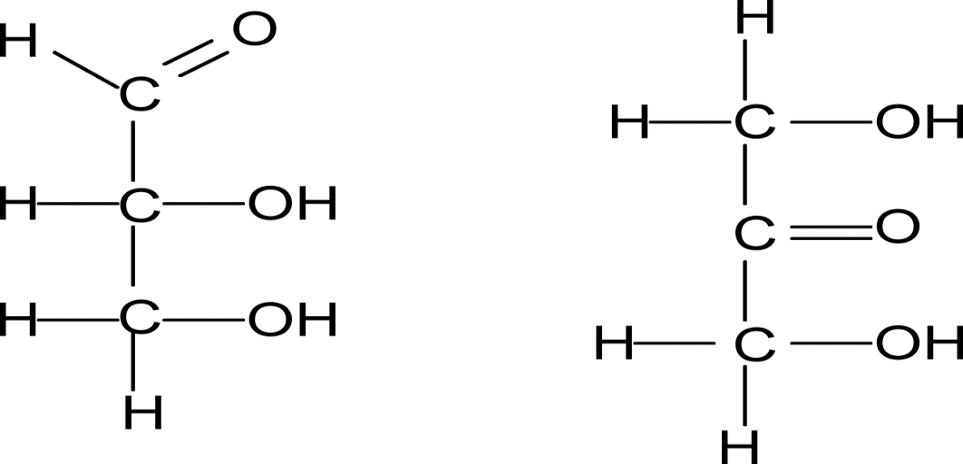
Glyceraldehyde | Dihydroxyacetone

Five Carbone Sugars
Pentose Sugars ( C₅H₁₀O₅ )
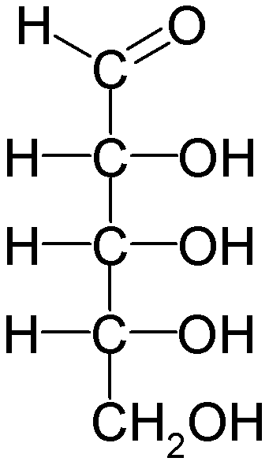 | 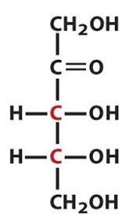
Ribose | Ribulose

Six Carbone Sugars

Linear and ring structure of glucose :
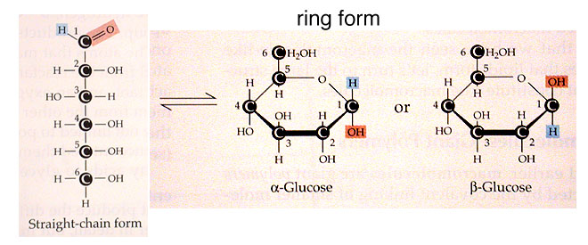

Example of Disaccharides
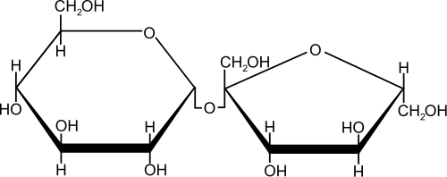 | 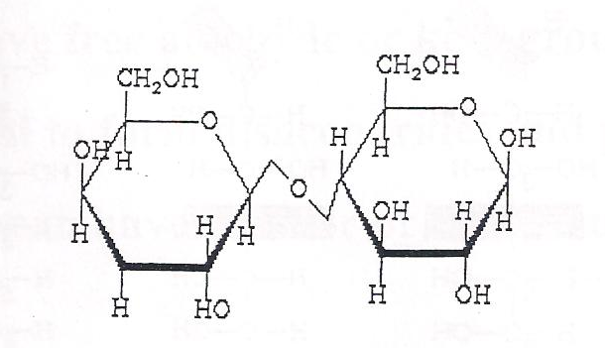 | 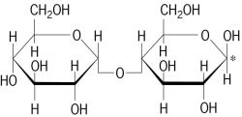
Sucrose | Lactose | Maltose

Some oligosaccharides are of importance in foods such as :
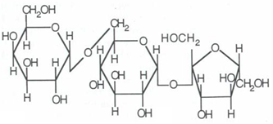
Raffinose (Galactose + Glucose + Fructose )

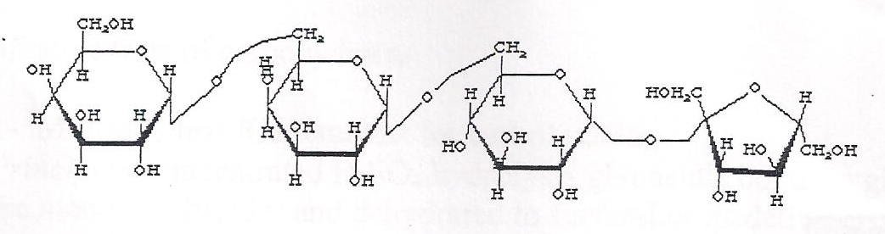
Stachyose (2Galactose + Glucose + Fractose)

Exp. No1
Qualitative tests of carbohydrates
1 - Molischs test / Principles General test for all carbohydrates. In this test, carbohydrates when reacted with conc. H2SO4 get dehydrated to form furfural and its derivatives.
When monosaccharide are treated with conc H2SO4 or conc HCl, -OH group of sugar are removed in the form of water and furfural is formed from pentose sugar and hydroxymethyl furfural is formed from hexose sugar. These products reacts with sulphonated α- naphthol to give a purple (violet red) colored complex.
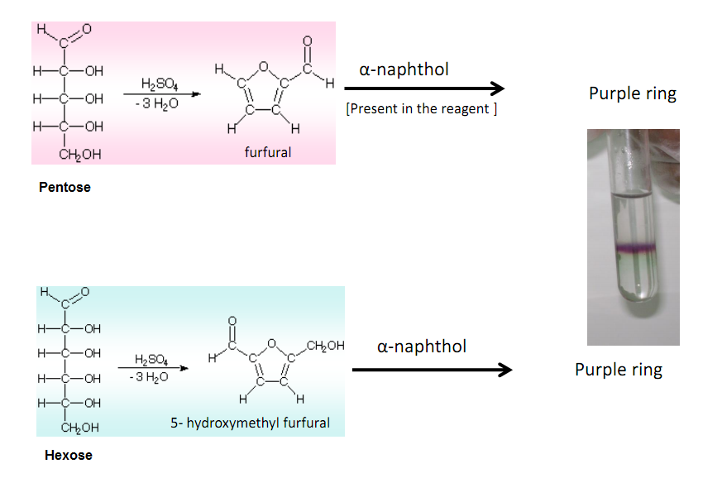

Reagents for Molisch’s test:
- test solution: 5 % Glucose, 5 % Sucrose, 5 % Starch
- Molisch’s reagent (5 % α naphthol in ethanol)
- H2SO4
- Dry test tubes
- pipettes

Procedure of Molisch’s test:
- Take 2ml of sample in dry test tube.
- Take 2ml of distilled water in another tube as control.
- Add 2-3 drops of Molisch’s reagent to the solution.
- Gently pipette 1ml conc. H2SO4 along the side of the tube so that two distinct layers are formed.
- Observe color change at the junction of two layers.
- Appearance of purple color indicates the presence of carbohydrates.

Result Interpretation of Molisch’s test:

Positive Molisch’s test: purple color complex

Negative Molisch’s test: no purple color

Exp. NO.2
2- Anthrone test / General test for carbohydrate. Principle" concentrated H₂S0₄ hydrolysis glycosidic bond to give the monosaccharides and hydrated to furfural or its derivatives (hydroxyl methyl furfural). These products then combine with anthrone to give blue -green complex.
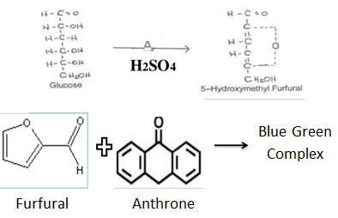

Reagents:
- test solution: 5 % Glucose, 5 % Sucrose, 5 % Starch
- Anthrone reagent: 0.2 % anthrone in conc. H2SO4

Procedures
- Take 1ml of sample in test tube.
- Take 1ml of distilled water in another tube as control.
- Add 2ml of anthrone reagent to all the tubes.
- Mix thoroughly all the content of the tube.
- Observe for color change in bluish green.

