Subject: Practical Biochemistry MSc.Sawen M.Ezzalddin
Class: 2nd / Exp.: 2

CARBOHYDRATES
A pentose is a monosaccharide with five carbon atoms. Pentoses are organized into two groups: Aldopentoses have an aldehyde functional group at position 1. Ketopentoses have a ketone functional group at position 2. In the cell, pentoses have a higher metabolic stability than hexoses.

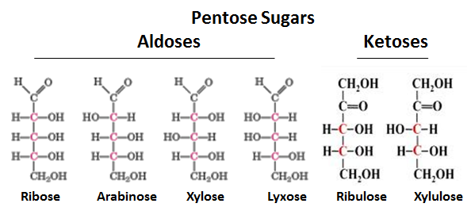

Exp.No3
3- Bials test for (pentose)
Principle when pentose are heated with conc. HCl furfural is formed which condenses with orcinol in the presence of Fe⁺³ ions to give a green color.
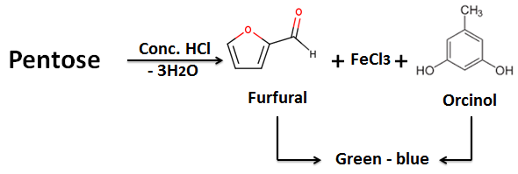

Procedure
1- Place 2ml bials solution in test tube
2- Add 1ml of test solution (pentose solution).
3- Heat gently, until boiling commences.
4- Immediately on cooling, the solution becomes green in the presence of pentose.
Exp. N0.4
4- Aniline test for (pentose)
Principle" when pentoses are heated with cone. HCL, furfural is formed which condenses with Aniline or Aniline acetate to give a red color.
Procedure
1- Place 1ml of pentose solution (test solution +1ml of glacial acetic acid +3 drop of Aniline .
2- Place 1ml of hexose solution (test solution + 1ml of glacial acetic acid + 3 drop of aniline
3- Heat gently until boiling (3min) the solution becomes red color.

Exp. N0.5
5-Resorcinol (selivanoffs test, for ketohexoses)
Ketohexoses fructose is converted to hydroxyl methyl furfural in hot hydrochloric acid .which combines with resorcinol to produce a red color compound. Sucrose may give a positive ketohexose test because of partial hydrolysis to glucose and fructose; sugars like glucose give essentially no color even after ten minutes.

Procedure:
1. Place 1ml of selivanoffs reagent in test tube.
2. Add 0.1 ml of 1% carbohydrate solution in water .
3. Heat the solution in a boiling water bath for (5min).
4. A deep red colored precipitate within (5min) indicates ketohexose.

Colors | Reagent | Used for | Tests
redish violet | sulphonated alpha-naphthol | General test for carbohydrate | Molischs | 1
blue -green | anthrone | General test for carbohydrate | Anthrone | 2
Green | orcinol | Pentose sugar | Bials | 3
Red | Aniline or (Aniline acetate) | Pentose sugar | Aniline | 4

