Subject: Practical Biochemistry MSc.Sawen M.Ezzalddin
Class: 2nd / Exp.: 4

CARBOHYDRATES
Mucic acid test
A specific biochemical test used to distinguish galactose from other aldose sugar were oxidized, when heated with conc. Nitric acid to dibasic sugar acids known as aldaric acid or saccharic acid; this is due to the oxidation of carbonyl and hydroxyl groups. These acids are characterized by their solubility in water, except the acid produced by galactose sugar which is called Mucic acid.
Mucic acid which is characterized by its insolubility in water, lactose my give positive mucic acid because of partial hydrolysis to glucose and galactose.
Galactose + Nitric acid Galactaric acid
Procedure
- Place about 50mg of galactose in clean dry test tube
- Add 1ml of distill water
- Add 1ml of conc. Nitric acid
- Heat in boiling water for 1.5 hour, stand overnight crystalline ppt of mucic acid, which may be identified by microscopically examination of the crystals, repeat this experiment using solution of glucose.
Hydrolysis and inversion of Sucrose
Principle
Sucrose is dextrorotatory and upon hydrolysis the molecule of sucrose takes one molecules of water and breaks down into fructose which is levorotatory than the glucose which is dextrorotatory the reaction called inversion and the mixture of fructose and glucose is called invert sugar as follows:
C₁₂H₂₂O₁₁ + H₂O C₆H₁₂O₆ + C₆H₁₂O₆
Dextro glucose dextro fructose strong levo
Procedure
1-Place 50ml of sucrose 5% in beaker.
2-Add 5 drops of conc. H₂SO₄ and boil for 1min.
3-Cool the solution and neutralize with saturated sodium hydroxide.
4-Filter the ppt of (sodium hydrosulfate) and with resulting fluid repeat the bendicts, barfoed and selivanoffes test.
Picric acid test
Yellow picric acid reduced in alkaline medium with monosaccharids to red picramic acid. This is another test for reducing sugar it is clinical test for determination of glucose in blood.
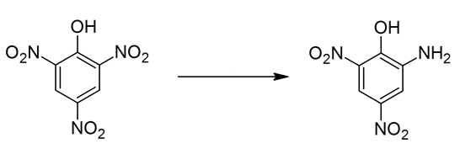
Picric acid picramic acid
Procedure
- Place 5ml of picric solution in test tube.
- Add 3-5 drops of 5% NaOH.
- Add 2ml of carbohydrate solution.
- Heat in boiling water bath for 5min this test for all organic compound that capable to reduced picric acid to picramic not just for reducing sugar.
Phenylhydrazine test
(microscopical test for carbohydrate, osazones formation)
Phenylhydrazine is reacting with monosaccharide's and carbohydrates which have free sugar group. Yellow crystalline compounds called osazone are formed.
Phenylhydrazine is the chemical compound with the formula C₆H₅NHNH₂
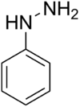
Glucose, Fructose and Mannose gives the same crystal form because the hydrogen and hydroxyl group distribution around carbon No. 3,4,5,6 are same but differ from carbon 1&2.
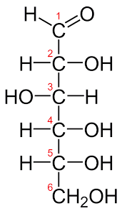 | 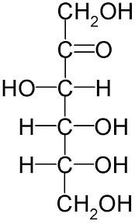 | 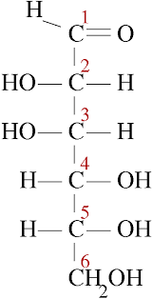

D- Glucose D-Fructose D-Mannose

Procedure:
1- Place (1gm) of phenylhydrazine hydrochloride mixture with sodium acetate in test tube.
2- Add (1ml) of the sugar (test solution).
3- Shake well, and heat on a boiling water bath for 30 – 45 min.
4- Allow the tubes to cool slowly (not under tap) and examine the crystals microscopically, draw the shapes of the crystalls.

