Subject: Practical Biochemistry Mr. Salar & Mrs.Sawen
Class: 2nd / Exp.: 5

CARBOHYDRATES
Polysaccharides
Two types:
- Homo polysaccharides ( 1 types of monomer) e.g., glycogen, starch, cellulose and chitin.
- Hetero polysaccharides (different types of monomer) e.g., peptidoglycan, glycosaminoglycans.

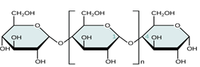 | 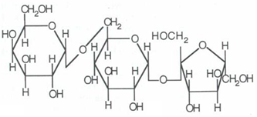
Amylose | Raffinose

Functions:
- Glucose storage (glycogen in animals and bacteria, starch in plant).
- Structure (cellulose, chitin, peptidoglycans, glycosaminoglycans).
- Information (cell surface oligo-and poly saccharids on protein/ glycoprotein and on lipid/ glycolipid).
- Osmotic regulation.
Starch and Glycogen
Function: glucose storage
Starch: 2 forms:
- Amylose: linear polymer of α(1 4) linked glucose residues.
- Amlyopectin: branched polymer of α(1 4) linked glucose residues with α(1 6) linked branches.
Amylose
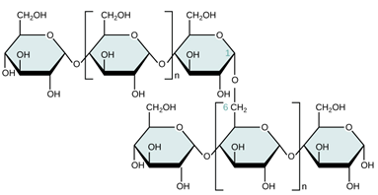
Amylopectin
Glycogen:
- Branched polymer of α(1 4) linked glucose residues with α(1 6) linked branches.
- Like amylopectin but even more highly branched and more compact.
- Branched increase H₂O-solubility.
Branched structure: many non reducing ends, but only one reducing end (only 1 free anomeric C, not tied up in glycosidic bond)
Cellulose and Chitin
Function : Structural, rigidity important.
Cellulose: homopolymer, β (1 4) linked glucose residues.
- Cell walls in plants.
Chitin : homopolymer, β (1 4) linked N-acetylglucosamine residues.
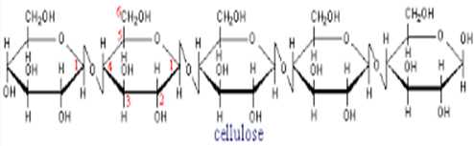
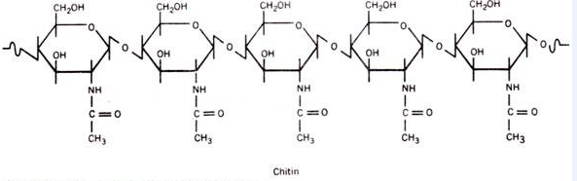
Exp. No. (11) Iodine test:
(Used to distinguish between monosaccharide & polysaccharides)
Iodine forms characteristic colored complexes polysaccharides. Starch gives blue, glycogen brownish red and dextrin purple or red color with Iodine solution. Whereas simple sugars' do not change the color of Iodine solution. These colors disappear on heating and re-appear on cooling. This test is sensitive for temperature and the reaction medium, need to complete this reaction in room temp. Also it needs a neutral solution because these colors disappear on alkaline solution the Iodine converted to Iodied salt.
I₂ + 6NaOH 5NaI + NaIO₃ + 3H₂O
When we add acid solution the Iodine color reappear
NaIO₃ + HCL HIO₃ + NaCL
NaI + HCL HI + NaCL
HIO₃ + 5HI 3I₂ + 3H₂O
At the last when we add sodium thio sulphate the iodine color disappear but not reappears with addition acid solution.
I₂ + 2Na₂S₂O₃ NaI + Na₂S₄O₆
Procedure
- Place (2-3)ml of starch solution in a test tube
- Add (1 drop) of iodine solution the production a blue color
- Heat the tube and note the dis appearance of the color it reappears with add acid solution.
- Repeat the same procedure with (2-3)ml of dextrin solution & glycogen solution

Starch hydrolysis
Hydrolysis by acid:
starch has branched structure with linear chain of glucose join glycosidic bounds.
The hydrolysis of these glycosidic bonds is catalyzed by either acid or enzyme in there is random cleavage of bonds with intermediate formation of all various possible oligosaccharides and with the final conversion of these oligosaccharides to glucose. The progress of hydrolysis can be observed by measuring the increasing in reducing sugar as assayed by fehling & bendict test.
HCl
Starch amylodxtrine erthrodextrin acrodextrin maltose glucose
Producer
- Place (3ml) of starch in a test tube.
- Add (1ml) of conc. HCl.
- Boil for (5min).
- Cool under tap water, neutrals with sodium hydroxide and test with fehling reagent or benidict.
- Cool anther portion and test with iodine if hydrolysis complete, no blue color would be produce.

