Detection And Isolation Of Bacteria Causing Acquired Infections In The Hospitals

Research project

Submitted to department of Biology in partial Fulfillment of the
Requirements for the degree of BSc
In Biology

By:
Malak Muhammed Ahmed

Supervised by:

Prof. Dr. Sawsan Mohammed Abdulla
February – 2023
Dedication
This study is wholeheartedly dedicated to our beloved parents, who have been our source of inspiration and gave us strength when we thought of giving up, who continually provide their moral, spiritual, emotional, and financial support. To our Brothers, Sisters, relatives, mentor, friends, classmates and department who shared their words of advice and encouragement to finish this study.

Acknowledgment

First thanks to Allah the most merciful for blessing us with strength, willingness and patience to complete this study. Then we would like to express our sincere gratitude to all who provide help in conducting this research project. Hence, we are profoundly grateful for their support. We highly appreciate the supports of our supervisor Dr..Sawsan Mohammed Abdullah for his valued advice, guiding, encouragement, and genuine efforts in supervising this study. Finally, I would like to express my special thanks to all who helped me to finish this research.

List of contents
Abstract
Chapter one
1. Introduction…………………………………………….1
Chapter two
2. Literature review ……………………………………….2
2.1Bacteria………………………………………………...2
2.2Etiology…………………………………………………3
2.3Causative Agents …………………………………… 4
2.4Source of Infection …………………………………….5
2.5Route of Transmission of Infection ……………………6
2.6Impact of nosocomial infections……………………….9
2.7Factors influencing the development of nosocomial infections…………………………9
2.7.1The microbial agent……………………………………9
2.7.2Patient susceptibility…………………………………..10
2.7.3Environmental factors………………………………….11
2.7.4Bacterial resistance……………………………………..11
2.8Infection control programmes…………………………….12
2.8.1Role of the microbiologist ………………………………12
2.8.2Role of the central sterilization service………………….12
2.8.3Role of the infection control team (hospital hygiene service) 13
2.8.4Role of the hospital pharmacist………………………………14
Chapter three
3. Conclusion ………………………………………………………...15
References ………………………………………………………….16

List of tables
Table 1
Table 2

Abstract
A hospital-acquired infection (HAI) is an infection that is acquired in a hospital or other health care facility. It is spread through contact surfaces such as bed rails, call buttons, touch plates, chairs, door handles, light switches, grab rails, intravenous poles, dispensers, dressing trolleys, and counter and table tops. HAI infections include central line-associated bloodstream infections. These are the most common nosocomial pathogens. Such as pathogenic bacteria,gram negative,gram positive.
Source of infection in hospitals is determined by the sources and environmental reservoirs of the more important pathogens responsible for septic diseases in hospitals, such as Staphylococcus aureus, group B streptococci, Gas gangrene, and tetanus. The microbiologist is responsible for handling patient and staff specimens, the central sterilization service is responsible for cleaning, decontaminating, test, prepare for use, sterilize, and store sterile hospital equipment, the infection control team is responsible for oversight and coordination of all infection control activities, the hospital pharmacist is responsible for obtaining, storing and distributing pharmaceutic preparations, dispensing anti-infectious drugs, obtaining and storing vaccines or sera, maintaining records of antibiotics, providing the Antimicrobial Use Committee and Infection Control Committee with summary and trends of antimicrobial use, and providing expert advice, analysis, and leadership in outbreak investigation and control.
Key word:Hospital ,Infection, Hospital acquired infection ,infection control ,bacteria.

CHAPTER ONE
1. Introduction
A hospital-acquired infection, also known as a nosocomial infection (from the Greek nosokomeion, meaning "hospital"), is an infection that is acquired in a hospital or other health care facility. To emphasize both hospital and nonhospital settings, it is sometimes instead called a healthcare–associated infection. Such an infection can be acquired in hospital, nursing home, rehabilitation facility, outpatient clinic, diagnostic laboratory or other clinical settings. Infection is spread to the susceptible patient in the clinical setting by various means. (Rosenthal VD et al., 2012).
As many hospital-acquired infections caused by bacteria such as methicillin-resistant Staphylococcus aureus, methicillin-susceptible Staphylococcus aureus, and Clostridium difficile are caused by a breach of these protocols, it is common that affected patients make medical negligence claims against the hospital in question. (Otter JA et al., 2009)
Touch surfaces commonly found in hospital rooms, such as bed rails, call
buttons, touch plates, chairs, door handles, light switches, grab rails,
intravenous poles, dispensers (alcohol gel, paper towel, soap), dressing trolleys,
and counter and table tops are known to be contaminated with Staphylococcus,
methicillin-resistant Staphylococcus aureus (one of the most virulent strains of
antibiotic-resistant bacteria) and vancomycin-resistant Enterococcus . (Monegro et al., 2020) For the last few decades, hospitals have taken the hospital-acquired infections seriously. The impact of hospital-acquired infections is seen not just at an individual patient level, but also at the community level as they have been linked to multidrug-resistant infections. Identifying patients with risk factors for hospital-acquired infections and multidrug-resistant infections is very important in the prevention and minimization of these infections. HAI infections include central line-associated bloodstream infections (CLABSI), catheter-associated urinary tract infections (CAUTI), surgical site infections (SSI), Hospital-acquired Pneumonia (HAP), Ventilator-associated Pneumonia (VAP), and Clostridium difficile infections (CDI), (Boev C et al., 2017). Hospitals have sanitation protocols regarding uniforms, equipment sterilization, washing, and other preventive measures. Thorough hand washing and/or use of alcohol rubs by all medical personnel before and after each patient contact is one of the most effective ways to combat nosocomial infections. (McBryde et al., 2004).
CHAPTER TWO
2. Literature review
2.1Bacteria
These are the most common nosocomial pathogens. A distinction may be made between:
● Commensal bacteria found in normal flora of healthy humans . These have a significant protective role by preventing colonization by pathogenic microorganisms. Some commensal bacteria may cause infection if the natural host is compromised. For example, cutaneous coagulase- negative staphylococci cause intravascular line infection and intestinal Escherichia coli are the most common cause of urinary infection.
● Pathogenic bacteria have greater virulence, and cause infections (sporadic or epidemic) regardless of host status. For example:
— Anaerobic Gram-positive rods (e.g. Clostridium) cause gangrene.
— Gram-positive bacteria: Staphylococcus aureus (cutaneous bacteria that colonize the skin and nose of both hospital staff and patients) cause a wide variety of lung, bone, heart and blood- stream infections and are frequently resistant to antibiotics; beta-haemolytic streptococci are also important.
— Gram-negative bacteria: Enterobacteriacae (e.g. Escherichia coli, Proteus, Klebsiella, Enterobacter, Serratia marcescens), may colonize sites when the host defences are compromised (catheter in- sertion, bladder catheter, cannula insertion) and cause serious infections (surgical site, lung, bacteraemia, peritoneum infection). They may also be highly resistant.
— Gram-negative organisms such as Pseudomonas spp. are often isolated in water and damp areas. They may colonize the digestive tract of hospitalized patients.
— Selected other bacteria are a unique risk in hospitals. For instance, Legionella species may cause pneumonia (sporadic or endemic) through inhalation of aerosols containing con- taminated water (air conditioning, showers, and therapeutic aerosols (Mayon-White R et al,1988)
2.2Etiology
The risk for hospital-acquired infections is dependent on the infection control practices at the facility, the patient's immune status, and the prevalence of the various pathogens within the community. The risk factors for HAI include immunosuppression, older age, length of stay in the hospital, multiple underlying comorbidities, frequent visits to healthcare facilities, mechanical ventilator support, recent invasive procedures, indwelling devices, and stay in an intensive care unit (ICU). Receipt of intravenous antibiotics within the last 90 days is one of the major risk factors for developing antimicrobial resistance to multiple drugs. While hospitalizations play a major role in the management of acute illnesses, and they also enhance the risk of susceptible patients for multiple nosocomial and often antimicrobial-resistant pathogens . These pathogens can be acquired from other patients, hospital staff, or the hospital facility. The risk is higher among patients in ICU. In a point prevalence study that included 231,459 patients across 947 hospitals concluded that about 19.5% of patients in ICU had at least one HAI (Alberto ,2022)
Clostridium difficile is the organism that causes colitis (CDI). Common organisms for CLABSI are candida spp (adult ICU), Enterobacteriaceae (adult wards, pediatric ICU and wards, and oncology wards), and staph aureus. Common pathogens that are known to cause CAUTI are Enterococcus, staphylococcus aureus, Pseudomonas, proteus, Klebsiella, and Candida. (Novosad,2020)) According to the National Healthcare Safety Network, the common causative organisms for SSI include (in descending order) staph aureus, coagulase-negative staphylococcus, Enterococcus, E Coli, Pseudomonas aeruginosa, Enterobacter, Klebsiella pneumoniae. (Novosad et all,2020) The most common pathogens for HAP and VAP are staph aureus and pseudomonas aeruginosa, while E Coli and Klebsiella pneumoniae can be seen in higher proportions among pediatric populations. (Babcock,2003)

2.3Causative Agents
The more important of the microbes responsible for hospital infection are listed in Table 1, where they are classified broadly into the following categoriesREF
P: "conventional" pathogens that cause disease in healthy persons in the absence of specific immunity to them.
C: "conditional" pathogens that cause disease, other than trivial local infections, only in persons with reduced resistance to infection (including newborn infants) or when implanted directly into tissue or a normally sterile body area.
0: "opportunist" pathogens that cause generalized disease, but only in patients with profoundly diminished resistance to infection.
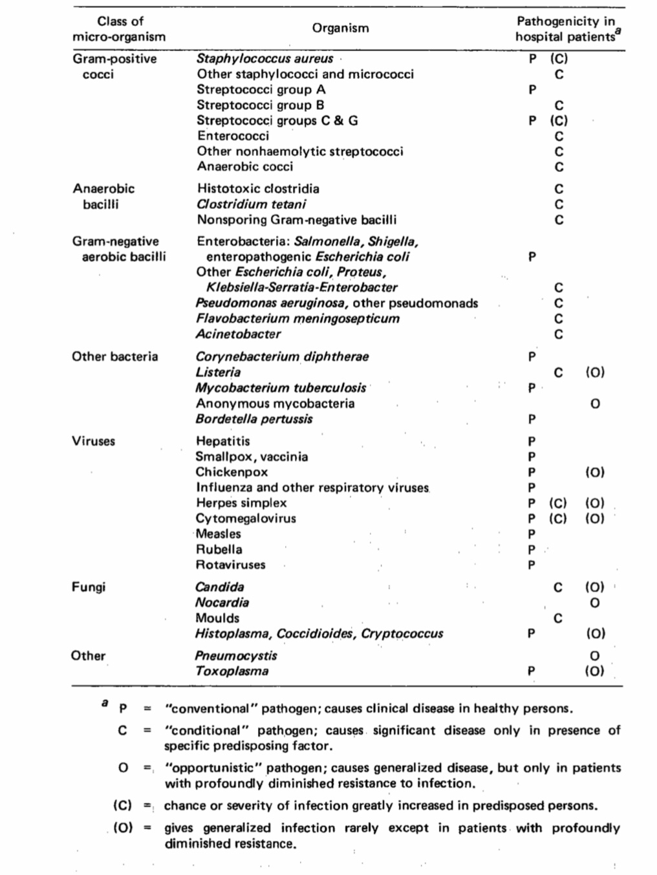
The symbol (C) indicates that a pathogen that may cause disease in normal persons does so much more often and in more severe form in certain classes of patient .grading accorded to individual pathogens could be challenged. Nevertheless, this classification gives some indication of the circumstances under which particular micro- organisms may be expected to cause infection in hospitals..REF
2.4 Source of Infection
The sources and environmental reservoirs of the more important pathogens responsible for septic diseases in hospitals (For the intestinal pathogens, sources and reservoirs in hospitals are similar to those in other institutions; knowledge of these is assumed.) The entries in the table indicate merely that an organism is commonly found in a stated place, or is known to have been acquired from a particular source; they carry few implications about the relative importance of individual sources and reservoirs, which may vary widely according to the situation in the hospital. Nevertheless, some generalizations are possible. Thus, newborn infants in most hospitals tend to acquire Staphylococcus aureus less often from their mothers than from other persons, and particularly from other babies. They are, however, known often to acquire group B streptococci from their mothers; the frequency of acquisition of group B streptococci from other hospital sources is uncertain. Gas gangrene is most often the result of self-infection from the bowel, and infection from other persons is uncommon; tetanus is acquired almost exclusively from external environmental sources. REF
The Gram- negative bacilli shown as "present in normal flora" include Escherichia coli, which is almost invariably present in large numbers, and other enterobacteria and Pseudomonas aeruginosa, which are found in a smaller proportion of persons and usually in lesser numbers. Among hospital patients, however, and particularly in those receiving certain antibiotics, carrier rates of the latter organisms may rise considerably, and some of the Gram-negative bacilli listed as "not present in normal flora" may also colonize the bowel in some hospital patients. In general, however, we may conclude that most infections caused by enterococci and other nonhaemolytic streptococci, anaerobic cocci, histo- toxic clostridia, Bacteroides, and Acinetobacter are self-infections; that S. aureus, group B streptococcal, enterobacterial, and P. aeruginosa infections may be acquired either from other persons or by self-infection, and that most group A streptococcal infections are from other persons. Infections with Oostridium tetani, Pseudomonas cepacia, Flavobacterium meningosepticum are nearly always, and infections with P. aeruginosa and members of the Klebsiella-Se"atia-Enterobacter group are often, acquired from "independent" environmental sources. Patients and hospital personnel may acquire hepatitis through contact with blood positive for hepatitis B antigen from patients and blood donors.REF
2.5 Route of Transmission of Infection
Table gives broad generalizations about the routes of spread of repre- sentative pathogenic agents. In aerial spread, the infective agent is liberated from its source and reaches the recipient on an airborne particle. Such particles are expelled directly from the mouth during talking, coughing, and sneezing, and even in the absence of these actions. The length of time a particle remains suspended in the air and the distance it is likely to travel are related inversely to the size of the particle. The range of infectivity is thus influenced by the frequency with which very small particles contain the infectious agent and the ability of the agent to maintain its infectivity when dessicated in the air. REF
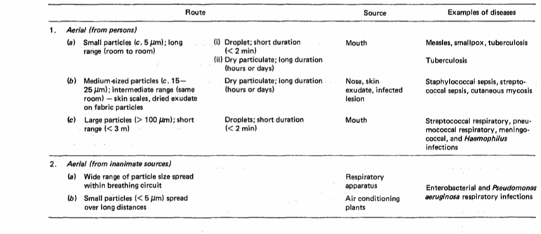
Some micro-organisms, e.g., tubercle bacilli, may cause infection by the aerial route in rooms at a considerable distance from that occupied by the source patient, and complete aerial isolation of the infectious person is neces- sary to prevent this. On the other hand, in diseases such as streptococcal ton- sillitis infectivity is progressively reducedat distances over 5m, presumably because large particles play an important part in the transmission of infection; in these diseases, prevention of overcrowding might be expected to reduce infection rates. It should be noted, however, that distance between patients has not been observed to influence the infection rate in septic infections caused by streptococci.Infectious particles are rarely expelled into the air from the nose. Staphy- lococci from the nose reach the air indirectly from the contaminated skin by the desquamation of epidermal scales. These are of such a size that they remain suspended in the air for a long enough time to reach distant parts of a large hospital ward. Particles of dried pus and exudate of a similar size may be simi- larly dispersed. Airborne particles that have sedimented on to surfaces may subsequently be redispersed into the air REF. Many pathogens remain viable in dust for long periods of time (days and weeks) but there is evidence that some of them undergo a considerable loss of infectivity. In practice, aerial transmission of staphylococcal and streptococcal infections can usually be traced to a source that is still present in the hospital or has left it very recently. ·Infection with Gram-negative bacilli appears very seldom to be spread by the aerial route in hospital rooms although it may occur under conditions of high humidity when the particles do not undergo desiccation, notably within respiratory machines.REF
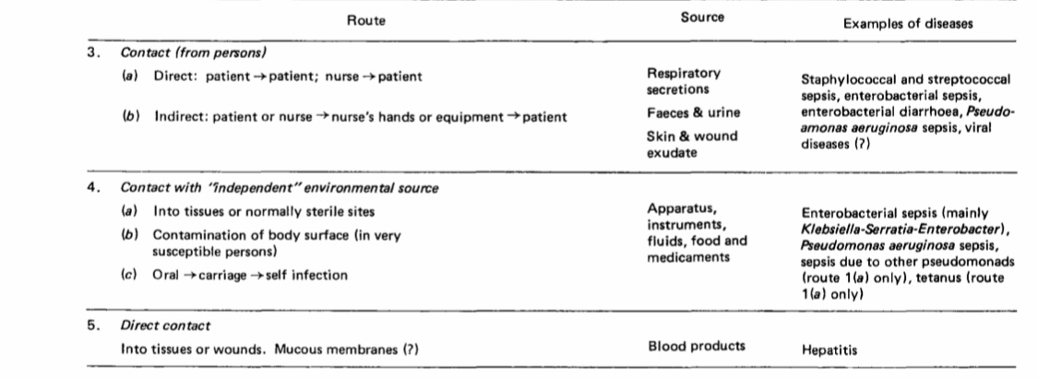
2.6 Impact of nosocomial infections
Hospital-acquired infections add to functional disability and emotional stress of the patient and may, in some cases, lead to disabling conditions that re duce the quality of life. Nosocomial infections are also one of the leading causes of death ( Ponce-de-Leon ,1991)The economic costs are considerable .The increased length of stay for infected patients is the greatest contributor to cost (Kirkland KB et al. ,1999) One study ( Coella R et al. ,1993)showed that the overall increase in the duration of hospitalization for patients with surgical wound infections was 8.2 days, ranging from 3 days for gynaecology to 9.9 for general surgery and 19.8 for orthopaedic surgery. Prolonged stay not only increases direct costs to patients or payers but also indirect costs due to lost work. The increased use of drugs, the need for isolation, and the use of additional laboratory and other diagnostic studies also contribute to costs. Hospital-acquired infections add to the imbalance between resource allocation for primary and sec- ondary health care by diverting scarce funds to the management of potentially preventable conditions.ReF
The advancing age of patients admitted to health care settings, the greater prevalence of chronic dis- eases among admitted patients, and the increased use of diagnostic and therapeutic procedures which,affect the host defences will provide continuing pressure on nosocomial infections in the future. Organisms causing nosocomial infections can be transmitted to the community through discharged patients, staff, and visitors. If organisms are multire- sistant, they may cause significant disease in the community.REF
2.7Factors influencing the development of nosocomial infections
2.7.1The microbial agent
The patient is exposed to a variety of microorganisms during hospitalization. Contact between the patient and a microorganism does not by itself necessarily result in the development of clinical disease other factors influence the nature and frequency of nosocomial infections. The likelihood of exposure leading to infection depends partly on the characteristics of the microorganisms, including resistance to antimicrobial agents, intrinsic virulence, and amount (inoculum) of infective material. Many different bacteria, viruses, fungi and parasites may cause nosocomial infections. Infections may be caused by a microorganism acquired from another person in the hospital (cross-infection) or may be caused by the patient’s own flora (endogenous infection). Some organisms may be acquired from an inanimate object or substances recently contaminated from another human source (environmental infection).REF
Before the introduction of basic hygienic practices and antibiotics into medical practice, most hospital infections were due to pathogens of external origin (foodborne and airborne diseases, gas gangrene, tetanus, etc.) or were caused by microorganisms not present in the normal flora of the patients (e.g. diphtheria, tuberculosis). Progress in the antibiotic treat- ment of bacterial infections has considerably reduced mortality from many infectious diseases. Most in- fections acquired in hospital today are caused by microorganisms which are common in the general population, in whom they cause no or milder dis- ease than among hospital patients (Staphylococcus aureus, coagulase-negative staphylococci, enterococci, Enterobacteriaceae).REF
2.7.2Patient susceptibility
Important patient factors influencing acquisition of infection include age, immune status, underlying disease, and diagnostic and therapeutic interventions. The extremes of life — infancy and old age are as- sociated with a decreased resistance to infection. Patients with chronic disease such as malignant tu- mours, leukaemia, diabetes mellitus, renal failure, or the acquired immunodeficiency syndrome (AIDS) have an increased susceptibility to infections with opportunistic pathogens. The latter are infections with organism(s) that are normally innocuous, e.g. part of the normal bacterial flora in the human, but may become pathogenic when the body’s immuno- logical defences are compromised. REFInjuries to skin or mucous membranes bypass natural defence mechanisms. Malnutrition is also a risk. Many modern diagnostic and therapeu- tic procedures, such as biopsies, endoscopic exami- nations, catheterization, intubation/ventilation and suction and surgical procedures increase the risk of infection. Contaminated objects or substances may be introduced directly into tissues or normally ster- ile sites such as the urinary tract and the lower respiratory tract.REF
2.7.3Environmental factors
Health care settings are an environment where both infected persons and persons at increased risk of infection congregate. Patients with infections or carriers of pathogenic microorganisms admitted to hospital are potential sources of infection for patients and staff. Patients who become infected in the hospital are a further source of infection. Crowded conditions within the hospital, frequent transfers of patients from one unit to another, and concentration of patients highly susceptible to infection in one area (e.g. newborn infants, burn patients, intensive care ) all contribute to the development of nosocomial infections. Microbial flora may contaminate objects, devices, and materials which subsequently contact susceptible body sites of patients. In addition, new infections associated with bacteria such as waterborne bacteria (atypical mycobacteria) and/or viruses and parasites continue to be identified.REF
2.7.4Bacterial resistance
Many patients receive antimicrobial drugs. Through selection and exchange of genetic resistance elements, antibiotics promote the emergence of multidrug- resistant strains of bacteria; microorganisms in the normal human flora sensitive to the given drug are suppressed, while resistant strains persist and may become endemic in the hospital. The widespread use of antimicrobials for therapy or prophylaxis (including topical) is the major determinant of resistance. Antimicrobial agents are, in some cases, becoming less effective because of resistance. As an antimicro- bial agent becomes widely used, bacteria resistant to this drug eventually emerge and may spread in the health care setting. Many strains of pneumococci, staphylococci, enterococci, and tuberculosis are currently resistant to most or all antimicrobials which were once effective. Multiresistant Klebsiella and Pseudomonas aeruginosa are prevalent in many hospitals. This problem is particularly critical in developing countries where more expensive second-line anti- biotics may not be available or affordable (Georgia,1990)
2.8 Infection control programmes
Prevention of nosocomial infections is the responsibility of all individuals and services providing health care. Everyone must work cooperatively to reduce the risk of infection for patients and staff. This includes personnel providing direct patient care, management, physical plant, provision of materials and products, and training of health workers. Infection control programmes are effective provided they are comprehensive and include surveillance and prevention activities, as well as staff training. There must also be effective support at the national and regional levels. (Haley RW et al.،1985)
2.8.1Role of the microbiologist
The microbiologist is responsible for:REF
● handling patient and staff specimens to maximize the likelihood of a microbiological diagnosis.
● developing guidelines for appropriate collection, transport, and handling of specimens
● Ensuring laboratory practices meet appropriate standards
● Ensuring safe laboratory practice to prevent infections in staff
● performing antimicrobial susceptibility testing following internationally recognized methods, and providing summary reports of prevalence of resistance
● monitoring sterilization, disinfection and the environment where necessary
● Timely communication of results to the Infection Control Committee or the hygiene officer
● Epidemiological typing of hospital microorganisms where necessary .

2.8.2Role of the central sterilization service
A central sterilization department serves all hospital areas, including the operating suite. An appropriately qualified individual must be responsible for management of the programme. Responsibility for day-to-day management may be delegated to a nurse or other individual with appropriate qualifications, experience, and knowledge of medical devices. The responsibilities of the central sterilization service are to clean, decontaminate, test, prepare for use, sterilize, and store aseptically all sterile hospital equip- ment. It works in collaboration with the Infection Control Committee and other hospital programmes to develop and monitor policies on cleaning and decontamination of:
● Reusable equipment
● contaminated equipment
Including
— wrapping procedures, according to the type of sterilization
— Sterilization methods, according to the type of equipment
— Sterilization conditions (e.g. temperature, du- ration, pressure, humidity)

2.8.3Role of the infection control team (hospital hygiene service)
The infection control programme is responsible for oversight and coordination of all infection control activities to ensure an effective programme.
The hospital hygiene service is responsible for:
● organizing an epidemiological surveillance pro- gramme for nosocomial infections
● participating with pharmacy in developing a pro- gramme for supervising the use of anti-infective drugs
● ensuring patient care practices are appropriate to the level of patient risk
● checking the efficacy of the methods of disinfec- tion and sterilization and the efficacy of systems developed to improve hospital cleanliness
● participating in development and provision of teaching programmes for the medical, nursing, and allied health personnel, as well as all other categories of staff
● providing expert advice, analysis, and leadership in outbreak investigation and control
● participating in the development and operation of regional and national infection control initia- tives
2.8.4 Role of the hospital pharmacist (ASHP,2006)
The hospital pharmacist is responsible for:
● obtaining, storing and distributing pharmaceuti- cal preparations using practices which limit potential transmission of infectious agents to patients
● dispensing anti-infectious drugs and maintain- ing relevant records (potency, incompatibility, conditions of storage and deterioration)
● obtaining and storing vaccines or sera, and mak- ing them available as appropriate
● maintaining records of antibiotics distributed to the medical departments
● providing the Antimicrobial Use Committee and Infection Control Committee with summary re- ports and trends of antimicrobial use
● having available the following information on disinfectants, antiseptics and other anti-infectious agents:
— toxic properties including sensitization or irritation of the skin and mucosa
— Substances that are incompatible with anti- biotics or reduce their potency
— Physical conditions which unfavourably affect potency during storage: temperature, light, humidity-— Harmful effects on materials.
2.4.9 Testing Methods for Diagnosis Purposes of Bacteria Involved in Nosocomial Infections
The conventional approach used to detect and identify bacteria is based on traditional culture methods, which are still the gold standard due to their reliability, efficiency, sensitivity, and range of applications [116,117]. However, culture methods are laborious and require long time for bacteria to grow, the results being reported in 1–5 days [118]. Because of these limitations, it is recommended that laboratories supplement or replace culture-based approaches with other detection methods. Recent advances in molecular and nonmolecular testing methods greatly reduce the time required to detect the bacteria involved in HAI [119]. Microbiological techniques for rapid diagnosis allow quick identification of bacteria, which is necessary for the early management of patients. Rapid diagnosis testing with ASP intervention has an 80% chance of being cost-effective, compared with testing without ASP intervention [20]. The diagnosis tools used for the detection of bacteria involved in nosocomial infections are categorized into nucleic acid-based, biosensor-based, immunological-based and mass spectrometry-based methods, Conventional methods for the detection of pathogenic bacteria are based on bacterial culture and involve several steps: sample preparation, enrichment, dilution, plating, enumeration, and isolation of single species colonies on selective media for further characterization [116]. Besides the long analysis time and laborious steps, the conventional methods have other limitations that make these methods inappropriate for field applications or situations that require immediate results: the need for special analysis conditions (temperature, light), low specificity compared to other methods, and the need for considerable quantities of consumables and qualified personnel [128]. Immunological methods, such as ELISA and ICA, are based on the antigen-antibody specific interaction that leads to a visible reaction in the test medium if the antigen is present in the sample [119]. These methods are widely used for the detection of bacteria due to their advantages, such as short analysis time, ease of use, high specificity, and relatively inexpensive equipment. The advent of commercially available ELISA kits and ICA strips has led to their widespread use for routine testing in some European countries. ICA strips also have the advantage of portability and can be used to detect bacteria in the field. However, these methods have lower sensitivity compared to other methods, such as molecular methods, are sensitiveto temperature and pH changes due to the low antibody stability and work best in the absence of interfering molecules in the samples [116,120,128].
The identification of HAI caused by bacteria can also be achieved based on the detection of specific biomarkers, such as quorum sensing molecules, various virulence factors or other specific metabolites of these bacteria. Usually, the first step in detecting specific toxins or metabolites is the detection of the toxin-producing gene using a molecular method, especially PCR. Unfortunately, this step does not provide convincing evidence of protein expression, so in addition to this genetic analysis, protein analysis must be performed to confirm the presence of the molecule. The most widely used methods for detecting bacterial biomarkers are immunoassays and mass spectrometry-based methods, but recently, due to their advantages, biosensors have gained popularity for detecting these small molecules [127,128,133].

CHAPTER THREE
3. Conclusion
At the end of this research we investigate that hospital acquired infection can spread due to microorganisms and especially bacteria that they can spread in different routes such as direct or indirect contact or through air.Some hospital acquired infection can causes death to the patient, and there is way to control infection in hospital. Prevention of nosocomial infections is the responsibility of all individuals and services providing health care. Everyone must work cooperatively to reduce the risk of infection for patients and staff.

REFENCES:
- American Society of Health System Pharmacists. ASHP statement on the pharmacist’s role in infection control. Am J Hosp Pharm, 1986, 43:2006– 2008.

- Babcock HM, Zack JE, Garrison T, Trovillion E, Kollef MH, Fraser VJ. Ventilator-associated pneumonia in a multi-hospital system: differences in microbiology by location. Infect Control Hosp Epidemiol. 2003 Nov;24(11):853-8.
- Boev C, Kiss E.(2017) Hospital-Acquired Infections: Current Trends and Prevention. Crit Care Nurs Clin North Am. Mar;29(1):51-65.
- Coella R et al. The cost of infection in surgical patients: a case study. J Hosp Infect, 1993, 25:239– 250.

- Flores-Mireles A, Hreha TN, Hunstad DA. Pathophysiology, Treatment, and Prevention of Catheter-Associated Urinary Tract Infection. Top Spinal Cord Inj Rehabil. 2019 Summer;25(3):228-240.

- Haley RW et al. The efficacy of infection surveil- lance and control programs in preventing noso- comial infections in US hospitals. Am J. Epidem, 1985, 121:182–205.

- Kirkland KB et al. The impact of surgical-site in- fections in the 1990’s: attributable mortality, ex- cess length of hospitalization and extra costs. Infect Contr Hosp Epidemiol, 1999, 20:725–730.

- Mayon-White R et al. An international survey of the prevalence of hospital-acquired infection. J Hosp Infect, 1988, 11 (suppl A):43–48.

- McBryde ES, Bradley LC, Whitby M, McElwain DL (2004). "An investigation of contact transmission of methicillin-resistant Staphylococcus aureus". Journal of Hospital Infection. 58 (2): 104–8.

- Monegro, Alberto F.; Muppidi, Vijayadershan; Regunath, Hariharan (2020), "Hospital Acquired Infections", StatPearls, Treasure Island (FL): StatPearls Publishing, PMID 28722887, retrieved 2021-02-01.
- Novosad SA, Fike L, Dudeck MA, Allen-Bridson K, Edwards JR, Edens C, Sinkowitz-Cochran R, Powell K, Kuhar D. Pathogens causing central-line-associated bloodstream infections in acute-care hospitals-United States, 2011-2017. Infect Control Hosp Epidemiol. 2020 Mar;41(3):313-319.
- Otter JA, French GL (2009). "Survival of nosocomial bacteria and spores on surfaces and inactivation by hydrogen peroxide vapor". J. Clin. Microbiol. P. 47.
- Ponce-de-Leon S. The needs of developing coun- tries and the resources required. J Hosp Infect, 1991, 18 (Supplement):376–381.

- Rosenthal VD, et al. (2012). International Nosocomial Infection Control Consortium report, data summary of 36 countries, for 2004-2009. In: American Journal of Infection Control; 40(5):396- 407.

- Sydnor ER, Perl TM.(2011) Hospital epidemiology and infection control in acute-care settings. Clin Microbiol Rev. 2011 Jan;24(1):141-73.

Alberto F. Monegro; Vijayadershan Muppidi; Hariharan Regunath.(2022), Hospital Acquired Infections,statpearls[internet].

