Department of Horticulture
College of Agricultural engineering Sciences
University of Salahaddin
Subject: Plant Growth Regulators
Course Book –Year 3
Lecturer's name:
Prof. Dr. Sawsan Mohammad-Saeed Ali Kanimarani
lect. Dilzar Basit Zrar
Academic Year: 2024/2025 second Semester

Course Book
1. Course name | Plant growth regulators /Second semester
2. Lecturer in charge | Dr. Sawsan M-S Ali Kanimarani  Dilzar Basit Zrar
3. Department/ College | Horticulture/Agriculture
4. Contact | e-mail: Sawsan.ali@su.edu.krd  Tel: Dr. Sawsan(07504549671)
5. Time (in hours)  per week | Theory: 2  Practical: 3
6. Office hours | 2 hours
7. Course code
8. Teacher's academic profile | Dr. Sawsan Kanimarani  1985-1986 graduated from Horticulture dep.  - Agricultural engineering sciences college  2001 MSc. in plant physiology  2009 PhD in plant physiology  2013 Professor  Lecturer since 2001  Dilzar Basit Zrar: I have got my B.Sc. at salahaddin University – Agricultural engineering science college – Forestry and Horticulture department in 2012; I have got M.Sc. at Salahaddin University – Agricultural engineering science college –Horticulture department in 2017. Nowadays I am working as Assist Lecturer in Department Horticulture- Agricultural engineering science College.
9. Keywords | growth regulators, plant, hormones, auxin, gibberellins, cytokinin, ethylene, abscisic acid
10. Course overview:
Putting effort into raising our students to make them meet the global standards of knowledge and scientific researches to use this knowledge in practical life for more efficient productivity in their own field, thus our country will get benefit from these eager young minds.

11. Course objective:
These lectures are for undergraduate students studying plant growth regulators for the first time. The objective of this subject is to understand some information about some organic compound other than nutrients and most of them produced by plants themselves and have a great function in growth and development regulation. Presence of these compounds in the plant tissues has a big role to avoid biotic and abiotic stresses in their environment. The text assumes that the student has completed courses in botany, biochemistry and plant physiology in last courses’.
The practical part aims to acquire the student the practical skills which is related to the theoretical part, and designed to:
- Provide the student with the principle knowledge of some physiological effects of plant hormones inside the plant.
- Students will understand the historical aspects and fundamental terms/concepts for plant growth substances including: Auxins, Gibberellins, Cytokinins, Abscisic acid, and Ethylene and others.
- Students will understand the role of PGRs as a tool to improve the production quality of many horticultural crops, including cut flowers and foliage, flowering potted plants and increasing production and size some of fruit crops.
- Provide the student with the knowledge about the preparation of plant hormone solution.

12. Student's obligation
- Students are required to take quiz of the previous lecture every new lecture.
- -Students are required to take semester exams.
-Class attending is obligatory.
- Some times students are prepared reports, seminars and assignments.
For practical part The student must attend the Laboratory and prepare for the tests or experiment tests in the lab, make assignment reports, and quizzes.
13. Forms of teaching
-Power point presentation, explanations of figures, schemes, chemical reactions and equations.
-Some times the white board will be used for explanations.
-The students have lectures about the objectives, which depended on the mentioned references.

14. Assessment scheme
- Students are required to take quiz of the previous lecture every week.
-Students are often required reports, seminars and assignments.
-Students are required to take two semester exams.
-Class attending is obligatory.
The following table includes practical part:
practical part | First exam | Second exam | Quiz, activity and report | Total quest | Total
degree | 10 | 10 | 15 | 35 | 35

15. Student learning outcome:
Upon the participation of this course, the students should able to:
- Recognize the type of plant hormones and their function.
- Gain the efficient knowledge about the preparation of plant hormones and select the best external application methods.
- At the end of course, Students will able to use the plant hormones in a trade range for plant propagation and production.

16. Course Reading List and References‌:
1-Taiz, L. and E. Zeiger (2006). Plant Physiology, 4th Edition. Senauer Assoc- iates, Inc. Publisher. USA.
2- Hopkins, W. G. and N. P. A. Huner (2009). Introduction to Plant Physiology, 4th edition. John Wiley and Sons, Inc.
3- Taiz, L, E. Zeiger, I. M. Moller and A. Murphy (2015). Plant physiology and development. 6th Edition. . Senauer Assoc- iates, Inc.Publisher. USA.
4- Some internet sites which were related with the subject.

References for practical part:

1 ) أبوزيد ، الشحات نصر ( 2000 ) . الهرمونات النباتية والتطبيقات الزراعية . الطبعة الثالثة – الدار العربية للنشر والتوزيع – القاهرة .
2) صالح ، مصلح محمد سعيد ( 1990 ) . فسيولوجيا منظمات النمو النباتية – الطبعة الاولى . دار الحكمة للطباعة والنشر .
3 ) عبدول ، كريم صالح ( 1987 ) . منظمات النمو النباتية . الجزء الثاني ، الطبعة الاولى - وزارة التعليم العالي والبحث العلمي – مديرية دار الكتب للطباعة والنشر .
4 ) عبدول ، كريم صالح ( 1987 ) . منظمات النمو النباتية . الجزء الأول ، الطبعة الاولى - وزارة التعليم العالي والبحث العلمي – مديرية دار الكتب للطباعة والنشر .
5 ) عبدول ، كريم صالح ومصلح محمد سعيد ( 1983 ) . إستخدام منظمات النمو في البستنة . مديرية مطبعة الجامعة – جامعة الموصل .

(6)Mukherji S . ( 2009 ). Plant Physiology . New central Book Agency ( P ) Ltd .
(7 ) Verma V. ( 2007 ) . Plant Physiology . Ane Books india .
17. The Topics of theoretical parts |  | Lecturer's name
Week 1: (2 hrs)  -Clarify the lectures topic  -Introduction to plant growth regulators  -History and Related definitions  __________________________________________________________  Week 2: (2 hrs)  -AUXINS  - discovery of Auxins  - Sites of synthesis  - Types of Auxins  - Biosynthesis of auxins  Week 3: (2 hrs)  - Auxins transport  - Effects of auxins on growth and development  - GIBBERELLINS  - discovery of Gibberellins  -Sites of synthesis  - Biosynthesis of Gibberellins  - Effects of gibberellins on growth and development  Week 4: (2 hrs)  - CYTOKININS  - Definition and chemical structures  - Sites of synthesis  - Types of CKs  - The physiological roles of cytokinins in plants  Week 5:  First examination  _______________________________________________________________________  Week 6: (2 hrs)  - ETHYLENE  - Ethylene biosynthesis  - Sites of synthesis in higher plants  - Effects of ethylene on plant growth and development:  Week 7: (2 hrs)  -ABSCISIC ACID  - ABA biosynthesis  - The two forms of ABA  - Sites of synthesis in higher plants  - Developmental and physiological effects of ABA  Week 8: (2 hrs)  JASMONIC ACID  - Chemical formula  - Developmental and physiological effects of Jasmonic acid  Week 9: (2 hrs)  - SALICYLIC ACID  Week 10: (2 hrs)  Second examination  ____________________________________________________________  Week 11: (2 hrs)  Physiology of flowering  ______________________________________________________________________-  Week 12: (2 hrs)  Apical dominance in flowering plants  Practical Topics |  | Dr. Sawsan M-S Ali Kanimarani  14 weeks  with 2 exams
  1- What are Plant growth regulators, kinds of Plant growth regulators, Methods of using growth regulators?
  2- Colloidal system:
  - Classification of Colloids.
  - Properties of colloids.
  - Experiments to show properties of colloids.
  3- Preparation of Solutions (Molarity, Molality and Normality)
  Home work: Some questions calculations about preparation of solution.
  Examination paper 1 (pending confirmation)
  4- Percentage concentration (%) & Part per million solution (ppm)
  Home work: Some questions calculations.
  5- Diffusion
  Experiments to show:
  (1) Diffusion of gases
  (2) diffusion of solid particles in liquids
  Imbibition
  about:
  - the change of weight and volume after imbibition
  - the production of thermal energy during imbibition
  Examination paper 2 (pending confirmation)
  6- Permeability
  - Experiment shows the effect of temperature, pH, salt solutions, and poisonous and toxic substances on the permeability of red beet protoplasmic membrane.
  7- Osmosis
  Experiment about:
  - Observation the Osmotic potential of a plant cell using tissue weight.
  - Clarify Osmosis (by using potato tubers)
  - Determination the water potential due to the stem bending or curvature.
  8- Transpiration
  Experiment about:
  1. Potometer method for determining the diffusion rate:
  2. Cobalt chloride paper method for observing the transpiration phenomenon:
  3.Comparing the rate of stomatal and cuticular transpiration by four leaves method:
  9- Photosynthesis
  (1) Methods of measuring the rate of photosynthesis.
  (2): Experiments to show factors affecting Photosynthesis
  - The effect of light
  The effect of carbon dioxide
  Chlorophyll and accessory pigments:
  Determination the amount of chlorophyll a, b and total, using spectrophotometer.
19. Examinations: (theoretical part)
1-Correct the underline terms: (14marks)
1- Cytokinin is a class of plant growth substances, it is a cytosine derivatives.
2- Benzyladinine has long been recognized as the hormone that accelerates the ripening of fruits.
2- Explain the followings
-Both Cytokinin and Auxin regulate the plant cell cycle and are needed for cell division.
Cytokinins were able to stimulate cell division in tissues supplied with an optimal level of auxin.
Evidences refer to that both auxin and cytokinins regulating the cell cycle
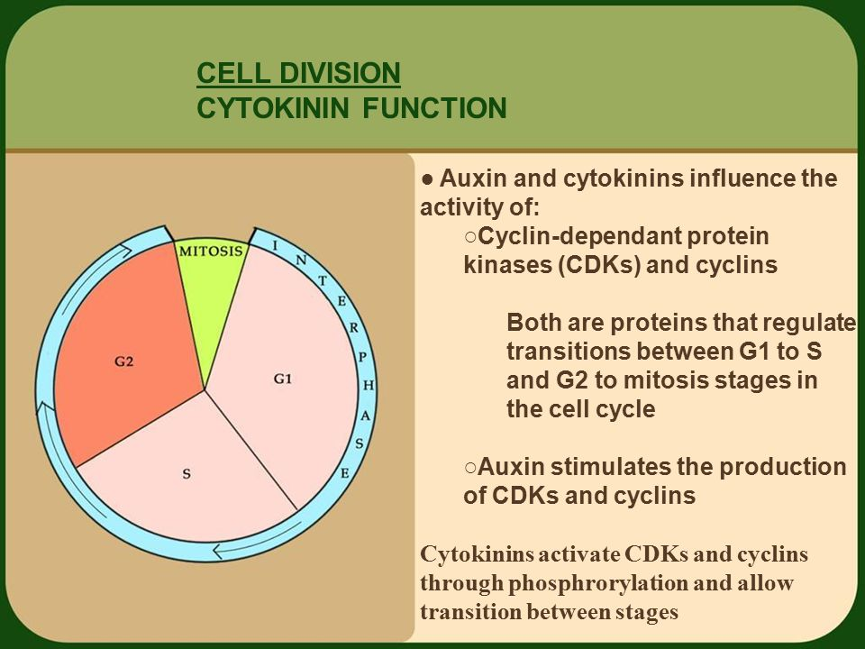

3-(Short compositional answer)
* Explain Ethylene biosynthesis in the plants.
- The precursor of ethylene biosynthesis in the plant is methionine amino acid is converted to ethylene through S-adenosyl methionine (SAM) pathway.
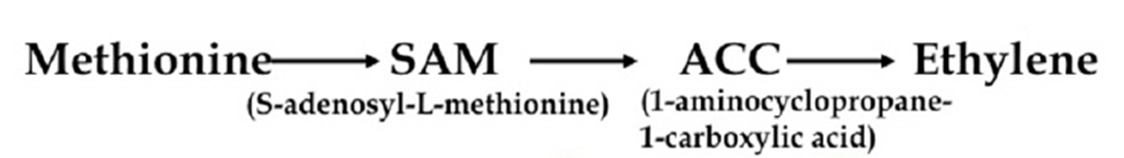

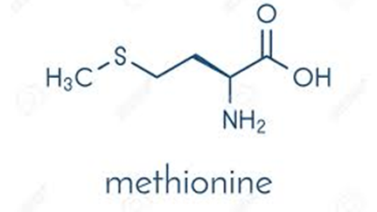

4- Enumerate the following:
* The pathways that responsible for the distribution of auxin in the plants.

1- Polar transport:
Auxin is the only plant growth hormone that has been clearly shown to be transported polar, and polar transport of this hormone is found in almost all plants, because the shoot apex serves as the primary source of auxin for the entire plant.
A-Basipetally; Soon after went's tests for auxin, it was discovered that IAA moves mainly from the apical to the basal end (basipetally).
B-Acropitally; It has been recognized that a significant amount of auxin transported also through the phloem acropetally in the root (toward the tip).
2- Non polar transport:
Most IAA that is synthesized in the mature leaves appears to be transported to other parts of the plant nonpolar via the phloem.
Note: Auxin translocation in the phloem is largely passive, not requiring energy directly.

5- Multiple choices:
* The In higher plants, the growing apical bud inhibits the growth of lateral (axillary) buds – a phenomenon called -------------.
(1)Phototropism, 2) abscission, 3) apical dominance

6-Give the reason for the following phrases:
* - How Cytokinins delay leaf senescence?
- Because Cytokinins help regulate the synthesis of photosynthetic pigments ( chlorophyll and carotenoids) and proteins so Cytokinins promote chloroplast development.

20. Extra notes:
Here the lecturer shall write any note or comment that is not covered in this template and he/she wishes to enrich the course book with his/her valuable remarks.
21. Peer review پێداچوونه‌وه‌ی هاوه‌ڵ
This course book has to be reviewed and signed by a peer. The peer approves the contents of your course book by writing few sentences in this section.
(A peer is person who has enough knowledge about the subject you are teaching, he/she has to be a professor, assistant professor, a lecturer or an expert in the field of your subject).
ئه‌م کۆرسبووکه‌ ده‌بێت له‌لایه‌ن هاوه‌ڵێکی ئه‌کادیمیه‌وه‌ سه‌یر بکرێت و ناوه‌ڕۆکی بابه‌ته‌کانی کۆرسه‌که‌ په‌سه‌ند بکات و جه‌ند ووشه‌یه‌ک بنووسێت له‌سه‌ر شیاوی ناوه‌ڕۆکی کۆرسه‌که و واژووی له‌سه‌ر بکات.
هاوه‌ڵ ئه‌و که‌سه‌یه‌ که‌ زانیاری هه‌بێت له‌سه‌ر کۆرسه‌که‌ و ده‌بیت پله‌ی زانستی له‌ مامۆستا که‌متر نه‌بێت.‌‌

19. Examinations: (practical part)
Q1/ Write the difference between True solutions and colloidal solutions.

Answer:

Property | True solutions | Colloidal solutions
Particle size | Less than 10⁻⁷ cm | Between 10⁻⁷cm and 10⁻⁵cm
Vis | bility of particles  Invisible to naked eye. Not visible under powerful microscope | Invisible to naked eye. Visible under powerful microscope
Sedimentation of particles | Do not settle down | Settle down under high centrifugation
Filtration through filter paper | No residue is formed | No residue is formed

Q2/ Enumerate only, factor effects on Diffusion rate.
Answer:
1.Temperature
2.Size and molecular weight of the particle
3.Concentration Difference
4.Diffusion Distance
5.Surface Area
6.Permeability

Q3/ Write the role of osmosis in plant.
Answer:
      - Absorption of water from the soil by the root hairs and transporting it to the other parts of plant is performed due to osmosis.
      - Support the plant cells to become in a turgid state, that gives the solidity, especially in the regions that the supporting tissues is not formed like the growth apex regions in root and stem.
      - The higher osmotic concentrations, increases the resistance of plants against high degrees of temperature and drought, because it prevents water loss.
      - The opening and closing process of stomata is combined with the osmotic pressure of the guard cells (as the osmotic pressure increased, the guard cell becomes turgid and the stomata will open at day, but it is vise versa at the night).

Q₄/ Filling the following gaps:

- Water potential of the cell (Y)= -------------------------.
Answer: Water potential of the cell (ψ) = -22.4 *M * N * T/273
M = molarity.
N= number of ions.
T= 273 + Lab. Temp. (ºC).
- Changed the colour of potato tubers when added NaCl solution (0.8 M) due to------.
Answer: Osmosis.
- When a liquid solution completely dissolved in another liquid the two liquid solution called -------------.
Answer: miscible

Q₅/How you can extract chlorophyll a & b from plant leaves?
0.5g 0f fresh leaves left in 10ml of absolute ethanol for 24 hrs, in dark condition. This process repeated three times for the complete extraction of the chlorophyll, the end volume reached 30ml.

21. Peer review پێداچوونه‌وه‌ی هاوه‌ڵ

