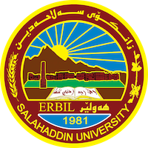
Academic Curriculum Vitae
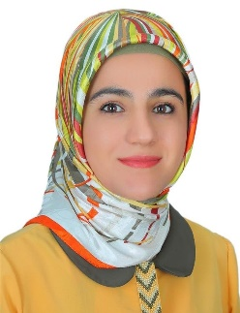
Personal Information:
Full Name: Sayran Yousif Jalal
Academic Title: Assistant Lecturer
Email: sayran.jalal@su.edu.krd
Mobile: +9647507435940

Education:
Date | Degree | College/University | Country
2011 | B.Sc. in Environmental Science | Science/Salahaddin | Iraq
2016 | M.Sc. in Solid Waste Management | Science/Salahaddin | Iraq

Employment:
Date | post | Department/College | University
2012-2013 | Lab demonstrator | Environmental science/ Science | Salahaddin
2016-2020 | Assistant lecturer | Environmental science/ Science | Salahaddin
2017-2018  2020-2021 | Member of Examination Committee | Environmental health and science | Salahaddin

- IT qualifications
Software
Name of Program | Type
Windows
Microsoft | Word
 | Excel
 | Power point
SPSS

- Language qualifications such as TOEFL, IELTS or any equivalent
IELTS (2015): 5.0

Qualifications and Skills
Training courses
Name of course | Duration | Place
Teaching methods | 6 weeks | University of Salahaddin
General English | 16 weeks | Cambridge college
Computer | 5 weeks | IT center of Salahaddin Unv.

Teaching experience:
Date | Subject | Stage/ College | University
2017-2018 | Principle of environmental science | First/ Science | Salahaddin
2018-2019 | Computer science | First/ Science | Salahaddin
2016-2017 | Environmental Engineering | Third/ Science | Salahaddin
2022-2023 | Soil Science | Fourth/ Science | Salahaddin
2019-2020  2022-2023 | Environmental Indices | Second/ Science | Salahaddin
2022-2023 | Ecostatistics | Second/ Science | Salahaddin

Research and publications
Title of thesis \ researches | Not published | Published | Approved to be published | Publishing place | Volume | Date
Applied compost quality indices for assessment different composting methods by using household solid waste
Compost quality assessment for the household solid wastes of Erbil city |  |  |  | Zanco Journal of Pure and Applied Sciences | 31 (5) | 2019
The effects of Insects on the Physicochemical Characteristics During  Composting |  |  |  | Iraqi Journal of Science | 60 (11) | 2019

Professional memberships
From 2011 to date member in Kurdistan biology syndicate
Professional Social Network Accounts:
ORCID ID: https:// https://orcid.org/0000-0001-8779-041X
Academic Profile: https:// https://academics.su.edu.krd/sayran.jalal/
LinkedIn: https:// https://www.linkedin.com/feed/
Scholar Account: https://scholar.google.it/citations?user=inFSIeoAAAAJ&hl=en
Research gate: https://www.researchgate.net/profile/Sayran-Jalal

