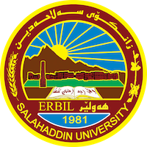
Academic Curriculum Vitae
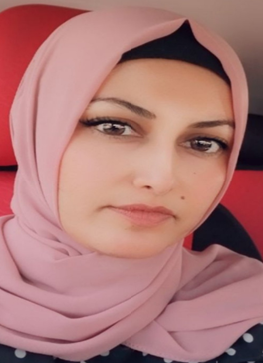Personal Information:
Full Name: Sayran Baqi Mohammed
Academic Title: Assistant lecturer
Email: (university email) sayran.mohammed@su.edu.krd
Mobile: 07504849298

Employment:
Assistant lecturer in Earth science and petroleum Department college of science Salahaddin University

Qualifications
COMPUTER SKILSS
- Microsoft Office
- Windows
- Coral

Languages
Kurdish, Arabic, English, Russian and Turkish

Education,Teaching experience:
- 1991-1997 Primary school - Khanay Qubadi in Erbil, Iraq
- 1997-2003 Secondary school - Media in Erbil, Iraq
- 2003-2006 2015 Salahaddin University, college of Science Geology department
- 2013- Got M.Sc. in Russia 2009 Work as assistant in college of science geology department Salahaddin university 2022 Assistant lecturer in geology Department college of science Salahaddin University
- 2022-2023 COMMITTEES
- 1- Exam committees
- 2-Field Application Commission
- TEACHING SUBJECTS
- 1-Practical General geology
- 2-Practical Geomorphology
- 3-Practical Engineering Geology
- 4-Practical Stratigraphy

Research and publications
- Маркетинговое исследование перспектив развития геологического туризма Иракского Курдистана
- ГЕОЛОГИЧЕСКИЕ ПАМЯТНИКИ ПРИРОДЫ ИРАКСКОГО КУРДИСТАНА И ИХ ОХРАНА

Conferences and courses attended
1-Computer training course:
2-English Course: Language Center
3-Teaching method course: Pedagogy

Professional memberships
1) Kurdistan Geologists Syndicate
2) Kurdistan Teachers Union

Professional Social Network Accounts:

https://scholar.google.com/citations?user=ox_vntMAAAAJ&hl=enhttps://scholar.google.com/citations?user=ox_vntMAAAAJ&hl=en

https://www.researchgate.net/profile/Sayran-Mohammed

