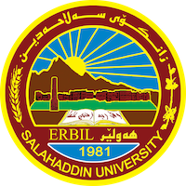
Academic Curriculum Vitae
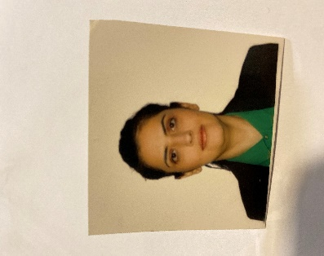
Personal Information:
✓ Full Name : Sazan Farouk Ahmed.
✓ Born: 4-5-1989.
✓ Nationality: Iraqi.
✓ Nationality: Kurdish.
✓ Email: sazan.f.ahmed@su.edu.krd
✓ Mobile: 07508997977.

Qualifications:
✓ Graduated from Salahaddin University / Erbil - College of Education / Department of Arabic Language Year: 2009-2010
✓ Master's degree in Arabic Language and Literature - Majoring in Modern Literature at Salah Al-Din University, College of Education, 2017.

The jobs he worked in:-
✓ Lecturer at the College of Education - Salahaddin University
✓ Assistant teacher at Salah Al-Din University, Faculty of Education, Makhmour
✓ Head of the Preparation Division at the College of Education - Makhmour
✓ Currently, she is the rapporteur of the Arabic language department at Salah Al-Din University, College of Education, Makhmou
Academic Title: Assistant Lecturer
Email: (university email) sazan.f.ahmed @su.edu.krd
Mobile:07508997977

Events
I have articles published in several magazines inside and outside the college.
✓ Former member of the Higher Examinations Committee at the Ministry of Awqaf in 2012.
✓ Former member of preparing and changing curricula for religious schools and Islamic institutes in the Ministry of Awqaf and Religious Affairs.✓
✓ Member of the examination committee for the academic year 2015-2016, and 2016-2017 at the Institute of Islamic Sciences.
✓ Member of the examination committee for the academic year 2020-2021: , in the College of Education - Makhmour.

thanks and appreciation obtained:
T Year Donor Number
1. 2019 President of the Kurdistan Regional Government of Iraq, Mr. Nechirvan Barzani. 1
2. 2019 Minister of Higher Education and Scientific Research 1
3. 2019 President of Salahaddin University 1
4. 2017 President of Salahaddin University 1
5. 2020 President of Salahaddin University 2
6. 2021 Acknowledgments from the Minister of Higher Education 1
7. 2022 Acknowledgments from the Minister of Higher Education 1
8. 2022 Thanks and Appreciation of the President of Salahaddin University 1
9. 2022 Thanks and Appreciation of the Dean of the College of Education - Makhmour 1
10. 2020 President of Salahaddin University 2
11. 2021 Acknowledgments of the Minister of Higher Education 1
12. 2022 Acknowledgments of the Minister of Higher Education 1
13. 2023 Acknowledgment of the Minister of Higher Education 2023
14. 2023 Thanks and Appreciation of the President of Salahaddin University 2023
15. 2023 Acknowledgment and Appreciation of the Dean of the College of Education - Makhmour 2023

1J Computer experience including: Word, Excel, PowerPoint, eccess.
✓ Participated in several strengthening the eccess program, which was conducted by Salah Al-Din University in 2012
2- A computer course in the College of Education at Salahaddin University. 2013
3- An English language course at the Language Center of Salah Al-Din University, 2013
4- A course in teaching methods at Salah Al-Alin University in Erbil. 2018
5- IELTS certificate in Erbil 2018
6- An English course at the Language Center of Salahaddin University. 2018

Note: Please do not hesitate to contact me if you have any questions. Thank you all.

