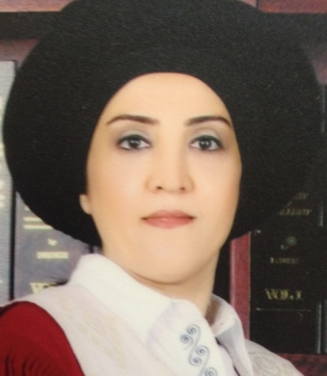
Curriculum Vitae

Personal Information

Name Sazan Mumtaz Haider

Address Zanko 2-98 B, Erbil City, IRAQ

E-mail sazanhaidary@yahoo.com

Contact No. +964 750 4484547

Place, &Birth Date Erbil, 30.Oct.1974
Civil Status Married
Height 165 cm
Weight 55 Kg
Gender Female
Citizenship Iraqi

Religious Muslim
Education:
- 2011-2014: (Ph. D in biomedical engineering). The title of the thesis is (Porous Silicon Nanoparticles as a Carrier for Folic Acid, Mitomycin C, and Tamoxifen for Potential Anticancer Therapies)., Faculty of Health Science and Biomedical Engineering, Universiti Teknologi Malaysia, 81310 Johor, Skudai, Malaysia

- 2002-2004: (M.Sc. in Biochemistry). Department of Chemistry, College of education , University of Bghdad-IRAQ.
- 1992-1996: (B.Sc. in Chemistry). Department of Chemistry, College of education , University of Salahaddin -IRAQ.

Employment:

2014-2023 Lecturer of biochemistry, Department of food technology, College of agriculture engineering science / University of Salahaddin.

2005-2011 Assist. Lecturer of of biochemistry, Department of food technology, College of agriculture engineering science / University of Salahaddin.

Supervised fourth year under graduation projects.
Supervised, M.Sc

Qualifications
- Substantial experience in performing research for publications
- Immense knowledge of preparing courses for undergraduate programs
- Ability to coordinate with students for biochemistry processes
- Ability to provide quantitative teaching to students

Teaching experience:
- Provided teaching lessons to undergraduate students on biochemistry, organic chemistry, food chemistry .
- Prepared models for various biological systems.
- Provided training to doctoral and master students.
- Participated in various departmental activities.

Research and publications
Nanoporous silicon as drug delivery systems for cancer therapies
Sazan M Haidary, Emma P Corcoles, Nihad K Ali

Effect of coatings and surface modification on porous silicon nanoparticles for delivery of the anticancer drug tamoxifen
SM Haidary, AB Mohammed, EP Córcoles, NK Ali, MR Ahmad

Folic acid delivery device based on porous silicon nanoparticles synthesized by electrochemical etching
SM Haidary, EP Córcoles, NK Ali

Effect of dopant concentration on the pore formation of porous silicon on n-type silicon
S Nadia, NK Ali, MR Ahmad, SM Haidary

Nutritional Status Assessment for displaced children in Dibagah shelter
Fatma.murad@su.edu.krd Sazan.haidar@su.edu.krd, Rafiq.salih@univsual.edu.iq

Synthesis of Zinc Nanoparticles using Portulaca oleracea Plant Extract
Sazan M. Haidary

The Protective Effect of Powdered Tart Cherry Supplements or Eating Local Iraqi Tart Cherry Fruit on Moderate to Border Level of Uric Acid and Lipid Profile in Human Serum
Firdaws A. AL-Mashhadani1,*, Shahad Abdulrasol Albayati2, Sazan M. Haidary

Cytotoxicity of Mitomycin C-Porous Silicon in Human Prostate Carcinoma Cells
MMB
Sazan M. Haidary , Nihad K. Ali, Kosar A. Omer , Fadzilah A .

magnetic Porous Silicon Composite For Localized Delivery Of The Anticancer Drug Tamoxifen
SM Haidary, NK Ali, EP Córcoles, MB Malarvili

