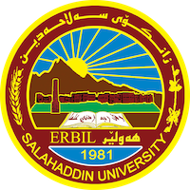
Academic Curriculum Vitae
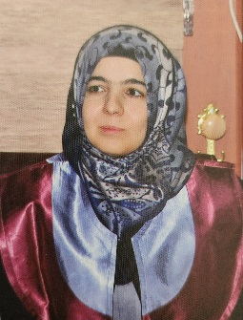
Personal Information:
Full Name: Sazan Jawhar Hamaghareb
Academic Title: Lecturer
Email: sazan.hamaghareb@su.edu.krd
Mobile: +964 750 496 5078

Education:
- Primary education: 1990 – 1996, Gulistan Primary School, Erbil.
- Secondary Education: 1996 – 1999, Angel Girls Center, Erbil.
- High School: 1999 – 2002, Ronaki Girls High School, Erbil.
- University Education: 2002 – 2006, Bachelor's Degree with second rank in Department of Kurdish, College of Language, Salahaddin University-Erbil.
- Higher Education: 2011, Master of Arts in Kurdish Literature, College of Language, Salahaddin University-Erbil.
- Higher Education: 2019, PhD in Linguistic, College of Language, Salahaddin University-Erbil.

Employment:
- Assistant Lecturer, Kurdology and Scientific Thinking, Hayat University, 2011 - 2012.
- Assistant Lecturer, Head of Registration Department, College of Language, Salahaddin University-Erbil, 2012 - 2013.
- Assistant Lecturer, Kurdology, College of Engineering, Salahaddin University-Erbil, 2012 - 2020.
- Assistant Lecturer, Kurdology, Paitaxt Technical Private Institute, 2016 - 2017.
- Lecturer, Linguistic, Kurdish Department, College of Language, Salahaddin University-Erbil, 2020 until now.

Qualifications:
- Korean Zaytuna Training Course in IT programs (Windows, Microsoft Office ‘Word, Excel, Powerpoint’), 2007.
- “Teaching Methods”: Salahaddin University-Erbil, 2011.
- "Neuro-linguistic Programming – NLP": Aga Organization for Training and Awareness, 2015.
- "Principles of Women's Leadership": Women Leaders Organization in coordination with Aga Organization for Training and Awareness, 2015.
- "Influential Women": Aga Organization for Training and Awareness, 2017.
- "Active Teacher with Montessori System": Aga Organization for Training and Awareness in collaboration with Knowledge University, 2017.
- Diploma Course "Psychological Format Program": Aga Organization for Training and Awareness, 2017.
- “Teaching Methods: Its Goals and Reliable Basis in its Choices”: University of Diyala, 2023.
- “Scientific Research and Publishing Skills”: Komar University for Science and Technology, 2023.

Teaching experience:
Undergraduate courses delivered:
- Kurdology, Hayat University, 2011 - 2012.
- Scientific Thinking, Hayat University, 2011 - 2012.
- Kurdology, College of Engineering, Salahaddin University-Erbil, 2012 - 2020.
- Kurdology, Paitaxt Technical Private Institute, 2016 - 2017.
- Kurdology, Kurdish Department, College of Language, Salahaddin University-Erbil, 2020 until now.
- Kurdology, Department of French Language, College of Language, Salahaddin University-Erbil, 2020 until now.
- Literary genres, Kurdish Department, College of Language, Salahaddin University-Erbil, 2020 until now.
- Sufism literature, Kurdish Department, College of Language, Salahaddin University-Erbil, 2020 until now.
- Comparative literature, Kurdish Department, College of Language, Salahaddin University-Erbil, 2020 until now.

Research and publications
- ڕەنگدانەوەی هزر و بیری بەرگری لە پەندی پێشینانی کوردیدا، گۆڤاری زانکۆ بۆ زانستە مرۆڤایەتییەکان.
- پاڵەوان لە حیکایەتی فۆلکلۆری کوردی ناوچەی کەرکووک، یەکێتی نووسەرانی کورد/لقی کەرکووک.

Professional memberships
- Kurdistan Teachers Union, 2013.
- Salahaddin University Cultural Center, 2013.
- Aga Organization for Training and Awareness, 2015.
- Smart Guide for Education and Consultancy, 2019.

Professional Social Network Accounts:
- ResearchGate: https://www.researchgate.net/profile/Sazan-Hama-Ghareb
- Google Scholar: https://scholar.google.com/citations?hl=en&user=Xx889H0AAAAJ
- LinkedIn: https://www.linkedin.com/in/sazan-hama-ghareb-b5564a145/

