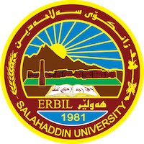
Academic Curriculum Vitae
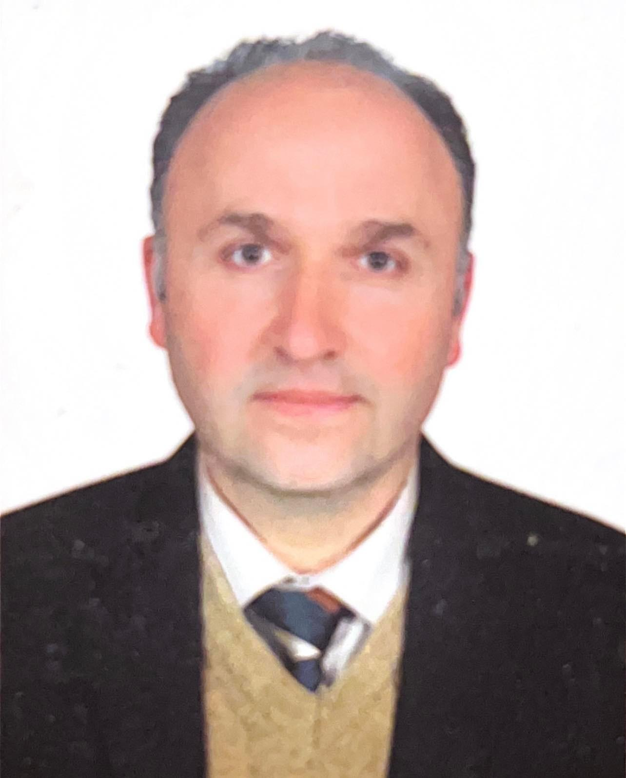

Personal Information:
Full Name: Sazar Sami Noraldeen
Academic Title: Assistant Lecturer
Email: sazar.noraldeen@su.edu.krd
Mobile: +9647504495331

Education:
B.SC : 1985-1986 / Horticulture / University of Salahadin
M.SC : 2002/ Plant Productions/Horticulture (Ornamental Plants) / University of Salahadin

Employment:
College of Education/University of Salahadin 1994
College of Agriculture/University of Salahadin 2003
Qualifications
- Studied in the University of Salahadin, College of Agriculture, Department of Horticulture. MSC on ornamental plants in University of Salahadin. Experienced many managing position like chief of library in College of Education, Salahadin University; assistant of dean in College of Agriculture; I was Head of Academic Relations in College of Agriculture, University of Salahadin; and teaching staff in Horticulture Department
- I can use microsoft word and powerpoint
- The professional courses I attended were: I did many training courses in Spain (2006), which included cultivate agriculture and drip irrigation and plant propagation and extensions including teaching methods for a duration of 3 months. And again in 2007, I visited Jordan for a training course about post-harvest technology and agricultural marketing. And for the academic year 2014-2015, I visited the Netherlands for a training course with Aeres group.

Teaching experience:
- I have taught undergraduate courses:
- Principles of horticulture (stage 2)
- Ornamental plants (stage 3)
- Landscape design (stage 4)
- Ecology and climate (stage 2)
- Cultivated agriculture (stage 4)
- Turf grass (stage 4)
- Vegetable crops (stage 3)
- Academic skills (stage 1)
- English language (stage 1)
- I have also taught the practical version of all the subjects listed above
- I have done training courses for the center of research in Ainkawa about horticulture (ministry of agriculture)
- I have done training for the farmers in extension center of ministry of agriculture
- I taught the refugees from Mosul during ISIS takeover (polytechnic of agriculture)
Research and publications
1) Evaluation study of chlorophyll estimation technique (published on October 13, 2021)
2) Effect of NPK, Humic Acid, Biofertilizer and Light Intensity on Vegetative Growth and Bulb Production of Narcissus trilandrus L. and Hyacinthus orientalis L. 576 5/12/2022 (Published on February 20, 2023)

Conferences and courses attended
- HSAD Extension workshop 2013
- Course of Agrarian training program and teaching methods 2006 Spain
- Professional Development training in Netherlands 2015
- 2nd Scientific Agricultural conference 2016
- General English for University Students training programme 2012
- Second Educational Conference of College of Basic Sciences in Kurdistan Region 2019
- Specialized training in Iraq Agricultural Extension Revitalization Project in Jordan 2008
- Academic Workshop about Professional Speaking 2015
- Online Course Development training 2012
- Environmental Training Course for MOA and College of Agriculture in KRG 2012
- Training for Fertilizer, Soil, and Plant analysis 2012
- Workshop about awareness of ecological guidance 2014

Funding and academic awards
- I got a governmental grant to travel to Jordan in 2007 for a course on post harvest technology
- I got a governmental grant to Spain in 2006 for drip irrigation and plant propagation and extensions including teaching methods
- I visited the Netherlands in 2015 for a training course in teaching methods and ornamental bulbs and tomato cultivation
- I won an academic award in 2015 for stage 1 academic debate
- I won academic award in poster design
- I received an award for teaching Mosul students during 2016-2017

Professional memberships
- Member of Teacher's syndicate
- Member of Agricultural Engineer's syndicate
- Member of Registration
- Member of community committee
- Member of College consultant
- Member of culture center in Salahaddin university

Professional Social Network Accounts:
- https://www.researchgate.net/profile/Sazar-Alasady
- https://www.facebook.com/sazar.sami
- https://twitter.com/SazarSami
- https://www.linkedin.com/in/sazar-sami-87641a142/?original_referer=https%3A%2F%2Facademics.su.edu.krd%2F
- https://scholar.google.com/citations?hl=en&user=V9KdYKYAAAAJ&view_op=list_works&citft=1&email_for_op=sazar.noraldeen%40su.edu.krd&gmla=AJsN-F5AvJowgS1mFSRNUeqN8B7mCQVapvoIZIe4zWfSl4zb1GDrXC-C7E2KeB3Tz9OQHmQsGgt17_xwchkd0_bO-FQAVIjA82h6A2HTMHVWdRBrCgOxHBkIo0WfF8b2dFAvdaS1dKctECzxPIKDYaf3LIcMPAGw-apM5HkZpSCzhCxelEChFknduhbqLvS3UWtosu6sdgTgLX6lCjLFdxp3dDRhlaazuiUYyy-j5wo4OvivkR1oWwDq63ITK4zS3HWi_8XC8jmG
- https://orcid.org/0009-0009-9205-4447

