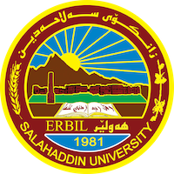
Academic Curriculum Vitae
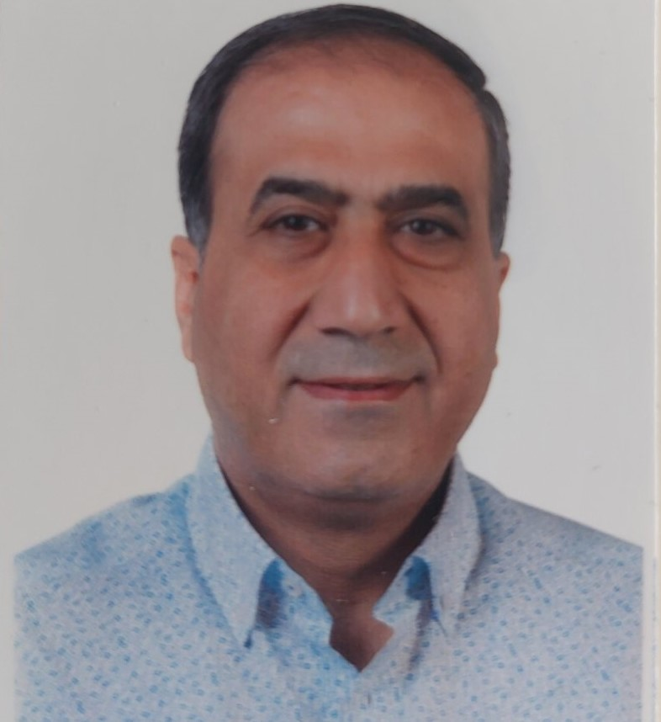
Personal Information:
Full Name: Seerwan Kareem Abdullah
Academic Title: Assistant Professor
Email: seerwan.abdullah@su.edu.krd
Mobile: 07504467455

Education:
In 1992-1993, Bachelor's degree in physical Education from Salahaddin University.
- In 1999, received Master's degree in physical Education from Salahaddin University.
-In 2003, received (ph.d. ) degree in physical education from Salahaddin University.

Employment:
Department of physical education and sport sciences of education collgge in salahaddin university in 1993
Qualifications
- Teaching qualifications:doctor of philosophy/biomecanic
- IT qualifications : Electronic programs required by my college work
- Language qualifications such as TOEFL, IELTS or any equivalent: nothing
- Any professional qualification: The international referee for athletics and holds the NTO certificate
- You could put any professional courses you have attended

Teaching experience:
- State all teaching courses you delivered, stating undergraduate or post graduate
Courses, trainings, lab supervision, etc.,:
1- Supervision of 4 master's researches and one Ph.D.
2- Lecturer in an educational course for athletics for the year 2017.

Research and publications

State all researches, publication you made.

1-A comparative analysis study between the two types of platform start (normal and track start) in some Biokinetic variables in the swimming of (freestyle …

2-The Effect of Corrective Exercises by Using Assistance Tools on Some Kinematics Variables and Slice Serving Accuracy in Tennis

3-Comparison of the distances of the three jumps of the Iraqi champions in the effectiveness of the triple jump with the distances of the international ratios (horizontal – vertical

4-Comparison of a number of function values (vertical force - time) in the triple jump of advanced Players

Conferences and courses attended
- Give details of any conferences you have attended, and those at which you have presented delivered poster presentations.
- I have attended two research conferences in Antalya, Turkey

Funding and academic awards
- List any bursaries, scholarships, travel grants or other sources of funding that you were awarded for research projects or to attend meetings or conferences.
- I attended a leadership course in Germany in
- I have been a member of two College of Physical Education and Vocational Sciences Curriculum Conferences
- I participated in the conference of sports institutes in the region to set the curriculum
- I was a member of the Kurdistan Ministry of Sports and Youth Sports Conference in Wales - UK

Professional memberships
- List any membership you hold of any professional body or learned society relevant to your research or other life activities:
Vice President of the Kurdistan Central Athletics Federation

Professional Social Network Accounts:

- List your profile links of ReserchGate, LinkedIn, etc. https://www.linkedin.com/in/seerwan-kareem-abdullah-a99133261/
- https://scholar.google.com/citations?view_op=new_articles&hl=en&imq=seerwan+kareem+abdullah#

It is also recommended to create an academic cover letter for your CV, for further information about the cover letter, please visit below link:
https://career-advice.jobs.ac.uk/cv-and-cover-letter-advice/academic-cover-letter/

