Journal of Economics and Administrative Sciences JEAS

Available online at http://jeasiq.uobaghdad.edu.iq/
DOI: http://dx.doi.org/10.33095/jeas.2000.00.0.0000

Security and confidentiality of information under the application of cloud accounting compared to traditional accounting

Kawa Wali (1)  Salahaddin University-Erbil, Iraq | Bnar Karim Darwish(2)  Salahaddin University-Erbil, Iraq | Shadan Jabbar Abdulfattah (3)  Salahaddin University-Erbil, Iraq
kawa.wali@su.edu.krd | bnar.darwish@su.edu.krd | shadan.abdulfattah@su.edu.krd

Received 00/00/2022, Accepted 00/00/2022, Published 00/00/2022

This work is licensed under a Creative Commons Attribution-NonCommercial 4.0 International (CC BY-NC 4.0)

Abstract
Due to the continuous development and transition from manual to electronic accounting methods, users are now finding that accounting is simpler and more convenient. The recent shift in accounting to a faster technology has greatly improved its ability to serve users.
The research aims at a number of goals, including: Learn about cloud accounting and software-based accounting, compare the services of ten major cloud accounting service providers around the world in terms of security and confidentiality to understand how they differ from traditional accounting, and understand the current impact of cloud accounting using insights from accounting experts.
Primary data were collected from accounting experts from various academics and professionals. A questionnaire form has been prepared for this purpose.
Secondary data were collected from annual reports, books, international journals, the Internet, and other sources. The information collected was helpful in understanding the concepts and their effectiveness.
According to the results, cloud accounting is a much-preferred option over traditional accounting for any organization looking to compete due to its many benefits, including accessibility, affordability, high security, and ease of use.
Further study needed, recent advances in accounting not only help small and medium-sized businesses (SMEs) improve their efficiency but also provide significant cost savings. In such circumstances, it is necessary to ascertain whether companies and financial institutions such as banks that promote these trends in their operations bring clear benefits, as well as how this may affect the business future of newly established companies and institutions. This paper provides insight into cloud accounting in small and medium-sized businesses from a managerial accounting perspective.

Paper type: Research paper

Keywords: Cloud accounting, Traditional accounting, Cloud software

- Introduction
Back in Mesopotamia, the Sumerians kept accounting records. At first, the data comprised records of the worth of various agricultural products. Accounting has been steadily evolving over the last few years with all of its new functions and improvements, which has facilitated its widespread usage by individuals in all spheres of the business modern accounting has advanced to this point through modest adjustments over time, while keeping pace with rapidly expanding technical improvements. Accounting has become easier and more appropriate, for users as a result of the continuous modification and evolution from manual techniques to electronic alternatives. The current transition of accounting toward a faster technology has greatly enhanced its ability to serve users. According to recently published studies, "cloud computing" is the dominant trend in informational technologies used in accounting, from which the following informational categories were further deduced: "Real-time accounting," "cloud accounting," "e-accounting," and other similar terms. Researchers found that the most successful companies are those whose managers make good use of cloud accounting software by analyzing revenues and expenses and how effectively the company generates sales had the most positive and least negative impact. They also consider accounting software a powerful tool that companies use to get the job done in the shortest possible time.

- Methodology
  - The problem and research question
Despite the effective and positive role that information technology plays, the wide spread of this technology and the diversity of its use have increased the risks to which it is exposed, whether these risks are human or natural. Fraud, manipulation and misuse of the internet account for are newly emerging problems. The primary problem with cloud accounting is how to provide software. Software and systems programming errors, database design, and unauthorized use of systems, software, and applications were also part of the problem. An information crime is another criminal activity that is committed using computers or an information network. With the rise of a new model in the context of accounting and concepts such as cloud accounting to address financial and economic issues, as well as security, confidentiality, accuracy and easy access to information under this model, so in light of these problems and challenges, the study question can be formulated as follows:
Does access to information secure and confidential under cloud accounting compared to traditional accounting and how effective is cloud accounting according to accounting experts?

2.2 Research objectives
The most important goal of the descriptive analytical comparison is to highlight the effects of cloud accounting on the security and confidentiality of information when using cloud accounting as opposed to traditional accounting.
General objectives:
- Cloud accounting as a new model for managing accounting information
- To become familiar with cloud accounting and software-based accounting.
Specific objectives:
- To compare the services of ten major cloud accounting providers around the world in terms of security and
confidentiality.
-To comprehend the effect of cloud accounting using insights from accounting experts.

2.3 Data collection sources and model analysis
Primary data was collected from accounting experts from various academia and professionals to highlight the importance and impact of cloud accounting compared to traditional accounting, and a questionnaire form was created for this purpose. The forms were distributed via Google Form to more than 35 accounting experts from different universities inside and outside Iraq, and the target group for receiving these forms are (Professor, Assistant Professor), 31 of these forms were received, filled out by experts and returned; one model was deleted because it did not match the rest. Secondary data was collected from the companies under study's annual reports (10 large cloud companies around the world), international journals, the Internet, and other sources. The data collected was useful in comprehending the concepts and their effectiveness.

- Theoretical background
3.1 Cloud accounting concept compared to traditional accounting.
Cloud accounting is defined as the use of cloud accounting to construct a virtual accounting information system through the internet. According to the equation, cloud accounting plus accounting equals cloud accounting. In order to enable strategic decision making, planning, and control, traditional accounting information systems must be able to gather cost and market data both internally and externally. An intellectual collection of services that are accessible from any location using a mobile device with internet connectivity is a system of virtualized computers that are interconnected and may be actively offered as a computational resource. Ping and Xuefeng (2011:83) for the first time introduced cloud accounting. Furthermore, Shah et al (2011:3) stated that traditional management accounting to systems is incapable of meeting current accounting requirements. Similarly, they argue that the system's emphasis is mixed, and that it is too one-sided for managers who plan, control, and make decisions. As a result, in order to achieve a paradigm shift in data processing and storage, management must replace outdated accounting information systems with new technologies that meet changing needs. A corporation must sign an operating contract with many cloud accounting software programs require a corporation to sign an operating contract, which is problematic for a business that is unaware of its own existence (Lin and Chen, 2012:15). Traditional accounting methods, according to Christauskas and Miseviciene (2012), are ineffective and insufficient in light of modern accounting regulations.

The information kept on a distant server and the program is given on a recurring basis. Cloud accounting varies from traditional accounting in that it requires the installation of software on a workspace or a local server, as well as the purchase of software. Rather than the actual location of the data files, the accounting software and data are managed by user login access. Data sharing in cloud accounting services is simpler than data transport from one computer site to another, which occurs in traditional accounting. Both cloud accounting and traditional accounting technology should be considered when planning. A business that uses cloud services is more likely to succeed. Because cloud accounting software is less expensive than traditional accounting software, small businesses will eventually invest in it. Furthermore, companies with remote employees could tend to favour the flexibility and availability of a cloud - based solution. Clear Books (2014) claimed that with the use of internet accounting solutions and better connectivity than was previously feasible, accountants, like everyone else, strive to advance. Small businesses benefit from cloud accounting because it protects their data from security threats, other organizations, and any potential physical calamity in the workplace that may damage hard drives and data, such as a burglary, flood, or fire, among other things (Dimitriu, and Matei, 2015:28). In contrast to traditional accounting, cloud accounting entails using a web browser to access accounting software and data (Singerova, 2018: 63).

Despite the advantages of cloud accounting, the majority of businesses continue to use traditional accounting software. Traditional software may be advantageous in several scenarios, including the following: Businesses that want tight control over accounting data and don't want it accessed anywhere where usage cannot be directly monitored and there is a secure wireless network; businesses that hold highly sensitive financial information (banks, for example) and don't want third parties to access it and can completely control the level of security by keeping it in-house (Ben Saeed et al 2018) Cloud accounting, which enables businesses to effectively and affordably use infrastructure and IT applications, may be the primary driving force behind this transition (Al-Rabi'e and Ali 2020).

3.2 An Innovative Cloud Accounting Business Model
The user's computer is frequently equipped with traditional accounting software that has been secured as a patent. As a distinct new product category, cloud accounting offers services rather than goods. Online accounting data handling businesses do not actually own the payroll system; rather, they rent the right to use it from a specific service provider. The use of accounting software is changing due to cloud accounting, which has an effect on the entire corporate sector. Managers can effectively make economic decisions by employing accounting software and a computer system to obtain timely, accurate, and reliable accounting information (Chanthinok and Sangboon, 2021). Global usage of the cloud-based internet service is depicted in Figure 1 Cloud accounting services are anticipated to be used by over 3.6 billion internet users in 2018, up from 2.4 billion users in 2013.

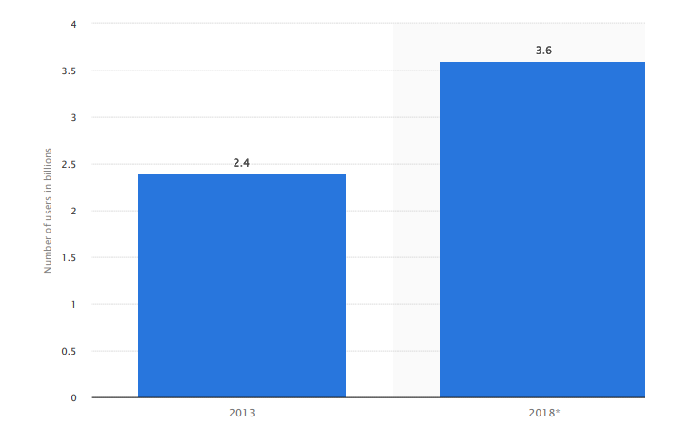

Source: (Consumer cloud computing users worldwide 2018 | Statista, 2022)

Figure 1: Number of consumer cloud-based service users worldwide (2013-2018) (in billions)

3.3 Accounting software in the cloud: what is it?
Cloud accounting software is similar to other types of accounting software. The data, however, is saved on remote external servers. When users interact with data in cloud accounting software, the input is quickly processed and saved. Cloud computing is not an electronic cloud suspended, it depends on saving data on servers especially those that are approved by companies or institutions, etc. (Awsam Khalid and Ahmad Jawhar, 2022:498)
The primary distinction between cloud storage and conventional storage is where the data resides, which is outside rather than internally.
Cloud storage has both advantages and cons
To determine if cloud accounting software is appropriate for your company, evaluate the strengths and weaknesses of cloud storage.
1) Accessibility
Cloud storage can have strengths and weaknesses in terms of accessibility. Check both cases
- Advantages
Users may access data from everywhere with connection of an internet while utilizing cloud accounting software. Because the globe is getting more mobile, people can work from anywhere. They are no longer tethered to their work PC. It provides enormous flexibility for both large and small businesses. Teams from all over the world can access data and information as if they were all in the same room.
Most of the information stored in the cloud is shared by coworkers. This category includes around 71.4 percent of data shares. The demand for accessibility is therefore primarily internal. But cloud accounting software is really helpful if you have customers that are spread out across several regions.
Data sharing is also made simpler. Users just need their own unique passwords to have access to the same system with cloud accounting. Large files can no longer be shared by flash drive or sent through email thanks to this technique.
- Disadvantages
Since cloud storage requires an internet connection in order to function, this is its main drawback over on-site storage. While internet connectivity is often available in professional and personal contexts, there are some places and times when this is just not feasible. As a result, there is a chance that not everyone can collaborate on the same project.

2) Safety
- Advantages
Data security is a constant worry. There are benefits and drawbacks to cloud storage. Generally speaking, cloud accounting offers a similarly secure means of data storage to that of conventional accounting software. It can even be more secure at times. Strong security methods are used by remote servers. Having remote storage rather than storage on the laptop or tablet will probably keep the information safe from compromise in the event that it is lost or stolen.
- Disadvantages
The most common reason for breaches is still stolen computers, with several situations happening often. A laptop with a spreadsheet of data is simpler to take than a server outlays related to data management and storage is infrastructure.
Since there are no internal servers to operate, cloud accounting software also means you require fewer IT workers. Significant savings may result from lower labor expenses.
Most of the savings come from labor and equipment reductions. You may also take into account the entire expense of maintaining your business.
- Disadvantages
Software for cloud accounting does have a cost. The volume of data stored and the number of users may affect that fee. Costs may also be impacted by functionality. To ascertain what you want and the precise cost, compare price and features. Be aware that as your business expands, expenditures may gradually rise.

4) Bandwidth
- Advantages
Users may stop attaching huge files to emails thanks to cloud store. They may provide a hook up or suggest the cloud to a coworker. Because bandwidth is unaffected, nothing should slow down, with cloud accounting software. (Team, 2022).
- Disadvantages
There may be bandwidth restrictions and allocations. If your organization uses more than these allotments, you can be charged more. Slower speeds are another possibility, that could be annoying for consumers. If this worries you, thoroughly investigate the bandwidth limitations and possible affect people regularly engage with technology.

Cloud-based accounting software offers in general a number of benefits for businesses.
1. Managing and storing data
Businesses no longer need to maintain pricey computer gear or store and manage data.
2. Affordable
If all you want is a smartphone with internet connectivity, cloud accounting might be far less expensive than desktop-based options.
3. Adaptability
In a fully linked environment, the data may be updated and viewed from any computer anywhere in the globe, providing ultimate flexibility.
4. Reduces errors
Your cloud-based file serves as the only ledger, which increases information accuracy and reduces mistakes throughout BAS and tax season.
5. Engage in live conversation
Instead of constantly gathering data and sending the data file manually, ledger owners may communicate with their tax agent in real time.
6. Up to date
The supplier automatically updates the software, so if the payroll module is utilized, you don't need to download changes like new tax rates.

To implement cloud-based accounting software, the following fundamental actions can be taken:
1. To photograph or scan documents
The desired financial documents should be scanned or photographed in the first phase.
Electronic version
A variety of tools, including a handheld camera and an office scanner, are used to create digital representations of financial papers.
2. Place documents online
The service provider provides the customer with a Login ID and Password so the client can access in, upload the documents to the cloud, and the documents instantly become a part of the service provider's records.
3. Viewing
Access the documents whenever required.
By the utilization, there's access to a versatile service which allows the users to look at their business accounts wherever and whenever required and thru any device (Team, 2022).

3.4 Services of the top 10 cloud accounting firms around the world

3.4.1 Sage Intacct
For small and medium-sized enterprises, Intacct has established itself as the industry leader in cloud financial management software. As the largest member association in the world that represents the accounting profession, the American Institute of Certified Public Accountants (AICPA), Intacct was a pioneer in bringing cloud computing to finance and accounting. AICPA named Intacct as its preferred provider of financial applications (Company, 2022).

3.4.2 NetSuite
With the help of automation of key business operations, NetSuite ERP, an all-in-one cloud business management system, businesses can run more efficiently. The platform offers immediate insight into business and financial performance (NetSuite ERP Pricing & Reviews 2022).

3.4.3 Quickbooks
Intuit created Quickbooks, one of the biggest and first small company accounting software companies in the world. Even in its most affordable bundle, the program has a variety of tools that sole proprietors and independent contractors may use to keep track of their earnings (QuickBooks Pricing & Reviews 2022).

3.4.4 FreshBooks
For service-based companies like therapists, architects, attorneys, plumbers, and more, FreshBooks' online accounting software is excellent. It is simple to use and intuitive. It is accessible on all of your devices because it is cloud accounting software (FreshBooks Pricing & Reviews 2022)

3.4.5 Zoho Books
Online accounting tool Zoho Books simplifies corporate processes and controls funds. The program facilitates cross-departmental collaboration and helps finance teams keep track of payables and understand where money is going.
3.4.6 WaveAccounting
Online accounting software includes a variety of functionalities such as billing, payment tracking, managing finances, and managing payroll (Wave Accounting Review 2022).

3.4.7 FinancialForce
On Salesforce's top cloud platform, FinancialForce provides business solutions focused on the needs of the client. With the only contemporary ERP package and the professional services automation (PSA), which provide real-time insights and wise decision-making, we drive corporate success.

3.4.8 Xero
Xero is a comprehensive online accounting tool that links entrepreneurs to their financial information, bank, and advisers at any time. Growing businesses now have access to their account information, transactions, and cash flow from anywhere (Xero Pricing & Reviews 2022).

3.4.9 ZipBooks
Is an accounting software company based in American Fork, Utah? The online accounting and bookkeeping application assist business owners with processing credit cards, sending invoices, and other functions (Zoho Books Pricing & Reviews 2022).

3.4.10 Kashoo
Small company owners may automate bookkeeping operations using Kashoo, a cloud-based accounting service. The most time-saving and effective accounting program for small company owners. (Accounting, 2022).

Table 1: Presents the services of the top 10 cloud accounting firms around the world
Companies  Products | Payroll Management | Tax Calculator | Customizable Invoices | Recurring Billing | Nonprofit Features | Rate
SageIntacct | YES | - | YES | YES | YES | 4
NetSuite | YES | - | - | YES | YES | 3
QuickBooks | YES | - | YES | YES | YES | 4
FreshBooks | YES | - | YES | YES |  | 4
ZohoBooks | YES | - | - | - | YES | 3
WaveAccounting | YES | - | YES | YES | YES | 4
FinancialForce | YES | - | YES | - | YES | 3
Xero | YES | - | YES | YES | YES | 4
ZipBooks | YES | - | - | - | YES | 2
Kashoo | YES | - | YES | YES | - | 3

Source: (Best Accounting Software for Small Businesses in 2022)

According to Table 1, the researchers' goal in providing the services of ten of the best cloud firms around the world is to demonstrate the importance of cloud accounting for the security and confidentiality of the information they provide to their users through online or telephone support without any problem. Unlike traditional accounting software, one of the main problems of technical staff is to respond to user inquiries within 24 hours. Moreover, cloud accounting software has more control and access to the security measures of its users, making it easier to track any vulnerabilities and avoid data breach, unlike traditional accounting.

- Discussion results
From the Table 1 it can been seen the most services (4/5) are offered by Quick Books to Small and medium-sized companies (SMEs). The smallest number of services (2/5) are offered to SMEs by ZipBooks. One thing that all ten businesses offer is payroll management. All ten businesses fail to offer a service that involves estimating tax calculator.

The following results were obtained from the opinion of 31 accounting experts from various organizations to reveal the importance of cloud accounting in small and medium-sized companies

1. Are you up to date on the latest accounting trends?
Response | Number of Respondents
Yes | 26
To some extent | 3
No | 1
Total | 30

2. Are you familiar with cloud accounting?

3. How did you learn about it?
Response | Number of Respondents
Internet and social media | 21
Workplace | 9
Total | 30

4. Do you make use of cloud accounting?

5. Do you believe the company's workforce will decrease with cloud accounting?
Response | Number of Respondents
Yes | 13.8
To some extent | 2.1
No | 14.1
Total | 30
6. Is cloud accounting useful to determine the company's actual financial position?

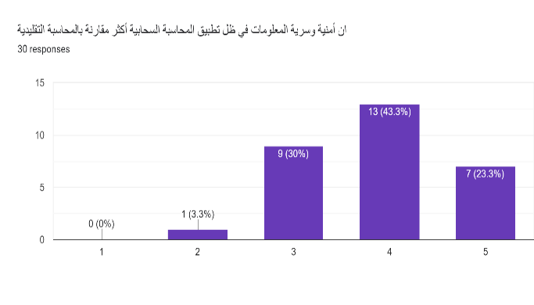
7. The security and confidentiality of information under the application of cloud accounting is more compared to traditional accounting
Response | Number of Respondents
Strongly agree | 7
Agree | 13
Partially agree | 9
Disagree | 1
Strongly disagree | 0
Total | 30

8. Do you believe that the accounting cloud has reduced the amount of accounting manipulations?

9. How would you rate the effectiveness of cloud accounting in revealing earnings management?

10. Do you believe that online payments are more effective than traditional ones?
Response | Number of Respondents
Agree | 23
Disagree | 7
Total | 30

11. Are you of the opinion that the audit process has been affected by cloud accounting?

12. Is cloud accounting financial data analysis superior to widely used alternatives?
Response | Number of Respondents
Strongly agree | 9
Agree | 11
Partially agree | 6
Disagree | 3
Strongly disagree | 1
Total | 30
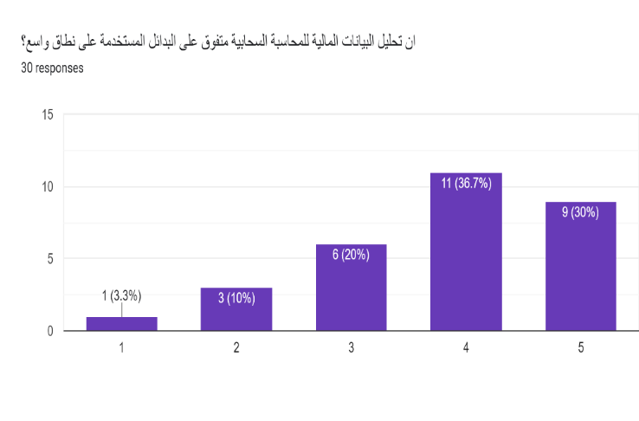

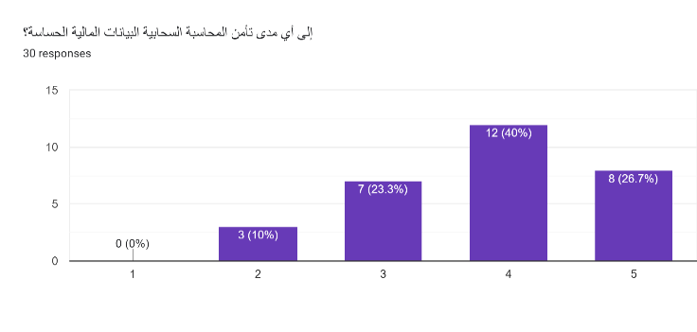
13. To what extent does cloud accounting secure sensitive financial information?
Response | Number of Respondents
Strongly agree | 8
Agree | 12
Partially agree | 7
Disagree | 3
Strongly disagree | 0
Total | 30

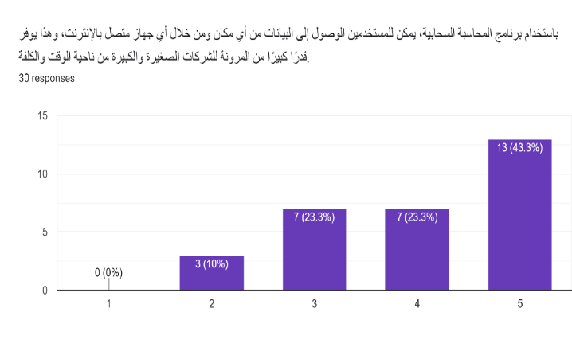
14. With cloud accounting software, users can access data from anywhere and through any device connected to the Internet, and this provides great flexibility for small and large businesses in terms of time and cost
Response | Number of Respondents
Strongly agree | 13
Agree | 7
Partially | 7
Disagree | 3
Strongly disagree | 0
Total | 30

15. Would you want to contribute any comments to make this article about cloud accounting even more rich?
A small percentage of the accounting experts who participated in the research sample stated that cloud accounting is a new understanding in accounting and another percentage said in their comments that the future of traditional accounting will end and will replace with cloud accounting because of this trend of significant advantages in terms of cost, time and security. However, cloud accounting does not completely prevent earnings management and information manipulation.

The cloud accounting phenomenon will be used frequently in the future, which will have a significant impact on all important facilities, both industrial and service-related, especially on commercial enterprises. Cloud accounting may be more useful if it is properly linked to sales and purchases in the shape of invoicing, but there is currently a lack of understanding and training in this area. Utilizing cloud accounting has allowed significant savings in time and effort, and its usefulness will increase with the integration of the enterprise system (Wali and Darwish 2021).
When making plans, both traditional accounting technology and cloud accounting should be taken into account. The likelihood of success for a business is increased by using cloud services. Due to its lower cost compared to traditional accounting software, small businesses will eventually invest in cloud accounting software. A cloud-based solution's scalability and accessibility are further advantages for companies with remote personnel. Cloud accounting benefits small businesses by protecting their data from security threats, other organizations, and any potential workplace catastrophe that could damage hard drives and data, such as a break-in, water, or fire, among other things.
Based on the research, 86% of experts were conscious of current accounting trends, and 90% of experts are familiar with cloud accounting. According to research, 70% of experts learned about cloud accounting online and through social media, followed by 30% through their place of employment. 36% of experts utilize cloud accounting, compared to 64% of experts who partially or don't. It says that 46% of experts somewhat agree, 7% don't agree, and 47% of experts absolutely agree that there has been a decrease in the number of people employed. Furthermore, cloud accounting reduces manipulations, according to 60% of experts, and 37% to some extent, while just 3% disagree. The security of sensitive financial data in cloud accounting is reported to be rated as agree by 40% of experts, strongly agree by 26.7%, 23.3% partially agree and disagree by 10% of experts. Moreover, cloud accounting's financial data analysis is superior, according to 87% of experts, while 13% disagree. 76.7 % of experts agree that cloud payment is more effective than other standard payments, while 23.3% disagree. Experts who believe cloud accounting is effective in revealing earnings management are 37%, 20% believe it is good to very good respectively, and 43% don't know. According to the research, while 13% of experts do not believe that cloud accounting has changed the audit process, 87% of experts have a good opinion. In addition, 60% of experts strongly believe that cloud accounting is useful in determining the true financial position of a company, 37% somewhat agree and 3% strongly disagree. 67.7% of experts agree that cloud accounting secures sensitive financial information. 67.7% of experts agree that cloud accounting secures sensitive financial information. The majority of experts made up of (23% and 43%=66%) strongly agree and agree, respectively, that the security and confidentiality of information under a cloud accounting application is more than traditional accounting. And only a small percentage of 7% of accounting experts do not agree. Finally, 90% of experts strongly agree and agree that users of cloud accounting software can access data anywhere with great flexibility for small and medium-sized companies in terms of cost and time, versus 10% who disagree.

Conclusion
Cloud accounting is sure to have great impact on the growth of SMEs. With a plethora of advantages such as cost efficiency, high security, ease of use, and so on, cloud accounting is the right choice for any business looking to stay competitive. Cloud accounting can be highly beneficial as it offers efficient technology and account service at a lesser cost.
- According to the results of the survey, which indicates that cloud accounting has a significant impact on the security and confidentiality of information, in contrast to traditional accounting.
- The impacts of the current innovations in cloud accounting will eventually affect a wide range of businesses and industries.
- Entrepreneurs won't utilize the conventional accounting method anymore since cloud accounting makes essential data easily accessible.
- As a result, business owners may confidently make more informed decisions more quickly.

Further Work
The researchers recommend, first of all, that it is necessary to study whether financial institutions, such as banks, due to recent accounting innovations that support these trends in their operations provide significant benefits, as well as how this may affect the future of operations of newly established institutions.
Another possible point for researchers, with security risks in mind, the emergence and growth of cloud accounting also encourage the growth of a market economy.

Acknowledgments
The researchers express their thanks and appreciation to all professors and accounting experts in both universities and institutes (Salahaddin, Knowledge, Baghdad, Muthanna, Dhiqar, Babylon, Mosul, Anbar, Najaf, Diyala, Erasmus, Toronto, Birmingham) for their contributions, in particular by expressing their views on the questionnaire prepared for this survey as well as the methodology.

References
Al-Rabi'e, A. and Ali, O. AM. (2020) "The Intellectual Impact of Cloud Accounting in Enhancing the Quality of Auditing for Jordanian Audit Offices" Journal of Business & Economic Policy ,Vol. 7, No. 3: pp. 32-41. doi:10.30845/jbep.v7n3p4
Awsam Khalid, T. and Ahmad Jawhar, M. (2022) ‘The Effectiveness of Electronic System Based on Cloud Computing to Develop Electronic Tasks for Students of the University of Mosul’ Journal of Educational and Psychological Researches, 2022, Volume 19, Issue 72, Pages 489-524. https://doi.org/ 10.52839/0111-000-072-017
Ben Saeed. A. & Abdel Rahim, N. & Makhlouf, A. (2018) “The future of accounting information systems under cloud computing technology”., pp. 7-20. DOI:10.47173/2134-001-001-001
Christauskas, C. and Miseviciene R. (2012) “Cloud Computing Based Accounting for Small to Medium Sized Business”, Inzinerine Ekonomika – Engineering Economics, vol. 23, no 1: pp. 14-21
Clear Books (2014) “How cloud accounting software is changing the business model of accounting firms” Available at: http://www.clearbooks.co.uk/themes/ClearBooks2013/images/ClearBooks/accounting-software-business-model.pdf
Dimitriu, O. and Matei, M. (2015) “A New Paradigm for Accounting through Cloud Computing”, Procedia Economics and Finance, 15, pp. 840-0846.
Gutierrez, A., Boukrami, E. and Lumsden, R. (2015) “Technological, organizational and environmental factors influencing managers’ decision to adopt cloud computing in the UK", Journal of Enterprise Information Management, Vol. 28 No. 6, pp. 788-807. https://doi.org/10.1108/JEIM-01-2015-0001
Kriangsak Chanthinok and Krittaya Sangboon (2021) “The Development of Digital Accounting System on Cloud Computing” Journal of Computer Science, 17 (10): 889.904
DOI: 10.3844/jcssp.2021.889.904
Lin, A. and Chen, N. (2012) “Cloud Computing as an Innovation: Perception, Attitude, and Adoption”. International Journal of Information Management, 32, 533-540.
http://dx.doi.org/10.1016/j.ijinfomgt.2012.04.001
Singerová, J. (2018) “Accounting in cloud’, European Financial and Accounting Journal, 2018, vol.13, no. 1, pp. 61-76. DOI: 10.18267/j.efaj.206
Ping, C. and H, Xuefeng. (2011) “The application in medium-sized and small enterprises informatization of cloud accounting”. J. Chongqing University of Technology and Social Science, 1, pp. 55-60.
Wali, K., Darwish, B.K. (2021) “Electronic Accounting Services and their Effect on Enhancing the Efficiency of Financial Institutions”. Journal of University of Babylon for Pure and applied science (JUBPAS). Vol.29; No.1; pp. 21-39

Business.org. 2022. Best Accounting Software for Small Businesses in 2022 | Business.org. [online] Available at: <https://www.business.org/finance/accounting/best-small-business-accounting-software/> [Accessed 11 September 2022].
https://sec.report/Document/0000896878-21-000233/. 2022. [online] Available at: <https://sec.report/Document/0000896878-21-000233/> [Accessed 11 September 2022].
Enovice.eu. 2022. [0nline] Available at: <https://envoice.eu/en/blog/cloud-accounting-vs-traditional-accounting-what-are-the-core-differences/ [Accessed 15 October 2022].
Oracle.com. 2022. [online] Available at: <https://www.oracle.com/a/ocom/docs/annual-report-2020-21.pdf> [Accessed 11 September 2022].
Accounting, S., 2022. Kashoo Classic Review. [online] PCMAG. Available at: <https://www.pcmag.com/reviews/kashoo> [Accessed 11 September 2022].
Sageintacct.com. 2022. Company. [online] Available at: <https://www.sageintacct.com/company> [Accessed 11 September 2022].
Statista. 2022. Consumer cloud computing users worldwide 2018 | Statista. [online] Available at: <https://www.statista.com/statistics/321215/global-consumer-cloud-computing-users/> [Accessed 11 September 2022].
The Motley Fool. 2022. Wave Accounting Review 2022: Features & More. [online] Available at: <https://www.fool.com/the-ascent/small-business/accounting/wave-accounting-review/> [Accessed 11 September 2022].
TechnologyAdvice. 2022. Xero Pricing & Reviews 2022 | Accounting Software. [online] Available at: <https://technologyadvice.com/products/xero-reviews/> [Accessed 11 September 2022].
TechnologyAdvice. 2022. FreshBooks Pricing & Reviews 2022 | Accounting Software. [online] Available at: <https://technologyadvice.com/products/freshbooks-reviews/> [Accessed 11 September 2022].
TechnologyAdvice. 2022. Zoho Books Pricing & Reviews 2022 | Accounting Software. [online] Available at: <https://technologyadvice.com/products/zoho-books-reviews/> [Accessed 11 September 2022].
TechnologyAdvice. 2022. NetSuite ERP Pricing & Reviews 2022 | ERP Software. [online] Available at: <https://technologyadvice.com/products/netsuite-erp-reviews/> [Accessed 11 September 2022].
TechnologyAdvice. 2022. QuickBooks Pricing & Reviews 2022 | Accounting Software. [online] Available at: <https://technologyadvice.com/products/quickbooks-reviews/> [Accessed 11 September 2022]
Team, R., 2022. 4 Advantages and Disadvantages of Cloud Accounting and Storage. [online] Reckon Blog. Available at: <https://www.reckon.com/reckon-blog/advantages-disadvantages-cloud-accounting-storage/> [Accessed 11 September 2022].
Statista. 2022. Consumer cloud computing users worldwide 2018 | Statista. [online] Available at: <https://www.statista.com/statistics/321215/global-consumer-cloud-computing-users/> [Accessed 11 September 2022].

أمن وسرية المعلومات في ظل تطبيق المحاسبة السحابية مقارنة بالمحاسبة التقليدية

شادان جبارعبدالفتاح(3) | بنار كريم درويش(2) | كاوه ولي محمد علي(1)
جامعة صلاح الدين-أربيل، العراق | جامعة صلاح الدين-أربيل، العراق | جامعة صلاح الدين-أربيل، العراق
shadan.abdulfattah@su.edu.krd | bnar.darwish@su.edu.krd | kawa.wali@su.edu.krd

تاريخ الاستلام 00/00/2000 - تاريخ القبول 00/00/2000 - تاريخ النشر 00/00/2000

هذا العمل مرخص تحت اتفاقية المشاع الابداعي نَسب المُصنَّف - غير تجاري - الترخيص العمومي الدولي 4.0
Attribution-NonCommercial 4.0 International (CC BY-NC 4.0)

المستخلص
نظرًا للتطور المستمر والانتقال من طرق المحاسبة اليدوية إلى الإلكترونية، يجد المستخدمون الآن أن المحاسبة أكثر ودا وأكثر ملاءمة من ذي قبل. فقد أدى تحول المحاسبة مؤخرًا إلى تقنية أسرع وإلى تحسين قدرتها على خدمة المستخدمين بشكل أكبر.
يهدف البحث إلى التعرف على المحاسبة السحابية والمحاسبة القائمة على البرامج والمحاسبة التقليدية، ومقارنة خدمات عشرة من كبار مزودي خدمات المحاسبة السحابية حول العالم، بالإضافة الى فهم التأثير الحالي للمحاسبة السحابية باستخدام رؤى من خبراء المحاسبة.
المنهجية: تم جمع البيانات الأولية من خبراء المحاسبة والأكاديميين فيمن مختلف المؤسسات وتم إعداد نموذج استبيان من قبل الباحثين لهذا الغرض. تم جمع البيانات الثانوية من التقارير السنوية والمجلات الدولية والإنترنت ومصادر أخرى. كانت المعلومات التي تم جمعها مفيدة في فهم المفاهيم وفعاليتها.
وفقًا للنتائج، تعد المحاسبة السحابية خيارًا مفضلًا كثيرًا على المحاسبة التقليدية لأي مؤسسة تتطلع إلى المنافسة نظرًا لفوائدها العديدة، بما في ذلك إمكانية الوصول، والقدرة على تحمل التكاليف، والأمان العالي، وسهولة الاستخدام.
مزيد من الدراسة المطلوبة: التطورات الحديثة في المحاسبة لا تساعد فقط الشركات الصغيرة والمتوسطة الحجم (SMEs) على تحسين كفاءتها ولكنها توفر أيضًا وفورات كبيرة في التكاليف. في مثل هذه الظروف، من الضروري التأكد مما إذا كانت الشركات والمؤسسات المالية مثل البنوك التي تروج لهذه الاتجاهات في عملياتها تحقق فوائد واضحة، وكذلك كيف يمكن أن يؤثر ذلك على مستقبل أعمال الشركات والمؤسسات المنشأة حديثًا. تقدم هذه الورقة نظرة ثاقبة عن المحاسبة السحابية في الشركات الصغيرة والمتوسطة الحجم من منظور المحاسبة الإدارية.

نوع البحث: ورقة بحثية

الكلمات الرئيسة: المحاسبة السحابية، المحاسبة التقليدية، برامج المحاسبة

(1) PhD in Financial Accounting, Department of Finance and Banking
(2) Lecturer in Financial Accounting, Department of Finance and Banking
(3) Lecturer in Financial Accounting, Department of Finance and Accounting
(1) دكتوراه في المحاسبة المالية، قسم المالية والمصرفية
(2) مدرس في المحاسبة المالية، قسم المالية والمصرفية
(3) مدرس في المحاسبة المالية، قسم المالية والمصرفية

