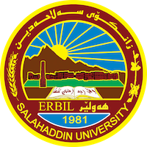
Academic Curriculum Vitae
Personal Information:
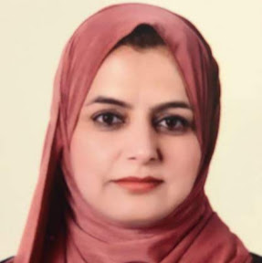
Full Name: Shadan Sabah Ahmed
Academic Title: Assistant Lecturer
Email: shadan.ahmed@su.edu.krd
Mobile: +9647504912254

Education:
BScs: Salahaddin Unv./ College of Administration & economics/ Business Administraion Department
(1997 –2000)
M.A.: Got a Master degree in Business Strategy . Salahaddin University/ Erbil. College of Administration & economics/ Business Administraion Department
(2013 –2016)
General Specialization : Business Administration
Specific Specialization: Business Strategy
Master Thesis Title:
The role of interpreniership performance in achieving the quality of higher education

Employment:
- Employed as a researcher in Salahaddin University/ Erbil. College of Administration & economics/ Business Administraion Department
(2001 - 2013)

- Currently :A.Lecturer in Salahaddin University/ Erbil. College of Administration & economics/ Business Administraion Department
(Nov. 2019 – Present)

Qualifications
- Method Teaching Qualifications
- English Language Efficiency Qualifications (SUE Language Center 2018/2019).

Teaching experience:
- Teaching the subject of Product & Operation Management 2019-2020-2021
- Teaching the subject of Management of risk & insurence
- Teaching the subject of Operation Researchs 2022 -2023
- Teaching the subject of Human Resource Management 2022-2023
- Teaching the subject Quantity Methods
- Teaching the subject of Environmental Management 2021/2022 – 2022/2023.

Research and publications links:
- The Role Of The Ieading Performance Of The College Councils In The Quality Of Higher Education Analytical Study Of The Views Of a Sample Of Faculty Members In The Universities Of The City Of Erbil - Kurdistan Region – Iraq , Prof. Dr. Khaled Hamad Amin Mirkhan, Shadan Sabah Ahmed‎ Iraqi Journal Of Adminstrative Sciences 2 (4), 51-51 ,2018
https://journals.iqsbms.org/index.php/ijas/article/view/126

- Spiritual leadership and its role in reducing bullying behavior in the workplace
https://www.iasj.net/iasj/article/251046

Professional memberships
- Member of Educational Committee 2021/2022
- Member of Examination committee at the College of Administration and Economics, 2020/2021 – 2021/2022.
- Member of Events committee 2022/2023
- Member of Scientific Research Discussion Committee for Fourth Stage Students 2020 - 2023

Professional Social Network Accounts:
- ReserchGate: https://www.researchgate.net/profile/Shadan-Ahmed-3
- Google Scholar: https://scholar.google.com/citations?user=xYxCU7kAAAAJ&hl=en
- Linkedin: https://www.linkedin.com/in/shadan-ahmed-771612267/
- ORCid: https://orcid.org/0009-0002-3869-0732

