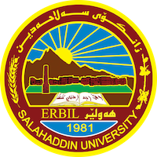
Academic Curriculum Vitae
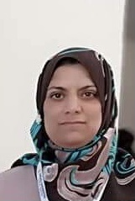
Personal Information:
Full Name: Shahla Burhan Abdulla
Academic Title: Assistant professor
Email: shahla.abdulla@su.edu.krd
Mobile: 07504703665

Education:
(2008-2007) Musle University/Erbil ,Iraq ,Phd In Islamic History.
(1998-1999) Musle University/Erbil ,Iraq ,MA In In Islamic History).
(1996-1995) Musle University , BA in history

Teaching experience:
I have taught many different subjects at Salahaddin University-College of Arts including;
History of the era of prophecy, Andalusian history,Historical notation, Umayyad and Abbasid history…….

Research and publications:
- History of the Bimarstanat under the Ayyubid state in Egypt
569-648 / 1173 AD -1252 AD, زانکۆى هەڵەبجە, 2019-04-25.
https://jhcs.tu.edu.iq/index.php/sala/article/view/302/258
- Contributions of women to building ribbons in the cities of Baghdad and Makkah In the late Abbasid era, مجلة ادب الرفدین, 2021-03-18
https://radab.mosuljournals.com/article_167774_76d149f63af0776761bd899a788d19d3.pdf

- مێژووی سیاسی شاری حەران لە سەردەمی دەوڵەتی راشدی و دەوڵەتی ئومەوی لە ساڵی 18ک تا 132ک/633ز تا 747ز، گۆفارى زانکۆى گەرمیان ،

https://jgu.garmian.edu.krd/article_91508_642206ac2b7cb44ce6bf0ec7b62d2831.pdf
- ژیانى سیاسى و کارگێرى نەصرانیەکانى شارە کوردیەکانى رۆژهەلاتى روبارى فورات

زانکۆى سۆران

https://docs.google.com/a/soran.edu.iq/viewer?a=v&pid=sites&srcid=c29yYW4uZWR1LmlxfHR3ZWplcnxneDoxNzBjMGYxODY0M2YxMWQ2

Conferences and courses attended

* پرسى ئینتیما و گرفتەکانى نیشتیمانسازى لەهەرێمى کوردستان
* دەولەت و مێرگەهین کوردى ل سەردەمێن ناڤەراست و نوو
* سەلاحەدینى ئەیوبى سەرکردەیەک بۆ هەموو سەرکردەکان

Funding and academic awards
- No

Professional memberships
- I don’t have them.

Professional Social Network Accounts:

https://scholar.google.com/citations?view_op=new_articles&hl=ar&imq=shahla+burhan+abdulla#

https://myaccount.google.com/?hl=ar

