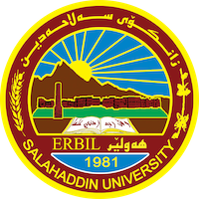
Academic Curriculum Vitae

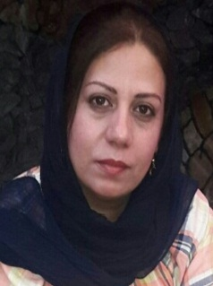
Personal Information:
Full Name: Shahla Al i Ahmed
Academic Title: Assistant Lecturer
Email: (shahla.ahmed@su.edu.krd)
Mobile: +96407504659177

Education:
- Diploma in Legal Administration –Erbil Technical Institute.
- B.A degree in Law, 2010, College of Law and Political Sciences/ University of Salahaddin – Erbil
- M.A degree in (Public Law), 2016/ College of Law and Political Sciences/ University of Salahaddin – Erbil.
- PhD student in Public Law from 2020 -current.
Employment:
I worked as a teacher for ten years in the ministry of Education.
I worked as an Assistant Lecturer in the College of Law Department of Law in 2016 – current
Qualifications
- Use of emails
- and office (word & excel)
- ICDL Certification

- I attended a course, IELTS to learn the English language, the languages I master

Languages Comprehensive Speaking Writing
Kurdish | Native | Native | Native
English | Good | Good | Good
Arabic | Native | Native | Native

Teaching experience:
- An introduction to the study of law /The first stage students / 2018-2017
- Public finance / The third stage students / 2019- 2018
- Labor law/ / The third stage students /2020- 2019
- Labor law/ / The third stage students/ 2021- 2020
- Public finance /The third stage students / 2022- 2021
- Public finance /The third stage students/ 2023-2022

Research and publications
- State all research, and publications you made.

Conferences and courses attended
- Fifth International Conference on Legal Issues Tishk International University - Erbil - College of Law -Iraq Submitting research.
- Sixth International Conference on Legal Issues Tishk International University - Erbil - College of Law Iraq Submitting research.
- African children and absent childhood Faculty of Arts, University of Kirkuk Iraq Participant as a guest 2022-06-25
- Criminal Justice Between Forensic Investigations and Psychological Expertise Kirkuk University Iraq Participant as a guest 2022-07-16
- Penal, correctional and reintegration institutions for female prisoners Kirkuk University Iraq Participant as a guest 2022-09-14
- Oncology interventions in the Arab world towards improving the quality of life for cancer patients and their families College of Arts, University of Kirkuk Iraq Participant as a guest 2022-10-30.
- Cancer in Arab laws and legislation and the legal formative role in a healthy life College of Arts, the University of Kirkuk International Participant in a course 2022-10-08 → 2022-10-08
- Electronic currencies and money laundering crimes Faculty of Arts, the University of Kirkuk International Participant in a course 2022-07-30 → 2202-07-30
- Women and drugs in the Arab world Tikrit University International Participant in a course 2022-11-17 → 2022-11-17
- Administrative and civil liability in the medical field, doctors' errors as a model Faculty of Arts, the University of Kirkuk International Participant in a course 2022-08-30 → 2202-08-30
- The list of references and sources are packaged in Arabic according to the APA system dispatch platform International Participant in a course 2022-07-23 → 2022-07-23
- How to choose your major smartly Training center for building leaders International Participant in a course 2022-07-03 → 2022-10-31

Professional memberships
- Certified Member of the BRC Scientific Foundation.
- Kurdistan Jurists Union.
Professional Social Network Accounts:

- https://www.researchgate.net/profile/Shahla-Ahmed
- https://scholar.google.com/citations?view_op=list_works&hl=en&user=cosCp3MAAAAJ:
- https://www.facebook.com/aashahla.

