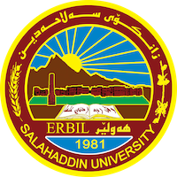
Academic Curriculum Vitae

Personal Information: 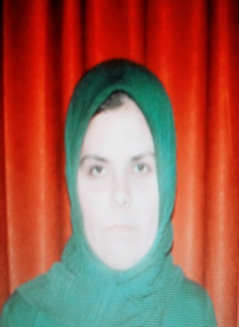
Full Name: Shahla Kareem Hussain
Academic Title:Assistant lectuer
Email: (shahla.husyin@su.edu.krd)
Mobile:07504917341

Education:
- B.A. in Kurdish Language from Slahaddin University- Erbil 2004-2007.
- M.A. in Kurdish literature from Slahaddin University- Erbil 2013-2015.

Employment:
- Assistant Research at Slahaddin University- Erbil Collage of Languages from-1/12/2007.- 1/9/2015.
- Assistant Lecturer at Slahaddin University- Erbil Collage of Languages from 1/9/2015-Current

Qualifications
- بڕوانامه‌ی ماسته‌رم له‌ (17-5-2015) لة زانكؤى سة لاحةددين وه‌رگرتووه‌.
- نازناوی زانستیم له‌ ڕێكه‌وتی (1-9-2015) وه‌رگرتووه‌.
- بروانامةى خولى ريكاكانى وانةوتنةوةم لة سالى(2015) وه‌رگرتووه‌.
- بڕوانامه‌ی خولی توانستی كۆمپیوته‌رم له‌سالى (2009)وه‌رگرتووه‌.
- بڕوانامه‌ی خولی توانستی ئينكليزيشم له‌سالى (2009)وه‌رگرتووه‌.
- بڕوانامه‌ی خولی وانةى كارامةي ئةكاديمى له‌سالى (2016)وه‌رگرتووه‌.

Teaching experienc -Method of Kurdish Literature.
- Kurdish Folklore Literature.
- Kurdish Genaral Literature.
-Theory of Kurdish Literature.
-Old Kurdish Literature.
-New Kurdish Literature.
-Kurdology.
e:

Research and publications
- State all researches, publication you made.

Conferences and courses attended
- كؤنفرانسى باشترين ثرؤذةى دةرضوونى قؤناغى ضوار لةكؤليَذى زمان لة 25/4/2022 .
به‌شداری سێیه‌مین كۆنفرانسی زانستی هاوبه‌شی نێوده‌وڵه‌تی زمان و ئه‌ده‌بی فارسی و كوردی نێوان زانكۆی سه‌لاحه‌دین و زانكۆی ڕاپه‌ڕین و زانكۆی كوردستانم كردووه‌.

Funding and academic awards
- List any bursaries, scholarships, travel grants or other sources of funding that you were awarded for research projects or to attend meetings or conferences.

Professional memberships
- List any membership you hold of any professional body or learned society relevant to your research or other life activities.

Professional Social Network Accounts:

- List your profile links of ReserchGate, LinkedIn, etc.

It is also recommended to create an academic cover letter for your CV, for further information about the cover letter, please visit below link:
https://career-advice.jobs.ac.uk/cv-and-cover-letter-advice/academic-cover-letter/
Languages:
Kurdish, English, Arabic،Farse.

