Lab: 6
Bacteriological Examination of Cerebrospinal Fluid
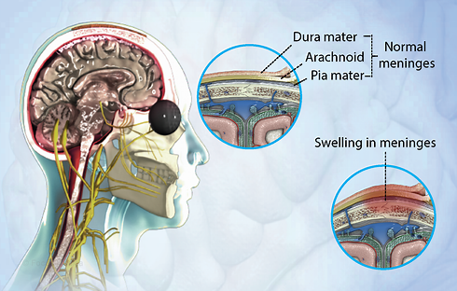
- Cerebrospinal fluid (CSF) examination is an essential step in the diagnosing of bacterial and fungal meningitis and CSF must always be considered a priority specimen that requires prompt attention by the laboratory staff.

- Meningitis is an infection of the meninges; the protective tissue of the brain that causes a stiff neck, headache and fever.
Normal CSF composition:
Normal CSF is sterile and clear and usually contains three leukocytes or fewer per mm³ and no erythrocytes. The chemical and cytological composition of CSF is modified by meningitis or encephalitis. The CSF leukocyte count is of paramount importance.

Collection and transportation of specimens
- In view of the danger of iatrogenic bacterial meningitis, thorough disinfection of the skin is mandatory.
- Approximately 5–10 ml of CSF should be collected in two sterile tubes by lumbar or ventricular puncture performed by a physician.
- The specimen should be delivered to the laboratory at once, and processed immediately since cells disintegrate rapidly.
- Part of the CSF specimen will be used for cytological and chemical examination, and the remainder for the microbiological examination.

Common causes of bacterial and fungal meningitis:
In neonates (from birth to 2 months):
Escherichia coli, Streptococcus agalactiae (group B), Listeria monocytogenes, Salmonella spp. and Citrobacter spp.

In all other age groups:
Haemophilus influenzae (capsular type b), Neisseria meningitidis, Streptococcus pneumonia, Mycobacterium tuberculosis, Listeria monocytogenes, Staphylococci and Cryptococcus neoformans.

Macroscopic inspection:
The appearance of the CSF should be noted and recorded as: clear, hazy, turbid, purulent, yellow (due to haemolysis or icterus), or blood-tinged, with fibrin web or pellicle.

Microscopic examination:
Preparation of specimen:
If the CSF is purulent (very cloudy), it can be examined immediately without centrifugation. In all other cases, the CSF should be centrifuged in a sterile tube (preferably a 15-ml conical tube with a screw cap) at 10000 g for 5–10 minutes. Remove the supernatant using a sterile Pasteur pipette fitted with a rubber bulb, and transfer it to another tube for chemical and/or serological tests. Use the sediment for further microbiological tests.

Direct microscopy:
Examine one drop of the sediment microscopically (40X), between a slide and coverslip, for: leukocytes (polymorphonuclear neutrophils or lymphocytes), erythrocytes, bacteria and yeasts.
- If the yeast-like fungus Cryptococcus neoformans is suspected, mix a loopful of the sediment with a loopful of India ink on a slide, place a coverslip on top, and examine microscopically for the typical, encapsulated, spherical, budding yeast forms.
- In areas where African trypanosomiasis occurs, it will also be necessary to search carefully for actively motile, flagellated trypanosomes.
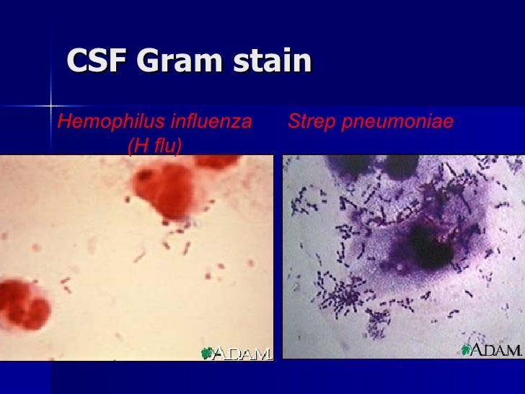
- A rare and generally fatal type of meningitis is caused by free-living amoebae found in water (Naegleria fowleri) which enter through the nose and penetrate the central nervous system. They may be seen in the direct wet preparation as active motile amoebae about the size of neutrophilic leukocytes.
Gram-stained smears:
As the causative agent of bacterial meningitis may often be observed in a Gram-stained smear, this examination is extremely important.
Acid-fast stain (Ziehl–Neelsen):
Examination of an acid-fast-stained preparation of the sediment or of the fibrin web is indicated when tuberculous meningitis is suspected by the physician.
Culture:
If bacteria have been seen in the Gram-stained smear, the appropriate culture media should be inoculated. If no organisms have been seen, or if the interpretation of the Gram smear is unclear, it is desirable to inoculate a full range of media, including blood agar with a streak of Staphylococcus aureus to promote growth of H. influenzae. Blood agar and chocolate agar plates should be incubated at 35 ˚C in an atmosphere enriched with carbon dioxide. All media should be incubated for 3 days, with daily inspections.
When tuberculous meningitis is suspected, at least three tubes of Löwenstein– Jensen medium should be inoculated with a drop of the sediment and incubated for 6 weeks. Smears from any suspicious growth should be prepared, preferably in a bacteriological safety cabinet, and stained by the Ziehl–Neelsen method.
Table: Cerebrospinal fluid findings associated with meningitis:
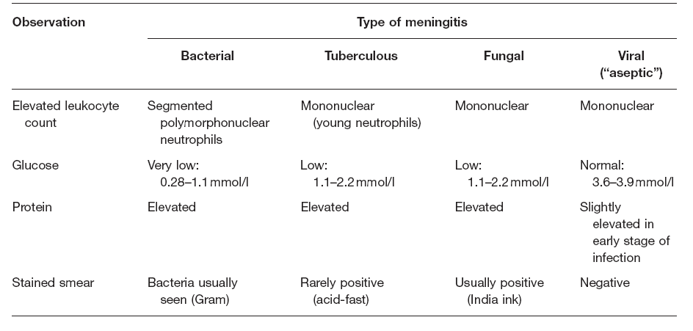
Susceptibility testing:
- Antimicrobial susceptibility test was performed for each of the isolates by Kirby-Bauer Disc Diffusion Method.
- Mueller-Hinton (MHA) agar was used for antimicrobial susceptibility testing for most bacteria while (MHA) with 5% sheep blood for S. pneumoniae and all strains of pneumococci should be tested for susceptibility to chloramphenicol, benzylpenicillin and oxacillin.
- Strains of H. influenzae and N. meningitides should be tested for susceptibility to chloramphenicol or other new generation of cephalosporines using chocolate agar or a supplemented blood agar.
- The agar plates were incubated at 35°C for 18 h, and antimicrobial susceptibility pattern was interpreted as per the Clinical and Laboratory Standards Institute guidelines.

