Lab 12 : Non- spore forming Gram-positive bacilli

Genus: Corynebacterium sp

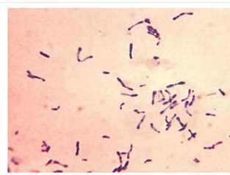
- Corynebacteria /coryneform bacteria means "club-shaped", a group of rod-shaped, non-spore former gram-positive and most are aerobic.
- Occur commonly in nature in the soil, water, plants, and food products.
- The commensal (diphtheroid) Corynebacterium species can even be found in the mucosa and normal skin flora of humans and animals.
- C. diphtheriae is the major pathogenic species which acquires the capacity to produce diphtheria toxin only after interacting with a bacteriophage.
- Other pathogenic species in humans include:, C. striatum, C. urealyticum, and C. xerosis; all of these are important as pathogens in immunosuppressed patients.

Clinical features of C. diphtheriae
- Diphtheria: Infects the nasopharynx. Toxigenic strains secrete a potent exotoxin which may cause diphtheria. The symptoms of diphtheria include pharyngitis, fever, swelling of the neck or area surrounding the skin lesion. Diphtheritic lesions are covered by a pseudomembrane. The toxin is distributed to distant organs by the circulatory system and may cause paralysis and congestive heart failure.
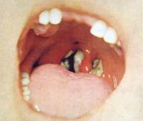
- Cutaneous diphtheria: Skin infection.
Diagnostic Laboratory Tests:
Specimens: Throat swab and nasopharyngeal specimens are recommended for respiratory illness. For cutaneous diphtheria, collect skin/wound, throat, and nasopharyngeal specimen must be obtained before antimicrobial drugs are administered. Swabs should be collected from beneath any visible membrane.

Smear: C. diphteriae are gram positive bacilli, non spore forming, arranged in Chinese letters form often club shaped, appears beaded due to the presence of intercellular “Metachromatic " granules.
Nonpathogenic species are often called diphtheroids because their microscopic morphology resembles that of C. diphtheriae.
Gram stain

Cultures: (Incubate all at 37 °C)
- Blood agar plate: Colonies on blood agar are small, granular and gray and may have small zone of haemolysis.
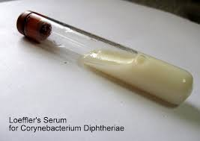
- Loeffler slant: In 12–18 hours, the Loeffler slant may yield organisms of typical "diphtheria-like" morphology. Many of the normal throat flora organisms do not grow on Loeffler’s medium, so it is somewhat selective.
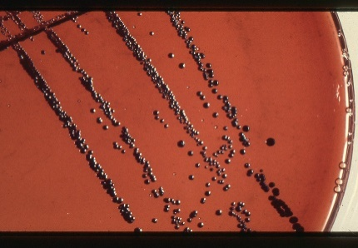
- Tellurite agar plate: In 36–48 hours, the colonies on tellurite medium are sufficiently definite for recognition of C diphtheriae. The tellurite not only suppresses many other throat flora, but it is metabolized by C. diphtheria with resulting blackening of its colonial growth.

Biochemical differentiation:
- Catalase +ve , Oxidase –ve
- Carbohydrate fermentations: glucose and maltose +ve
- A presumptive C diphtheriae isolate should be subjected to testing for toxigenicity.

There are several tests for toxogenicity:
- In vitro
- Elek immunodiffusion test
This test is based on the double diffusion of diphtheria toxin and antitoxin in an agar medium. A sterile, antitoxin-saturated filter paper strip is embedded in the culture medium, and C diphtheriae isolates are streak-inoculated at a 90° angle to the filter paper.

The positive result is production of diphtheria band in the agar which is an antigen (toxin) –antibody (antitoxin) precipitation intersection.

(2) Polymerase chain reaction-based methods have been described for detection of the diphtheria toxin gene (tox).

(3) Enzyme-linked immunosorbent assays can be used to detect diphtheria toxin from clinical C diphtheriae isolates.

- In vivo
Historically, toxigenicity of a C diphtheriae isolate has been demonstrated by injecting two guinea pigs with the emulsified isolate. If the guinea pig protected with diphtheria antitoxin survives while the unprotected one dies, the isolate is considered to be toxigenic.

- Treatment: A single dose of intramuscular penicillin or a 7- to 10-day course of oral erythromycin. The only effective control of diphtheria is through immunization with a multidose diphtheria toxoid.

