Backcut: -
When the undercut has been completed, the tree is severed by back cutting on the opposite side; the back cut is made slightly above the hinge point of the undercut, by driving one or more wedges in the backcut, a tree can be forced in part in the direction desired. The height of back cut 5-10 cm above horizontal line of the undercut depending on the size of tree.

The depth of undercut
The depth of the undercut should vary with the size of the tree and whether it is to be felled in the direction of its lean.
**In an erect, even crowned, sound tree the bottom of the undercut is sawed in horizontally for a distance of one-fourth to one-third of the diameter of the tree
**When the tree is leaning in the direction of fall, the undercut should be deeper.
**When the undercut is leaning opposite to the direction of fall, the undercut should be shallower.
The base of a tree being felled opposite the direction of lean is in tension on the undercut side and in compression on the backcut side; hence wedging is necessary to prevent saw bind and to force the tree to fall in the desired direction, a deep undercut would free the side in tension enough to permit the tree to split and fall in the opposite direction from that desired before it had been sufficiently backcut.
After the undercut has been sawed the correct distance, it is chopped or sawed out, when chopped, the angle should be only sufficient for good axe work, or about 45°.
Types of undercut
A- Conventional undercut: can be made with a parallel saw cut and a diagonal axe cut, or both cuts can be made with the saw. This undercut is generally used on medium diameter tree
B- Humboldt undercut: Humboldt cutting made in the precious trees with large diameters to keep an important and valuable part of the wood. The diagonal cutting is to be in the stump, that is to say the part that is removed from the trunk for stump is from the bottom of the horizontal cutting line, so we would get a flat end of a base trunk instead of diagonal cutting end. This method sometimes provides 3-7% of the volume of the piece of the trunk bottom, which are often the most valuable part.
C- Straight undercut: This type made by making two parallel cut by a saw and they should be far from each other in a distance ranging between 10-15 cm and then still remaining wood between the two pieces will be removed by using a special equipment called (Pulaski) Axe-adz and this style is used usually to bring down trees with a diameter some more than 75cm.
D- Step undercut: three parallel cuts with the saw, leaving a step. The cutting procedure is the same in principle as in straight undercut. This under cut is used on trees of very large diameters.
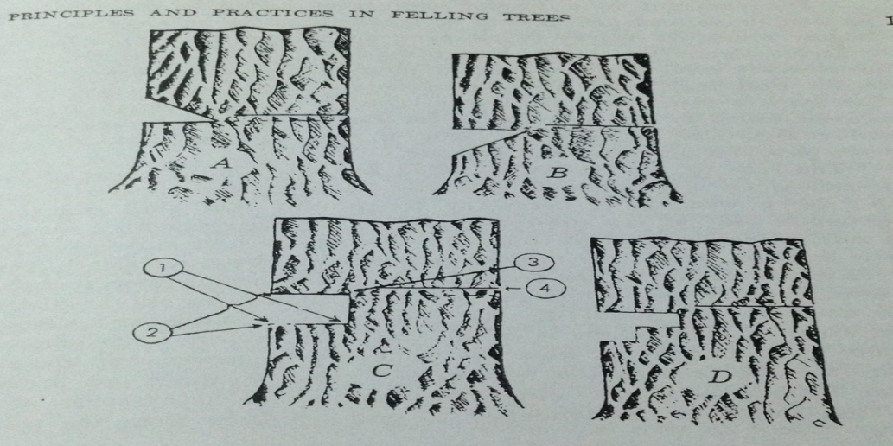
Match-sawing
Some trees can also be felled satisfactorily without undercutting by a method called match sawing which means that the bole is severed from the stump by two saw cuts meeting near one side in the same plane. The tree must be forced to fall by wedging if it does not lean, however, if it leans or if the crown pulls it in one direction, match sawed trees will nearly always fall in that direction.
Disadvantage of match-sawing
1- Lacking control over the direction in which the tree will fall this add materially to the danger in felling by match-sawing.
2- Since there is no hinge (holding) between the undercut and back cut the tree nearly always slips back over the stump in falling.
3- If the crown is uneven the tree will rotate since there is no "hinge" to control it.
Felling small trees
In felling small trees, the undercut can be chopped in and made shallower than for large trees, as the tree can be pushed in the chosen direction
Tree Stump
After a tree has been cut and felled, the stump or tree stump is usually a small remaining portion of the trunk with the roots still in the ground. Stumps may show the age-defining rings of a tree. The study of these rings is known as dendrochronology.
Stumps are sometimes able to regenerate into new trees. Often, a deciduous tree that has been cut will re-sprout in multiple places around the edge of the stump or from the roots.
The process of deliberately cutting a tree to a stump to regrow is known as coppicing.
Stump height
The best stump height in sound trees is the natural stump height or just below the top of the butt swell, this varies from species to species and from tree to tree of the same species, usually varying with tree diameter in the latter case.
Limbing (Delimbing):.
Limbing is the removal of unwanted branches from the trees.

Limbs must generally be removed from the portion of a tree to be used, regardless of the product. This is a comparatively simple operation, done with either an axe or the one-man chain saw used in felling or bucking.
Limbing may be done before trees are bucked into logs, or it may be done as bucking progresses from the butt of a tree toward the top.
It is generally preferable to complete limbing before bucking has proceeded so far that log length cannot be adjusted to fit the top limit of merchantability.
In some case it is preferable to leave uncut some of the limbs on the underside of a tree until bucking has been completed to hold the bole off the ground for easier bucking and to reduce saw bind and prevent splitting

