ORGANIZATION OF CUTTING CREW
Crew organization varies greatly with: -
- The size of the operation.
- Products type.
- The nature of preferences for workers in harvesting operation.
On small operations, for example, there may be only one or two falling crews; while on operations supplying large wood there may be as many 25 to 50 falling crews.
Every 5 to 6 crews need to one supervisor to manage the operation.
The numbers of men supervised by a foreman or assistant foreman depend on
- Local conditions.
- Labor stability.
- Seasonality.
- The value of the timber. (Veneer operations, because of the high value of the product, require more supervision than pulpwood operations).

Designation Of Falling Area
Each falling crew should be assigned to a strip or block for the following reasons: -
1-To avoid confusion on the operation,
2- To provide for orderly falling and bucking condition
3-To facilitate supervision.
- To assures that all designated trees will be cut.
otherwise if the falling area did not organize to strip or blocks especially on piecework jobs, some crew would cover a large area and pick only the large and easy to fell trees and leave scattered trees uncut; thus their daily production and hence their wages would be greater.
Falling and bucking must be carefully planned. They must proceed in regular order if the operation is to be economical. Thus, when trees bucked to log lengths as soon as felled are promptly skidded, falling should proceed from the farthest point toward the area closest to the log yard or landing. Otherwise,
- Teams, tractors, or other skidding or long moving machines would constantly be hampered by the severed tops of felled trees.
2-Also there is much less danger to men, animals, and equipment from falling trees when the cutting is begun at the back of the strip and progresses toward the landing.
Choosing the direction of fall
In deciding upon the direction of fall for a tree to be bucked for logs or for other timber products, the following considerations are important: -
1-Breakage
How the trees are breakage?
- When trees are not fall on empty ground it may be hang up of adjacent trees or strike irregular surfaces such as stumps, logs, rocks or abrupt changes in topography, because of their heavy, weighing several tons when of sawlog size and the force with which they strike the ground is sufficient to break even large trees.
- The speed of a falling tree is much greater in the upper portion than at the lower end because of the much greater distance the top must travel to get to the ground in the same length of time as the butt. This greater force in the top, combined with the smaller diameter and the weakness frequently caused in tops by limbs and knots, results in more breakage in upper sections of trees than in their butts.
- Trees with heart rot or other decay are particularly susceptible to falling breakage.
4- When the tree strikes level ground, the butt will be usually far 1- 3 ft. (feet) from the stump. These changing forces affect the possibility of breakage or injury to workers.
Some cases of falling
1-The ideal condition is practically level, spongy ground.
2- Dropping trees squarely on rock or stumps unless they are relatively close to the stump of the falling tree will burst the trunk at the rock or stump even when no bending stresses are present
3- Dropping a tree across a ridge or log about 60 ft. or more from the stump so that the butt is not supported will break the tree at the ridge or log
4- Dropping a tree across a ridge or log 30 to 40 ft. from the stump will not ordinarily break the tree at the ridge or log
5- Dropping the tree across a hollow and over a ridge 100 or more feet from the stump ordinarily will break the tree both at the ridge and over the hollow
6- Trees may be dropped across two ridges without breaking at the first ridge (30 or 40 feet from the stump) or over the hollow between the ridges but trees will break at the second ridge (as much as 100 ft. from the stump)
7- Hanging the tree on the stump or on a large log near the stump will produce the equivalent of a hollow on other wise level ground and may be sufficient to break the bole below the center of its length.
8- When the middle of a falling tree strikes a leaning tree or snags near the ground the falling tree is likely to be broken at the leaning snag or tree.
9- A falling tree that strikes a leaning tree or snag materially closer to the stump than one half the height of the falling tree (60 or 80 ft.) will ordinarily have the butt thrown to one side without breakage.
10- Trees that are thrown uphill are at times hung up on the stump or spur roots and are broken in the bole because of bending or because the butt split upon a spur root
11- On moderately uniform slopes throwing trees at an angle of about 45º instead of directly uphill appears to give the best results.
12- Throwing trees directly downhill breaks the tops badly but does not seem to break the boles any worse than throwing the trees directly uphill.
.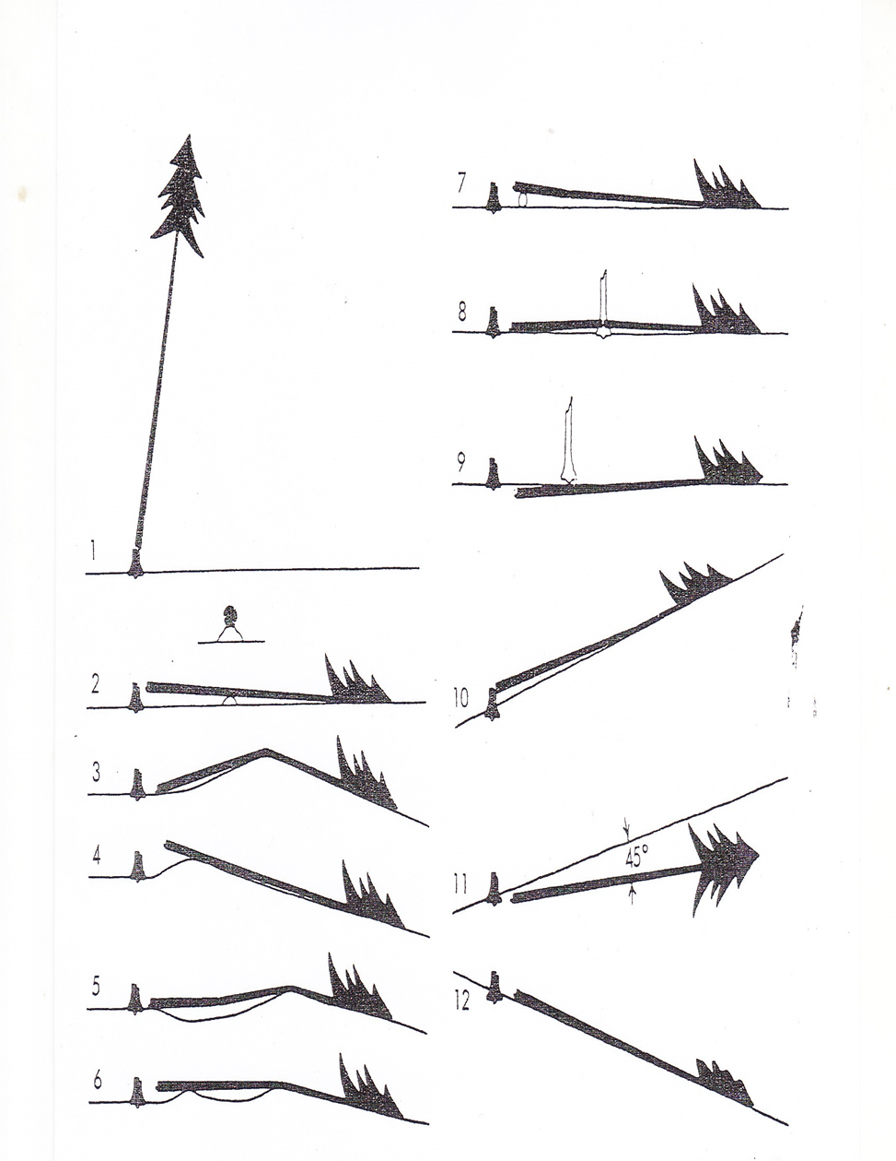
Fig. (1): some cases of fallin

