Bucking to the highest value
Previously, the stem of trees was being invested to the first fork, and leave the rest of the woods inside the forest. The reason for this goes back to the following point:-
1 - Lack of markets that accept the tree branching contain large knot.
2 - Feeling at that time because the hugeness of the amount of wood and the size there is no reason to waste time and effort harvest in this part of the wood 's poor quality and low value.
3 - Primitive of harvesting tools at the time like handsaws and axes, and the use of animals skidding.

Nevertheless, today is not excessive in any part of the tree might have value because of: -
1 - The evolution of the instrument of harvesting operation to a large degree.
2 - The progress made ​​in the timber processing techniques.
3 -A growing shortage of wood supply and high prices on the other hand.
The bucking processes vary from investment to another and from product to another product to get the highest value. Also differ as to whether the investor does meet the demands factory specializes to produce one produce, or one that works on the integrated investment for a factory that produces lumber, veneer and pulp wood, and the sale and export of logs sometimes. That this method any method of integrated investment achieves higher profits to the diversity of product.

- Depend on the diameter to achieve the highest value
logs metering systems include instructions determine grade of log, number and size of the knot, curvatures, cracks, etc., and determine the minimum diameter for each class, so the bucker must concern with the minimum diameter section for the highest value of the log.
For example: - if you cut the plywood log (No.2) diameter of 29 in. Instead of 30 in., it turns it to plywood class (No. 3) and then its value will be reduced by 25-30 dollars per thousand board feet.
Table (2) show an explanation of how to control the diameter of the log through the bucking process and its impact on the realizable value of the tree (Figure 1) In the first method, the bucking done to three logs without taking the diameter into consideration the result was three logs of class SM, 3P, 3P and total volume of 3350 board foot with final value of $ 483 dollars
while in the second method the bucker has made some effort and extra time to buck off the tree to four log concentrating on the diameter required for each class. It was obtained from this increase of the value $ 103 dollars in which the value has risen from 144.17 dollars to 166.44 dollars per thousand board feet.
Table (2) how to control the diameter of the log and its impact on the total value of the tree
First method
Value($) | class | Size (board ft.) | Length(ft.) | Diameter(in.) | Log
228 | 3P | 1520 | 40 | 29 | 1
173 | 3P | 1150 | 40 | 25 | 2
82 | SM | 680 | 36 | 21 | 3
 |  |  |  |  | 4
483 |  | 3350

Second method
Value ($) | class | Size (board ft.) | Length (ft.) | Diameter(in.) | Log
288 | 1P | 1440 | 35 | 30 | 1
164 | 3P | 1090 | 35 | 26 | 2
75 | 3P | 500 | 20 | 24 | 3
59 | SM | 490 | 26 | 21 | 4
586 |  | 3520

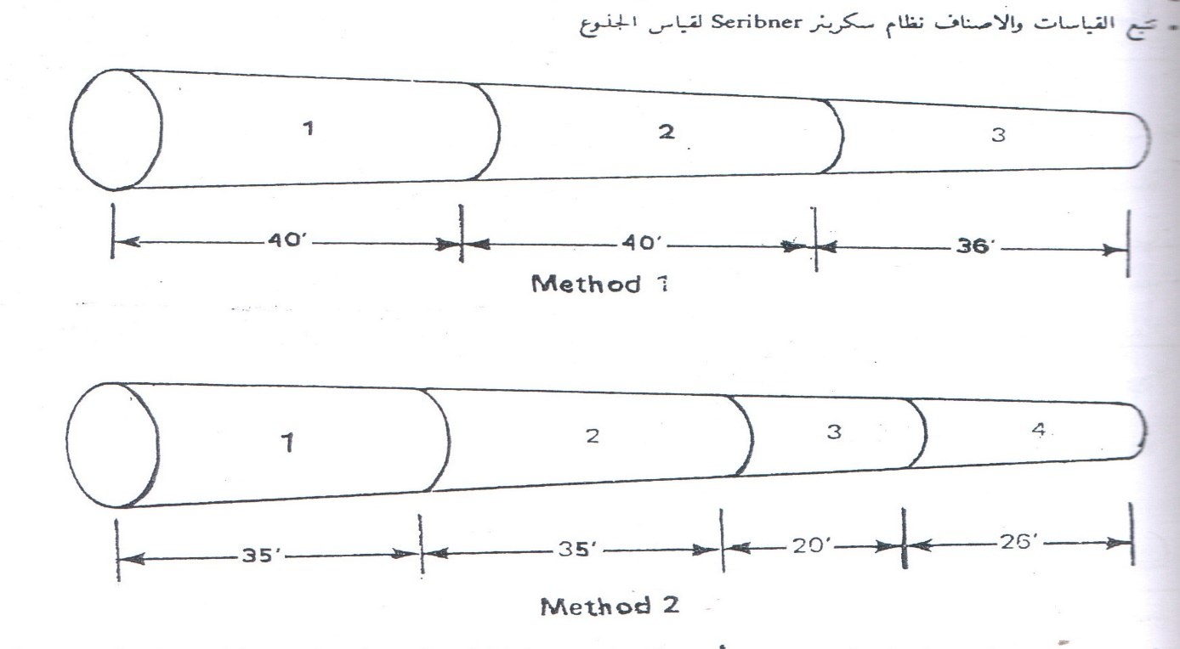

B- Grade depend to achieve the highest value
Bucking may be depending on the diameter; however, you get a loss in value due to lack of bucker awareness to the requirements and grade specification for the various logs. The first log which its length is 40 foot and its minimum diameter is 18 in. is a grade 2S if it contains more than two knot from which a diameter of more than 1.5in., as it’s shown in (Table 3). But this log if it was shortened to a length 32 foot becomes encompassing the two knot only (Figure 3) will raise its Rate to grade better named special mill grade SM even though he is shorter in length, this product produces more than 65% of the good commercial lumber and its price increases by approximately 15% for the price of product no. 2 (Sawmill grade)2S.
Table (3) show how to control the class log and its impact on value
First method
Value ($) | Class | Size (board ft.) | Length (ft.) | Diameter(in.) | Log
56 | 2S | 530 | 40 | 18 | 1
22 | 3S | 260 | 36 | 14 | 2
8 | 3S | 100 | 34 | 9 | 3
88 |  | 890

Second method
Value ($) | class | Size (board ft.) | Length (ft.) | Diameter(in.) | Log
58 | SM | 480 | 32 | 19 | 1
30 | 2S | 290 | 40 | 14 | 2
89 | 3S | 110 | 38 | 9 | 3
97 |  | 890

