Bucking techniques
The first consideration in safe log bucking is to determine the direction log segments will move after the cut is completed.
- When bucking the tree, hold the saw (bucking tools) firmly in both hands, and stand to one side as the cut is started, and care should be taken to avoid cutting all the way through the log and hitting rocks or soil that will damage the chain.

There are five positions should be recognized at preparing trees for bucking which are:-
- 1- Top bind
- 2- Bottom bind
- 3- Side bind
- 4- Drop
- 5- End pressure

- Top bind
This case happen when the tree is hung up on the edges of trough (fig. 1- a), due to this situation un effort will generate as a result of the weight of the tree to make the top of the stem in the case of compression and the bottom in the case of tension.
And When we make a bucking from the upper part, and tree in this case: - It tends to continue with cut off to pour out toward the bottom due to its weight and this increases the pressure on the upper part of the wood makes saw bind.
However, when we make a cut from the bottom this leads to a break irregularly or fission in the wood before the completion of the process of cutting and if this happened in the middle of the log, it causes a significant loss in wood and we called this kind of wrong breakage bucker's break.

Steps for correct bucking in case of top bind:
1-Saw should be placed first at point A and works downward arc cut to point C in order to cut the part (1).
2- Then pull the saw to point B to cut part (2)
3- Then cut a peripheral arc downwards which represents the part (3) in (Fig1-b).
4- Then the saw stick into at the point D in the stem and his movement toward the bottom part (4) is cut.
5- When the cut been completion the saw will back to the line E-D to complete cutting direction toward the top till break the remaining simple part of the wood.
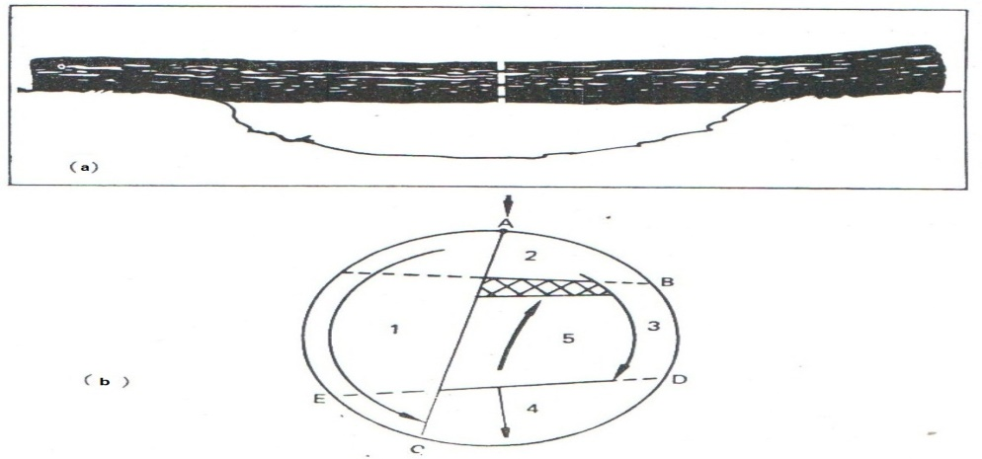
(Fig.1)
2- Bottom bind
This kind of the bind occur when the fall tree is resting on the hard body, or when it settles on one end while the other end in relation to the air, this situation makes the upper part of the tree be in tension, and the lower part will be in compression
The correct way for bucking trees in this case:
1- The cut will start from the top part first, the pressure here hanging from the bottom upwards in the cutting area as the arrow is pointing at the bottom of the (figure 2).
2- After we cut part (1) from A toward the bottom B we cut bottom part (2) from C to D.
3- Then we cut a peripheral part in the sap wood depth as shown in the number (3) and to the top of the point E.
4-Then we cut sections (4) and (5) straight cut downward then the notch will open and this will prevent saw bind, except the remain part of a few representative space that shaded form the figure 2-b which then break regularly.
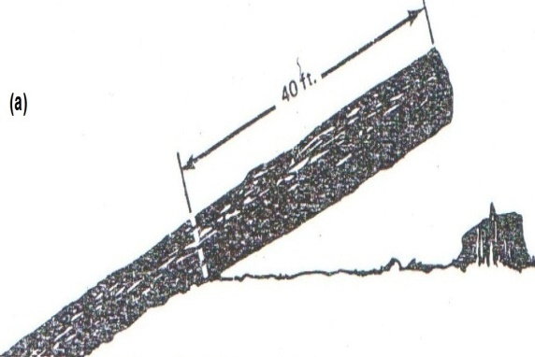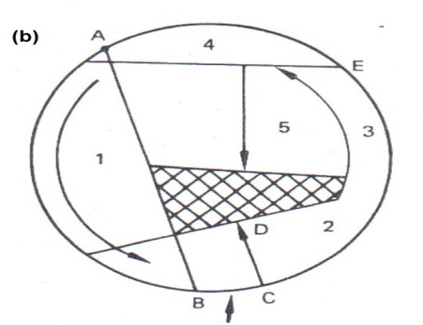
(Fig.2)

3- Side bind
Sometimes the buckers see that the fall tree is based at both ends to a solid object and in the same time affects the third body of the tree somewhere in between the two extremes (Figure 3 - a) in making curved shape.
The side which will get the compression is indicted as curved arrow in shape (3 - b) begins cutting as
1- Put the anterior part of the Saw at point A and drag it to the bottom of the part (1) to be end at point B.
2- then place saw blade on the top of the upper part and make a straight cut toward the downward as the arrow indicates in part (2).
3-The third cut will be done by insert the saw to inside the log at point C Wood cut off part (3) the movement direction of the arrow saw Point D. The last pieces shall be cut off part (4) the movement of arc upward and to the rear area of ​​compression in order to bind Saw, and continues to be broken wood shaded region.
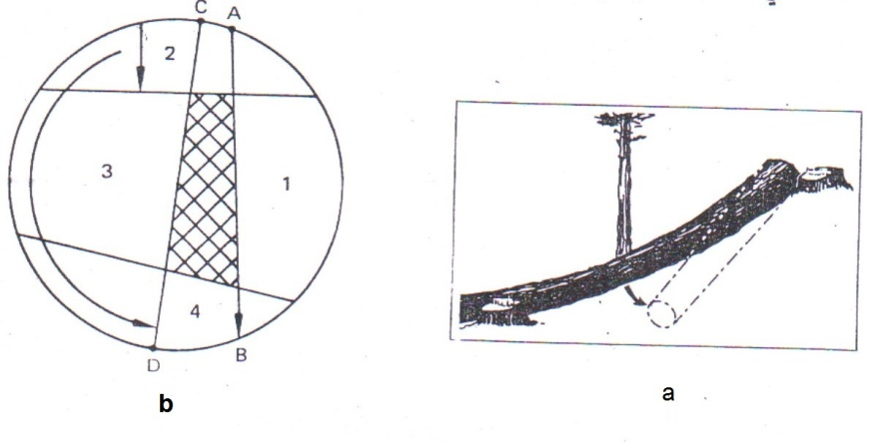
(Fig.3)
4- Drop
This situation result when one of the end parts of the log is cut based on the ground while the other party is not after completion of the process of cutting the based end will remain stable, while the other side will drop toward the swale land.
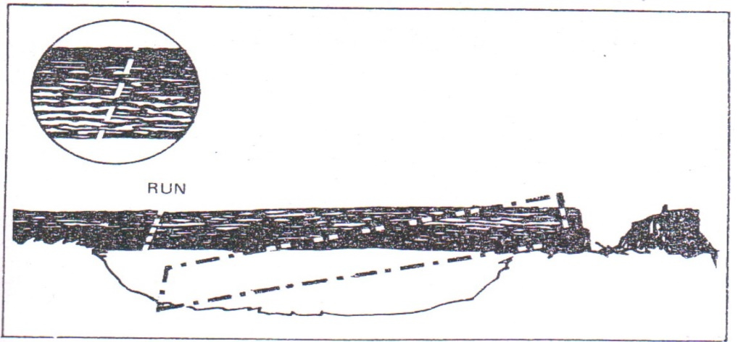
(Fig.4)

5- End pressure
This case happen when the log which is intended to be cut is been falls in to a steep slope then both its end will be directed upward and downward. When cutting the upper log, it will be sliding down and compress on the end of the log that followed. This pressure leads to the saw bind or to be hang if not treated in a timely manner.
This situation is easy treated and does not require the use of more than Wedges.

Log splitting
- Splitting occurs when a log is being bucked from the unsupported end of a felled tree. The weight of the end causes a split into the next log before it has been completely severed.
Splitting can be prevented:-
- 1-by providing a support beneath the hanging end of an unsupported log.
- 2-by bucking at other points along the tree until the unbucked portion of the tree lies without stresses.

Forked trees
- The problem of bucking logs correctly from forked trees occasionally arises in softwoods but is more common in hardwood timber
- In a forked tree the diameter of each fork is always considerably smaller than the diameter of the trunk below the fork.
- Logs with forked ends not only result in lumber loss but are awkward to skid and load and often require more time to handle than they are worth.
PULPWOOD
Trees cut for pulpwood seldom exceed 15-18 inch in diameter and may be as small as 6 or 7 inch.
The advantages of bucking trees for pulpwood comparison with bucking trees for sawlogs:-
1- Bucking trees for pulpwood is much simpler than bucking trees for sawlogs.
2- Also pulpwood is usually cut to a uniform length on each operation, and there is no need to vary bolt lengths to obtain full utilization.
3- Most of the considerations involved in bucking trees for sawlogs to avoid loss do not apply to pulpwood.
The disadvantages of bucking trees for pulpwood Requires a large amount of time as compared with the other parts of the harvesting operation.
- Pulpwood bolts are usually cut short enough for loading and unloading by hand, which is the reason longer than 5 ft. or 5 ft. 3 in., are not cut.
- The correct location of bucking cuts, are not involved in bucking because the bolt lengths from any one tree are the same.
Bolts
- Bolts are, in effect, short logs, usually not over 8 ft. long
- They are cut for such products as veneer, particle board, staves, and hardwood dimension stock.
- Piece Products
- When trees are bucked for piece products such as pols, piles, ties, mine props, and posts, care must be observed to cut correct lengths to prevent damage and loss.

