Method of moving trees
The trees are moving from places of their growth to place for final upload sites, industrialization and consumption with three distinct methods based on machinery used
A- Short wood
B- Tree length
C-Full or whole tree
A- Short wood: -
Is the method which commonly used for the production of pulp wood in the majority of countries producing this type of wood, and length of each log is ranged between 1-2 m. And this Method can be divided into two main parts on the basis of the degree of use of mechanization in the respective processes: -
1- SHORT WOOD METHOD
2- SHORT WOOD SYSTEM
1- short wood method: - In this way trees are felling, delimbing and bucking with hand by using chainsaw, and the bucking logs are grouped as stockpiles by hand also, and then the short logs will moved to forest roadside and arranged in large accumulate in preparation for loading onto trucks and transported out of the forest to the consumer sites. This method requires a high proportion of labor between 70-80% of the total work
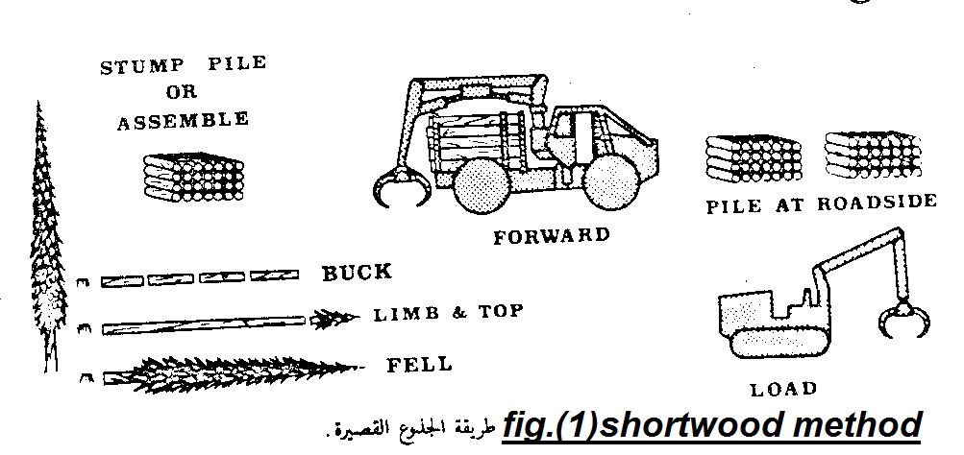
2- short wood system: - In this system all operations concerning tree felling, delimbing, bucking and accumulation will be done mechanically in contrast with the former methods, and reduces the labor ratio up to 15-30%.
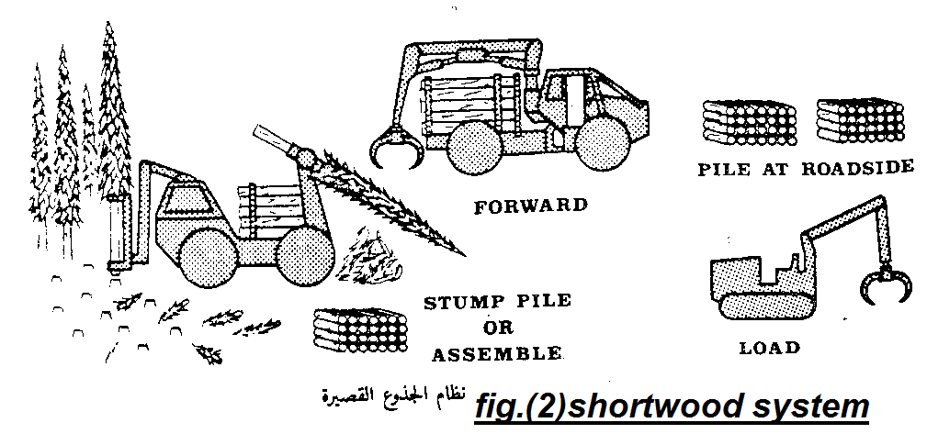
B- Tree length: -
This method used in the production of pole and lumber wood, as well as wood pulp, it can be divided into two main sections on the basis of the degree of mechanization in the respective operations?
1- TREE LENGTH METHOD
2- TREE LENGTH SYSTEM
1- Tree length method
In this way trees are felling and delimbing manually using the chainsaw and transfer logs as primary transportation by means of suitable extraction system to the forest roadside or to the timber conversions yards in which the bucking logs will be done with suitable heights by using the chainsaw and accumulate them in preparation for loading onto trucks and transported out of the forest. contribute labor in this way between 55-65% of the total work
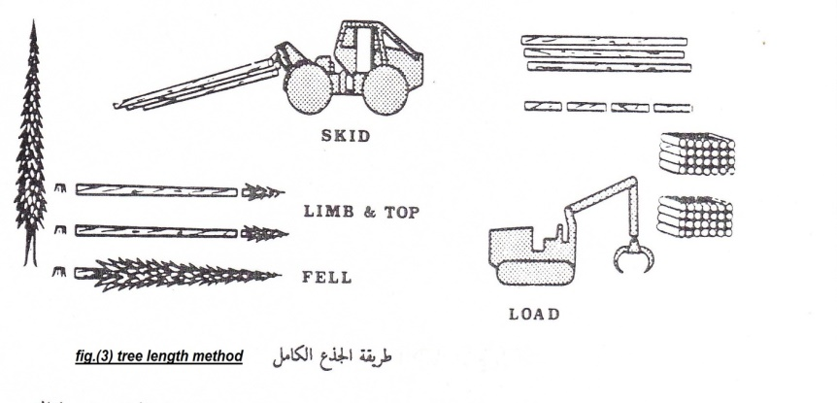

2-Tree length system
Trees are felling and delimbing machinery, which also collect whole logs as a group ready for extraction by means appropriate extraction system to the forest roadside or to the timbers conversion yards and then the logs will be bucked to suitable lengths with Slasher and the cutter logs will have accumulated and loading on trucks for transfer them outside the forest. Contribute labor in this way between 45-55% of the final total work.
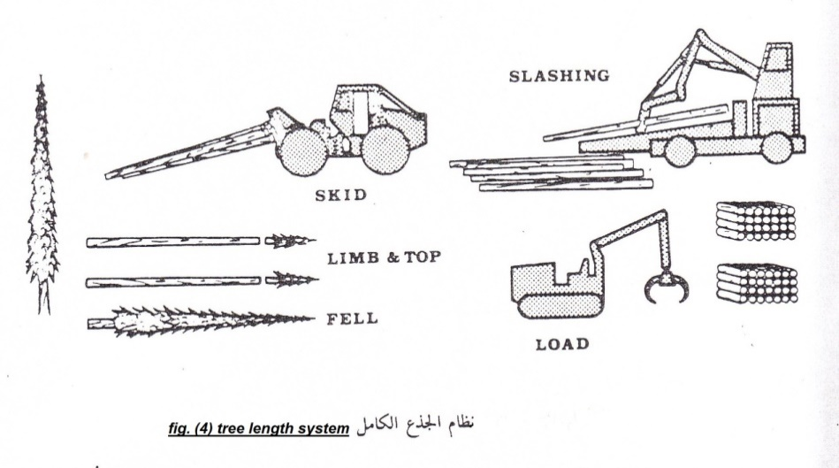
C- Full or whole tree
The purposes of using this method: -
1- To reduce the likelihood of fires to lack its remnant trees forest land investing.
2- to benefiting from all portions of the tree, such as small branches and leaves.
3- Can be helpful in forest managing and to reduce the negative effects on the forest soil.
And this method is divided to two main sections on the basis of the degree of use of mechanization in the respective operations:
1- FULL OR WHOLE TREE METHOD
2- FULL OR WHOLE TREE SYSTEM

1- Full or whole tree method
In this way trees are felling manually using chainsaw and the logs are been transported to the forest roadside in which the delimbing , bucking and accumulation will done by machines and then load them on trucks to move outside the forest. Contribute to the workforce by 35-45% of total work
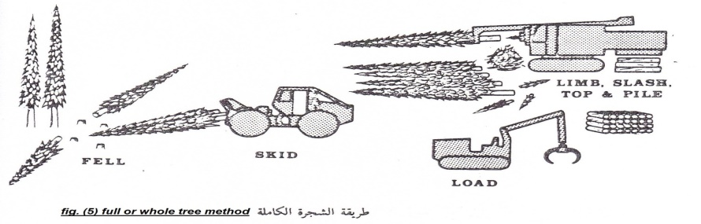
2- Full or whole tree system
Trees are felling using machines and extracted to the forest roadside in which the same method of full tree system will be repeated. Contribute manpower by 25-35% of total macro action
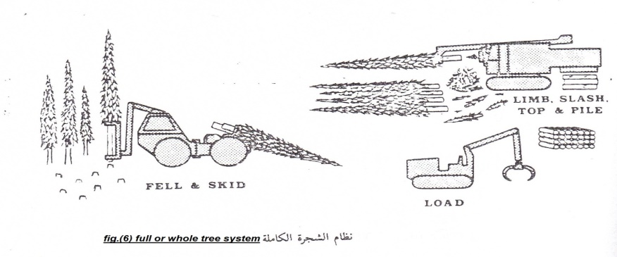
Timber stacking yards
The required conditions in Timber stacking yards: -
1- Stacking yards should be large enough and fits the activities and movements of trucks.
2- Organization of unloading and loading sites and entry and exit of the first transport system to ensure safety for workers and trucks.
3- A regression in the land of stacking yards must not exceed 10% slope.
4- The stacking yards should be in the forest roadside and not in its tracks.
5- If you use the stacking yard as a gallery to sell timber its necessary to arrange logging makes it easier to view.

