Questions of General English

Listening:
B. Developing Vocabulary. p11
* Complete each sentence with a word or phrase from the list of vocabularies:
- The academic year in my country starts in October. All university students go back then.
- When does the second semester start? Is it in February?
- Which faculty are you in? Education? Mathematics? Modern Languages?
- Which lecturer gives the Science in Education lectures?
- How many staff are in the Faculty of Education? I mean, how many people work there?
- Where is the student accommodation at this university? Where do the students live?
- This is a large campus. There are ten faculty buildings, the library, the Resource Centre and the Students’ Union.
- A university student is called a fresher in the first year.

C. Understanding Words in Context. P12
Campus | The University Buildings
Resources | things to help with studying
Fees | money for a course
Welfare Office | a place to go if you have problems
JCR | Junior Common Room
SCR | Senior Common Room
Hall of Residence | accommodation for students on campus
Students’ Union (SU) | a special place for students

B. Identifying a new skill. p14
Words | Definitions
Assignment | A piece of work to do on your own
Deadline | The time to give in an assignment
Research | Reading articles
Journals | Academic magazine
Tutorial | A small discussion

C. Listening for definitions. p14
Words | Definitions
Food court | It’s a place with lots of different restaurants.
Vending machines | Which are machines with food and drink.
Launderette | It’s a place you can wash your clothes there.
Crèche | It’s a place to leave your children for a few hours.
Gym | It’s a place to do exercise..

B. Defining an action with the subject-verb- gerund. p15
Students:
1. Revising: It’s going over something again, something you have studied before.
2. Contributing: It means taking part in something, like a tutorial. It means giving your ideas or your opinion.
3. Parting: It means saying goodbye.
4. Graduating: It means getting your degree and leaving university.
5. Advising: It is telling someone what to do.
6. Disagreeing: It is saying you don’t agree.

Speaking:
- Activating Ideas for (T & F) question. p17
- Read these statements. Do you agree or disagree with each one?
- All schooling should be mixed, not single-sex. There should be girls and boys in the same class.
- Children should study all the subjects on the curriculum. They should not drop Geography, for example, at the age of 14.
- All children should learn a foreign language.
- There should not be physical punishment of children at any age.
- Children with different abilities should be in different classes.

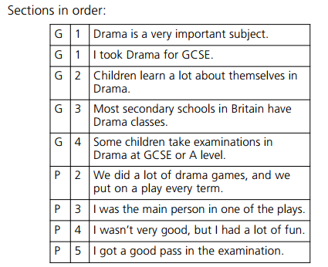
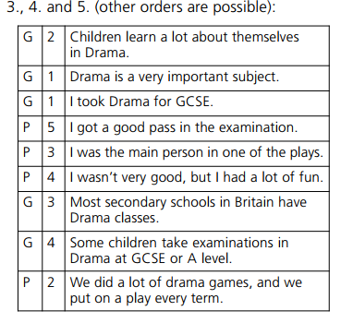
- Identifying a new skill & Skill Check 1, Organizing a talk. P20

C. Researching Information (Good and bad teachers). p22
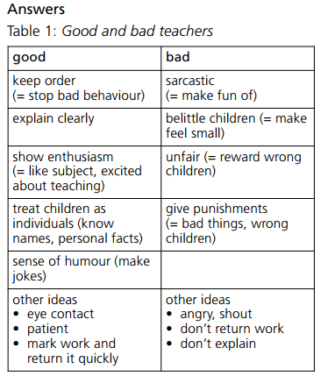

Reading:
- Developing Vocabulary. p23

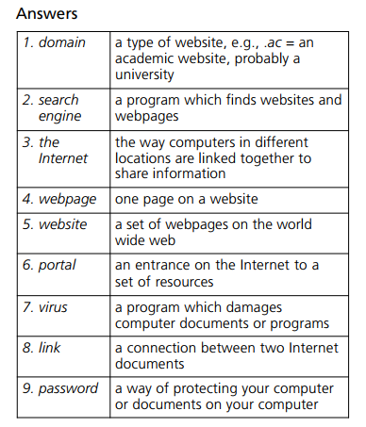

- Building Background Knowledge. p23
At university, lecturers often give assignments with deadlines, for example: ‘
You must write 2,000 words on a particular topic by next Tuesday.’
You must do research for an assignment in the library or on the Internet. This is called secondary research.
You must find out about the research and ideas of other people. However, sometimes you must do primary research.
This is ‘first’ research. It means doing an experiment yourself and recording the results. You must then analyze your data.

- Understanding Vocabulary in Context. p24

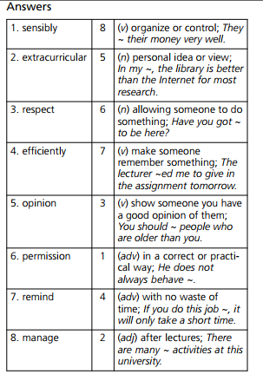

- Developing critical thinking. p24-25
- Predicting Time with Phrases. p27
 | Present | Past
At one time,
At that time,
At the moment,
At the present time,
Currently,
in her childhood,

 | Present | Past
In the 20th century,
Last week,
Now,
Nowadays,
Then,
Yesterday,

D. Present or Past. P28-29
GF: Plagiarism is copying someone’s work. The word comes from Latin. It means to ‘steal or kidnap’.
PAST: At one time, students stole paragraphs from WebPages. Lecturers accepted their work. But in 2001, a lecturer at an American university checked student assignments. He had a new computer program. He found158 cases of plagiarism. Forty-eight students had to leave the university.
PRES: Nowadays, all university lecturers use computer programs. They find plagiarism easily.
ADV: Don’t cut and paste from websites.
GF: Sometimes, the lecturer gives no marks for an assignment with plagiarism. Sometimes, the university asks the student to leave.

Writing:
B. Understanding New Vocabulary. P31
Answers
  - You can apply direct to the university of your choice.
  - You must complete an application form, in paper or online.
  - The form asks for personal details, such as name and address.
  - These details include information about your education and your qualifications.
  - You must demonstrate that your language level is high enough to take a tertiary course in English.
  - You must also complete a Personal Statement.
  - This statement tells the university your reasons for applying for a particular course.
  - You must also tell the university about any work experience, full-time or part-time.
  - Some admissions officers at university want to know about your hobbies and interests.
  - You must supply the name of a referee – a teacher in Kurdistan, for example, who can write about your suitability as a university student.

