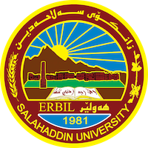
Academic Curriculum Vitae

Personal Information:
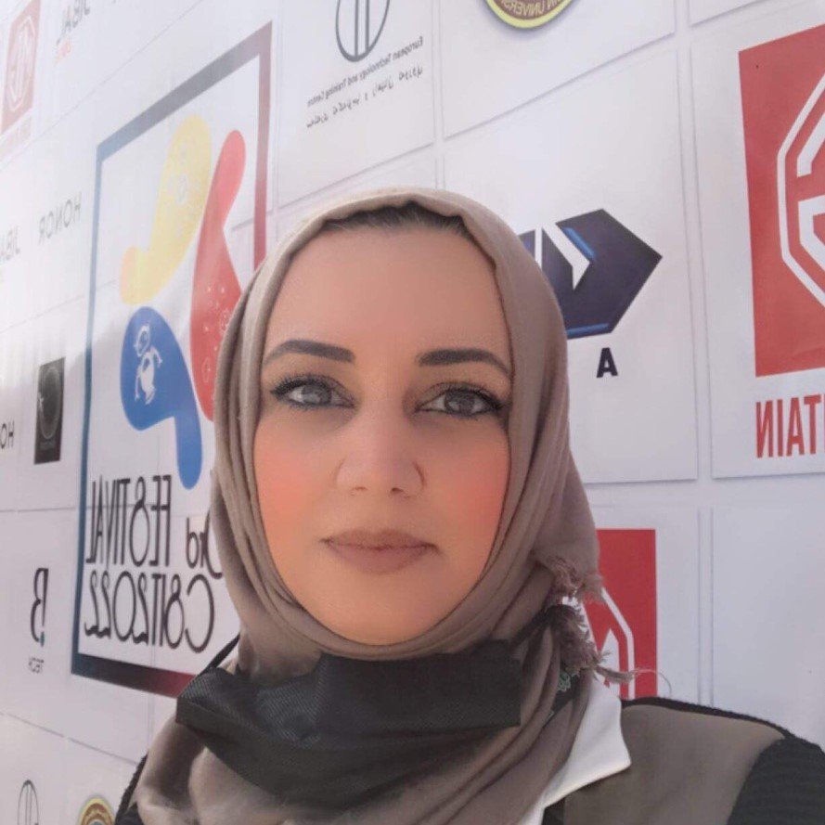
Full Name: Dr.Shaimaa Awadh Bahaelddin
Academic Title: Lecturer
Email: (Shaimaa.alaubi@su.edu.krd)
Mobile:07517838544

Education:
- BSc. College of education /computer science department/ Al_mustansyriah University/Iraq/Baghdad/1998
- MSc. University of Technology/ computer science department/Iraq/Baghdad/2001
- Ph.D Iraqi commission for computers & informatics/Iraq/Baghdad/2008

Employment:
- Al_Rafidain University-computer Science Department-Iraq-Baghdad(2001-2007)
- Cihan University-Computer Science Department-Erbil(2007-2008)
- Salahaddin University-College of Science- Cs&IT department(2009-currently)

Qualifications
- Teaching qualifications

Teaching experience:
- Compiler Construction
- Computation Theory
- Data Structure
- Operating System
- Neural Network
- Artificial Intelligence

Research and publications

A Face Recognition System Based on Principal Component Analysis-Wavelet and Support Vector Machines

Conferences and courses attended
2nd international conference of mathematics and its applications (TICMA)

Professional memberships

Professional Social Network Accounts:
https://scholar.google.com/citations?hl=ar&user=mcF1ovMAAAAJ&view_op=list_works&citft=1&email_for_op=shaimaa.alaubi%40su.edu.krd&gmla=AJsN-F6G37iY-osSlFMDP3WuEmysbDJozFtuj_FwnBjijE5z26gYfPW2ET4DXYIzOSpsTYP09MwEYTVtMeRt1f-j8eLmcqwChNYTLUv2nZCwgKpGdtdoh2DR_nTKBXyPTSIhf3BBhknH_JonIP5vlLx_tWTuNQbxkf_EfH8rcpCZKF2UI55BWolDET_HCmOZAkY5ozmnctbM71Ub2oHZoTUrYPTrGHgWD_30aM0DqfVGR6r8S0TkZwZgTbRNtM_nMNKbiy9-88RZlothCTdAdD8A1QvFzNAo9zgJdlAIpM87rz9QQdTtVCc
https://www.researchgate.net/profile/Shaimaa-Awadh
https://mobile.twitter.com/Shaimaa15488784
https://www.linkedin.com/signup/cold-join?session_redirect=https%3A%2F%2Fwww%2Elinkedin%2Ecom%2Ffeed%2F%3Ftrk%3Dhb_signin&trk=login_reg_redirect

