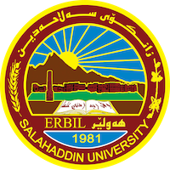
Academic Curriculum Vitae
Personal Information:
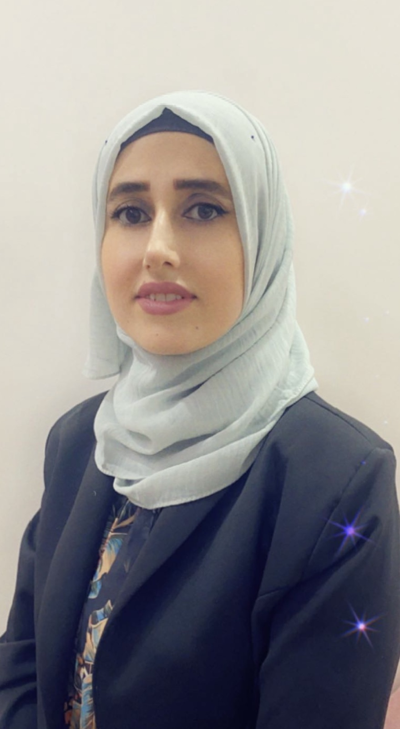
Full Name:Shaker Maghdid Azeez

Academic Title: Assistant lecturer
Email: (shaker.azeez@su.edu.krd)
Mobile:07504344917

Education:
- 2014-2017 M.Sc. Statistics Administration and Economic college, University of Salahaddin,Erbil , Iraq 2006-2010 B.Sc. Statistics Administration and Economic college , University of Salahaddin, Erbil , Iraq

Employment:
- 2011-2020 Researcher Department of Statistics, Administration and Economic college, University of Salahaddin

Qualifications
- IT qualifications (Microsoft Word, Microsoft Excel, Power point, SPSS, Stratigraphy)
- Language center and IELTS.
Teaching experience:
- Principle of Statistics.
- SPSS.

Professional Social Network Accounts:

- https://scholar.google.com/citations?hl=en&user=0zYwX5IAAAAJ

