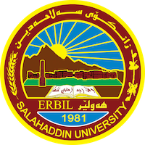
Academic Curriculum Vitae
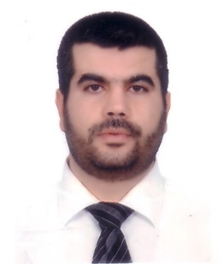
Personal Information:
Full Name: Shakhawan Omar Qader
Academic Title: Lecturer
Email: shakhawan.kadir@su.edu.krd
Mobile:07500828204

Education:
- 1999-2000: B.A of Islamic education, College of Arts, Salaheddin University. Erbil.Iraq.
- 2002-2004: M.A. of Islamic education,College of Islamic Education, Duhok University. Erbil. Iraq.
- 2009-2012: PhD of Arabic Language, College of Languages, Salaheddin University. Erbil. Iraq.

Employment:
- Since 2004 up to now: Lecturer at Department of Arabic Language, College of Languages, Salaheddin University. Erbil. Iraq.
- 2006-2007:Head of Arabic Department.
- 2004- 2010: Member of examination committee at the college of Languages
- 2000 up to now: Delivering many sermons and religious lectures in mosques and religious events.
- Presenting dozens of seminars inside and outside Salahaddin University.

Teaching experience:
- Teaching the Quran Interpretation for the 3th Year student at the Arabic Department.
- Teaching the Quran sciences for the 2nd Year student at the Arabic Department.
- Teaching the Quran expression for the 2nd Year student at the Arabic Department

Conferences and courses attended
- Member of Student Evaluation Conference, Salahaddin University. 2022
- Member of Student Evaluation Conference, Salahaddin University. 2023
- Participation on Towards social and cultural moderation Conference, Salahaddin University. 2023
- Participation The Arabic language for non-native speakers between reality and hope Conference, 2022.

Professional memberships
- Member of Berwadaran center for teaching and memorizing the Qur’an since 2017.
- Preacher in the mosque Senara since 2014.

Skills:
- IT and Computing
- Word, Excel and Power point
Languages:
- Kurdish : Mother tongue
- Persian: Mother tongue
- Arabic : Fluent
- English Upper intermediate

