Wheat Triticum sp.
Growing wheat
Wheat evolved from wild grasses and is thought to have first been cultivated between 15,000 and 10,000 BC. It is an annual plant belonging to the genus Triticum which includes common bread wheat (Triticum aestivum) and durum (Triticum turgidum).
Wheat is the largest grain crop in Australia. Australian wheat farmers produce around 16 million tonnes of wheat each year, 70% of which is exported. In world terms, Australia is the fourth largest exporter, contributing around 11% of world trade, and is the largest producer and exporter of white wheat in the world. Asia, the Middle East and the Pacific are the principal export destinations while the domestic market is the largest single market and is growing rapidly.
Wheat types
Winter and spring wheats are the two types of wheats grown in New South Wales. The main difference between the two types is that winter wheats need a period of cold temperatures to begin reproduction while spring wheats do not have a cold requirement.
Winter wheats
Winter wheats are commonly used in the mixed farming zones. Winter wheats need to experience a certain period of cold temperatures, between 0° and 10°C, to trigger a switch from vegetative growth to flowering (anthesis). This cold requirement is known as vernalization. The winter wheat varieties need different periods of vernalization, so it is important to take this into consideration when selecting a variety. The vernalization requirement means that winter wheats adapt to varying sowing times and so can be used for the dual purpose of grazing and grain. They can be sown from February to early April for grazing, depending on the vernalization requirement of the variety.
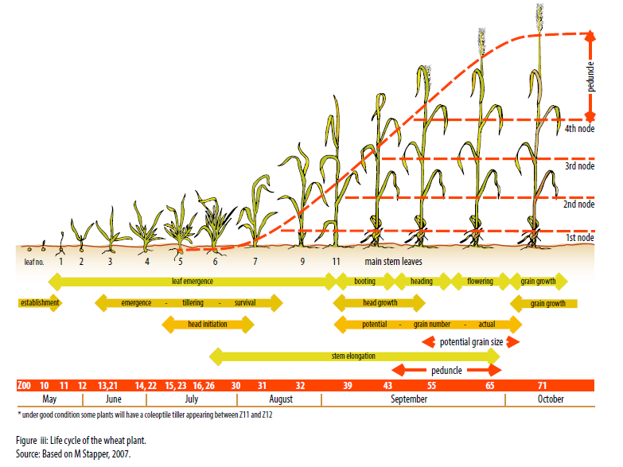
Spring wheats
The vast majority of wheat varieties grown in New South Wales are spring wheats. Spring wheats grow and develop in response to increasing temperature and photoperiod (daily hours of light). They do not have a vernalization requirement to initiate flowering and so are grown in the warmer regions of New South Wales. It is very important to sow spring wheats at the recommended time to minimize the risk of frost damage during flowering. Recommended sowing times are published each year by the NSW Department of Primary Industries in the Winter crop variety sowing guide.
Life cycle
The growth and development of the wheat plant is a complex process. During the life cycle of the plant, many of the growth stages overlap, and while one part of the plant may be developing another part may be dying. Figure iii represents the progression of the key growth stages, where they overlap, and the point where potential and actual yield are set. Zadoks references are also shown, and the main plant parts are identified.

Zadoks decimal growth scale
Effective crop management depends on being able to identify the growth stage of the crop. This is where a growth scale becomes a valuable tool.
A growth scale provides a common reference for describing a growth stage that enables better communication between farmers, agronomists, researchers and other agricultural professionals. An example of where this is important is in the timing of fertilizer and chemical applications.
A number of growth scales are in use around the world, with the Feekes, Zadoks and Haun scales the most widely applied. Growth stages are denoted in a number of ways, including GS (growth stage) and DC (decimal code). In this book, the Zadoks growth scale is used, indicated by Z (Table i). Zadoks is a decimal growth scale proposed for cereal plants by J Zadok, T Chang and C Konzak in 1974. The scale is based on 10 primary growth stages (0–9). Each primary growth stage is divided into 10 secondary growth stages that indicate the number of plant parts on the main stem or secondary stage of development, extending the scale from 00–99. So, each point on the scale has two digits, the first indicating the growth stage and the second the number of plant parts or secondary stages of development. For example, Z15 means growth stage 1 with 5 leaves on the main stem. Z24 means growth stage 2 with 4 tillers. Several of the growth stages occur together, so a plant may have more than one decimal code applied at the same time. For example, a plant may be producing leaves and tillering at the same time and so could have a code of Z15, 22, meaning it has 5 leaves on the main stem and 2 tillers.
Where appropriate, throughout Wheat growth and development a Zadoks reference is provided for the development stage under discussion. Zadoks decimal growth scale is provided in Table i.
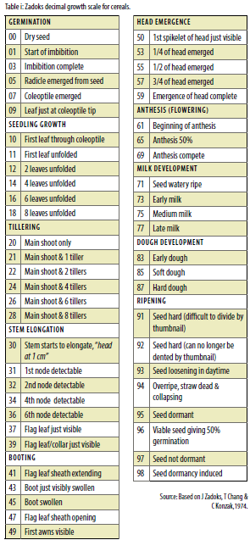
The wheat grains
The wheat grain is the reproductive unit of the wheat plant as well as the end-use product. A wheat grain can be broadly divided into three components (Figure iv):
- seed coat and aleurone layer (or bran)
- endosperm
- embryo (germ).

In most varieties, the proportion of each component of the grain is 14% seed coat, 83% endosperm and 3% embryo.
Seed coat: the outer protective covering of the seed.
Aleurone: a layer of protein surrounding the endosperm that secretes enzymes to break down starch reserves in the endosperm.
Endosperm: Tissue that surrounds the embryo and provides energy for germination. The germinating seed relies on these reserves until it has developed a root system. It makes up the bulk of the grain and stores the starch and protein that are milled for the production of white flour.
Embyro: contains the main plant structures, so it holds all the elements of the growing plant. It is made up of the scutellum, plumule (shoot) and radicle (primary root). It is found at the point where the grain is attached to the spikelet.
- Scutellum: a shield–shaped (cotyledon) structure that absorbs the soluble sugars from the breakdown of starch in the endosperm. It also secretes some of the enzymes involved in germination.
- Plumule: the growing point of the seed that develops into the shoot bearing the first true leaves. At the growing point is the coleoptile, three leaf primordia and the shoot apex.
- Radicle: develops into the primary root and is the first structure to emerge after germination.

Once filled, the wheat grain is 70% carbohydrate, and 97% of this carbohydrate is starch (Figure v). The protein content is between 8% and 15%, depending on final grain weight; this equates to between 4 and 10 mg
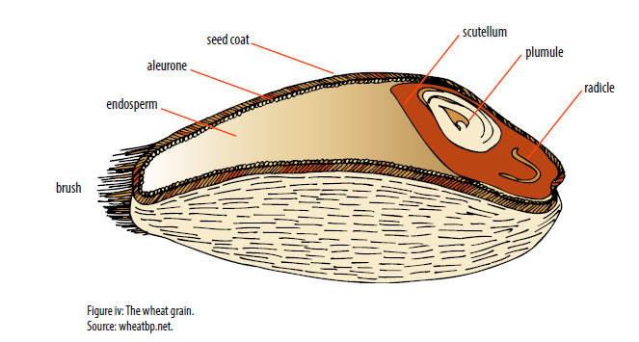
The wheat plants
The main structures of the plant are the coleoptile, leaves, tillers, stem, roots and head.
Coleoptile
The coleoptile is a protective sheath that encases the first leaf. It pushes through the soil to the surface.
Leaves
The leaf consists of a sheath, which wraps around the newly emerging leaf, and a leaf blade. The leaf sheath contributes to stem strength. The leaf collar is the point where the leaf sheath joins the leaf blade. The leaf collar has two features, the ligule and the auricles. The ligule is a thin colorless membrane around the base of the collar. The auricles are small hairy projections that extend from the side of the leaf collar. These features can be used to help identify grass species (Figure vi).
Leaves are produced in a set order, on alternate sides of the stem. The final leaf to grow before head emergence is the flag leaf.
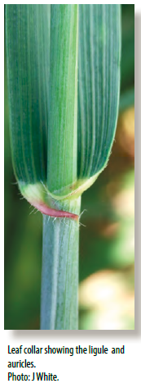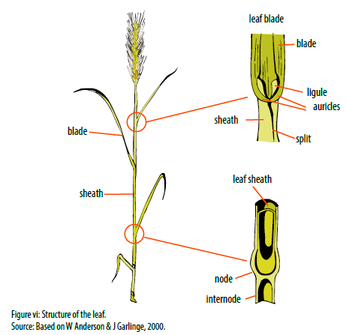
Tillers
Tillers are lateral branches or shoots that arise from buds in the axil of the leaves at the base of the main stem. Primary tillers are produced from the leaves of the main stem and can form their own, secondary tillers.
Stem
The stem is made up of nodes and internodes. Nodes are where structures such as leaves, roots, tillers and spikelets join the stem. The internode is the tissue between adjacent nodes that elongates as the stem grows. The stem is wrapped in the sheaths of the surrounding leaves.
This structure of stem and leaves gives strength to the shoot, helping to keep the plant upright.
As the stem grows it changes function from providing support for leaves to storing carbohydrates and nutrients for grain filling.
Roots
Wheat has primary and secondary root systems (Figure vii). The first roots to appear are the primary roots (also called seminal or seedling roots). At germination, the radicle breaks through the seed coat, followed by four or five lateral roots. These form the primary root system that supports the plant until the secondary root system develops. The secondary roots (also called adventurous, nodal or crown roots) initiate from nodes within the crown after germination.
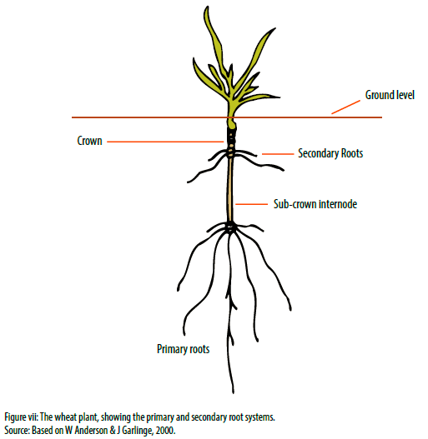
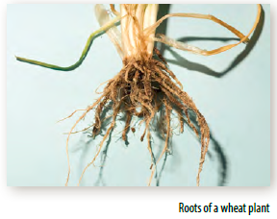
Head
The head of the wheat plant has a rachis (stem) made up of nodes and short, flattened internodes. At the nodes are the floral structures, called spikelet, that hold up to 10 florets containing the flower of the wheat plant, where grain is formed. Figure viii shows the structure of the wheat head, spikelet and floret.
Each floret is enclosed within two protective bracts called the lemma and palea. These structures wrap around the carpel. The carpel contains the ovary with the feathery stigmas, three stamens holding the anthers (pollen sacs), and the ovule. Once fertilised, the ovule forms the grain.
Figure ix shows the structure of the floret, and the location of florets on the spikelet.
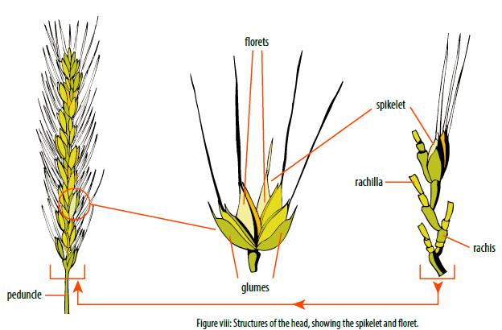
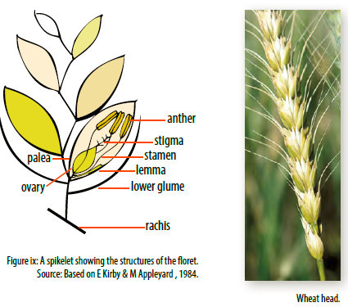
Faba bean …….. Vicia faba
Uses
Cultivated faba bean is used as human food in developing countries and as animal feed, mainly for pigs, horses, poultry and pigeons in industrialized countries. It can be used as a vegetable, either green or dried, fresh or canned. It is a common breakfast food in the Middle East, Mediterranean region, China and Ethiopia (Bond et al., 1985). The most popular dishes of faba bean are Medamis (stewed beans), Falafel (deep fried cotyledon paste with some vegetables and spices), Bissara (cotyledon paste poured onto plates) and Nabet soup (boiled germinated beans) (Jambunathan et al., 1994). "Feeding value of faba bean is high, and is considered in some areas to be superior to field peas or other legumes. It is one of the most important winter crops for human consumption in the Middle East. Faba bean has been considered as a meat extender or substitute and as a skim-milk substitute. Sometimes grown for green manure, but more generally for stock feed. Large-seeded cultivars are used as vegetable. Roasted seeds are eaten like peanuts in India" (Duke, 1981). Straw from faba bean harvest fetches a premium in Egypt and Sudan and is considered as a cash crop (Bond et al., 1985). The straw can also be used for brick making and as a fuel in parts of Sudan and Ethiopia.
Faba bean growth stages
Uniform growth-stage descriptions were developed for the faba bean plant based on visually observable vegetative and reproductive events.
Germination is hypogeal, with the cotyledons remaining below the soil surface. This enables it to emerge from sowings as deep as 25 cm. The node at which the first leaflet arises from the main stem above the soil is counted as node one. A node is counted as developed when leaves are unfolded and flattened out. Scale leaves at the base of the plant and close to the ground are not counted as true nodes.
The vegetative stage is determined by counting the number of developed nodes on the main stem, above ground level. Nodes are counted from the point at which the first true leaves are attached to the stem. The last node counted must have its leaves unfolded (Figure 1).
In faba beans, alternate primary branches (‘tillers’) usually originate from the base just above ground level (usually 1–5 primary branches on the main stem, depending on variety and growing conditions).
The reproductive stages begin when the plant begins to flower at any node.
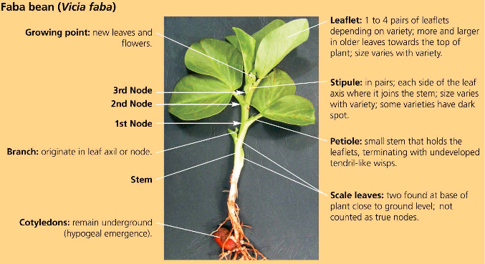
Figure 1: Faba bean early growth stages.

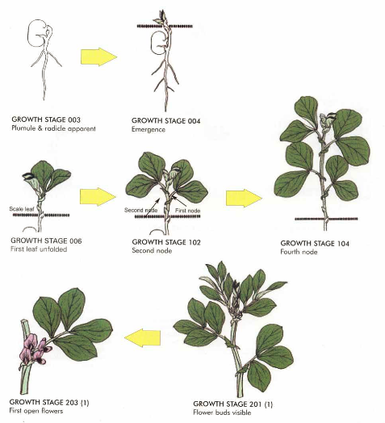
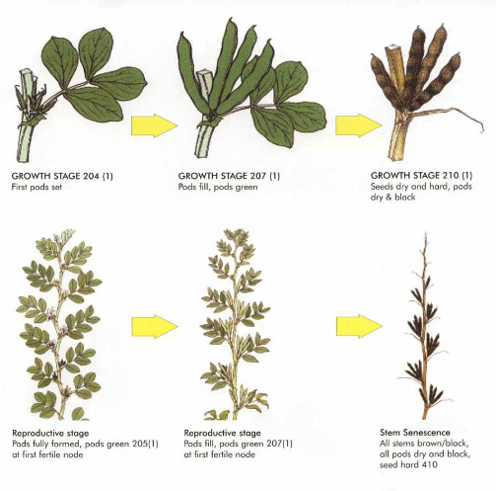
Figure 2: Stages in the development of the faba bean (Vicia faba).
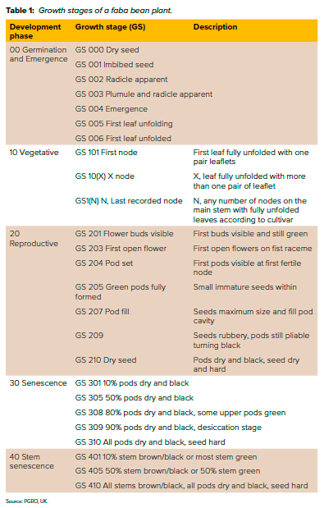
Chemistry
Quality Parameters
Wide variation of protein content (20-41%) has been reported (Chaven et al., 1989). When spring and winter faba beans are compared, winter beans have slightly higher concentrations of protein than the latter (Bond et al., 1985). Protein concentration is influenced by both genetic and environmental factors and it has been reported that inheritance of this trait is additive with some partial dominance (Bond et al., 1985). Amino acid content as mg g⁻¹ of nitrogen varies from 36-69 mg for methionine, 44-94 mg for cystine and 333-400 mg for lysine (Chevan et al., 1989). Legumin is the predominant globulin and has a larger proportion of arginine, threonine and tryptophan (Hulse, 1994). Utilizable protein, protein digestibility and biological value are reported to vary from 14.8-15.5%, 82-92% and 45-55%, respectively (Hulse, 1994). Faba bean contains small amounts of several possible antinutritional factors; however, their effects are less acute, and protease inhibitors are at much lower (2%) concentrations compared to soybeans (Lawes, 1980; Bond et al., 1985). Inhalation of the pollen or ingestion of the seeds may incite the condition known as favism, a severe hemolytic anemia, perhaps causing collapse (Smart, 1990). "It is an inherited enzymatic deficiency occasional among Mediterranean People (Greek, Italian, Semitics); The genetic disorder occurs in about 1% of whites, 15.0% of blacks" (Duke, 1981). The main factors responsible for favism, which can occur in susceptible people, are believed to be glucoside vicine and convicine and their hydrolytic derivatives divicine and isouramil, respectively. These anti-nutritional factors render the red blood cells of glucose -6- phosphate dehydrogenase deficient patients vulnerable to oxidation and destruction (Bond et al., 1985; Hussein and Saleh, 1985; Smart, 1990) which are uncommon in cooked beans (Lawes, 1980). "The whole dried seeds contain (per 100 g) 344 calories, 10.1% moisture, 1.3 g fat, 59.4 g total carbohydrate, 6.8 g fiber, 3.0 g ash, 104 mg Ca, 301 mg P, 6.7 mg Fe, 8 mg Na, 1123 mg K, 130 m g b-carotene equivalent, 0.38 mg thiamine, 0.24 mg riboflavin, 2.1 mg niacin, and 162 mg tryptophane. Flour contains: 340 calories, 12.4, % moisture, 25.5 g protein, 1.5 g fat, 58.8 g total carbohydrate, 1.5 g fiber, 1.8 g ash, 66 mg Ca, 354 mg P, 6.3 mg Fe, 0.42 mg thiamine, 0.28 mg riboflavin, and 2.7 mg niacin. The fatty acid composition of broad bean oil has been reported as 88.6% unsaturated" (Duke, 1981). The amino acid content except for methionine is reasonably well balanced (Bond et al., 1985).
Haemagglutinins (lectins), although found in many legumes, concentration is higher in faba bean and can be troublesome. These substances are destroyed during the normal food preparation process (heat) (Hussein and Saleh, 1985). Similarly, oligosaccharides mainly stachyose, raffinose and verbascose are also more prevalent in faba bean; these molecules contain glucose and galactose residues which can persist in sugar metabolism pathway in digestive tracts. They ferment and produce methane and other gases causing discomfort and abdominal pains. Faba bean contains other objectionable factors including, cyanogens, favogens, phytic acid, tannins, and tripsin inhibitors (Williams et al., 1988).
Traditional Medicinal Uses
As a folk medicine, it can be used as diuretic, expectorant, or tonic.
Origin
Faba bean is assigned to the Central Asian, Mediterranean, and South American centers of Diversity. Cubero (I974) postulated a Near Eastern center of origin, with four areas (1) to Europe (2) along the North African coast to Spain, (3) along the Nile to Ethiopia, and (4) from Mesopotamia to India. Secondary centers of diversity are postulated in Afghanistan and Ethiopia. However, Ladizinsky (1975b) reported the origin to be Central Asia. The wild progenitor and the exact origin of faba bean remain unknown. Several wild species (V. narbonensis L. and V. galilaea Plitmann and Zohary) are taxonomically closely related to the cultivated crop, but they contain 2n = 14 chromosomes, whereas cultivated faba bean has 2n = 12 chromosomes. Numerous attempts to cross the wild species to cultivated faba bean have failed (Bond et al., 1985).
Botany
Taxonomy, Morphology and Floral Biology
Vicia faba is an annual herb with coarse and upright stems, unbranched 0.3-2 m tall, with 1 or more hollow stems from the base (Bond et al., 1985; Duke, 1981; Heath, et al., 1994). The leaves are alternate, pinnate and consist of 2-6 leaflets each up to 8 cm long and unlike most other members of the Genus, it is without tendrils or with rudimentary tendrils (Kay, 1971; Bond et al., 1985). "Flowers are large, white with dark purple markings, borne on short pedicels in clusters of 1-5 on each axillary raceme usually between the 5 and 10th node; 1-4 pods develop from each flower cluster, and growth is indeterminate though determinate mutants are available. About 30% of the plants in a population are cross-fertilized and the main insect pollinators are bumblebees. There is a robust tap root with profusely branched secondary roots" (Bond et al., 1985). Based on seed size, two subspecies were recognized, paucijuga and faba. The latter was subdivided into var. minor with small rounded seeds (1 cm long), var. equina with medium sized seeds (1.5 cm) and var. major with large broad flat seeds (2.5 cm) (Kay, 1971; Bond et al., 1985). Cubero (1974) suggested four subspecies, namely: minor, equina, major, and paucijuga. Taxonomically the crop belongs to Section Faba of the Genus Vicia (Bond et al., 1985; Smart, 1990).
Ecology
Faba bean requires a cool season for best development. It is grown as a winter annual in warm temperate and subtropical areas; hardier cultivars in the Mediterranean region tolerate winter temperatures of -10°C without serious injury whereas the most hardy European cultivars can tolerate up to -15°C (Robertson, 1996). "It can be grown anywhere and does not winterkill. Well-adapted to wetter portions of cereal-growing areas of western Canada and elsewhere. Tolerates nearly any soil type; grows best on rich loams. Moderate moisture supply is necessary" (Duke, 1981). They are considered to be the least drought resistant of legume crops; however, cultivars with high water use efficiency have been developed at ICARDA (Robertson, 1996). "Moisture requirement is highest about 9-12 weeks after establishment. Faba bean is more tolerant to acid soil conditions than most legumes. Can be grown in nearly all parts of the United States without liming. Growing seasons should have little or no excessive heat, optimum temperatures for production range from 18 to 27°C (65-85°F)" (Duke, 1981). Rainfall of 650-1000 mm per annum evenly distributed is ideal (Kay, 1971). The maturity period ranges from 90-220 days depending upon the cultivars and climatic conditions (Bond et al., 1985).
Crop Culture
Field Cultivation
Even though faba bean has been cultivated in many countries, 60% of total world production comes from China (FAO, 1994). The date of introduction of Vicia faba var. minor to China is believed to be around 100 BC (Bond et al., 1985). In localities having no hard frosts, most cultivars can be sown in fall and survive the winter. In northern localities or at high elevations farther south, faba bean should be planted in early spring, when ground can be worked, at the same time as the earliest ordinary spring crops. Large-seeded cultivars are sown with planters used for lima beans, while small-seeded cultivars can be sown with a common corn planter. In some areas, such as Ethiopia and Sudan, broad bean seeds are broadcast. At seeding time, fields are plowed shallow and seeds are dropped into every second or third furrow. "Seeds are usually sown 5-10 cm deep in rows 75 cm apart, with seeds 15 cm apart in the rows. Rows 60 cm apart, or even closer, give good results under favorable conditions. Small-seeded cultivars are planted at 90-122 kg/ha, and large-seeded cultivars at 78-90 kg/ha. In United Kingdom, 450 kg seed/ha produces maximum yields. Yields are economically optimal at a seeding rate of 225-340 kg/ha for large seeded cultivars, and satisfactory at 190 kg/ha for small-seeded cultivars" (Duke, 1981). For green manure or forage, small-seeded cultivars are usually broadcast. Murinda and Saxena (1985) reported that faba bean fixes more nitrogen (135 kg N ha⁻¹) than lentil and chickpea. Inoculation is not always practiced if effective strains of Rhizobia are present (e.g. Europe in general and Middle East) (Murinda and Saxena, 1985; Bond et al., 1985). Applications of P and K in southern United States (Duke, 1981), and Nitrogen in Africa and Middle East (Murinda and Saxena, 1985) as starter fertilizers before or at seeding time have been reported to be beneficial for vigorous early growth. "Early deep sowing into a well-drained firm seedbed gives best results. Faba beans should be cultivated during their growing period. When planted in 60 cm rows or closer, special machinery is necessary for cultivation. When planted in 90 cm rows, ordinary cultivators can be used. In United Kingdom, thiram and captan are recommended as fungicides; chlorpropham plus diuron or fenuron, or simazine, as pre-emergence herbicides, and dinoseb-acetate as a post-emergence herbicide" (Kay, 1979; Duke, 1981).
Harvesting
When the crop is meant for dry seed, it is harvested when fully mature, and when grown for consumption as a vegetable, it is harvested green. The most common harvesting system is to pull and thresh the crop by hand; however, hand harvesting is costly compared to mechanized harvesting (Diekmann and Papazian, 1985). Time of harvest depends on whether hand or mechanical methods are used. Beans mature 90-220 days after planting based on localities (Bond et al, 1985). Harvest can be delayed a little longer for hand than for mechanical harvest. In either case, the crop should not be cut until the lower pods are matured and the upper ones fully developed. "If harvest is delayed until the upper pods are ripe, there can be great losses from shattering. The crop should be cut on cloudy days and may be cut at night. Large seeded cultivars are threshed with a common bean thresher with special adjustments to the cylinder" (Duke, 1981). Small-seeded types can be threshed without difficulty using a cutter bar and stationary thresher (Diekmann and Papazian, 1985). After threshing, the seed is cleaned with ordinary fanning mills. For canning, beans are soaked and allowed to swell and then are picked by hand to avoid hard seeds (Duke, 1981).

Yields and Economics
The lack of adequate pollination and reduced seed setting can be major constraints to yield. Flower drop and seed abortion and pests such as Botrytis fabae, Ascochyta fabae, Uromyces fabae, Orobanche crenata, and Aphis fabae are also major constraints to yield. Abiotic factors such as drought, high temperature, inadequate supply of nutrients, salinity and excessive moisture also play an important role. Yields are closely correlated with the number of pods per plant. China was the largest producer with estimated annual production ranging from 2.4-2.6 million MT (1161-1447 kg/ha) from 1979 to 1994 (FAO, 1994). Argentina reported the highest yield record of more than 9000 kg/ha from 1992 to 1994, followed by Switzerland (3350-4375 kg/ha), France (3000-3900 kg/ha) and Belgium (3350-3750 kg/ha) during the same years (FAO, 1994). In the past, faba beans for human consumption, feed for horses (commonly known as "horsebeans"); green manuring and feed for other stock were important uses in southern United States and along the U.S. Pacific Coast. Faba beans are grown in home gardens and mostly used as a green vegetable when the seeds are still succulent.
Faba bean production in the world is concentrated in nine major agroecological regions, namely; northern Europe, Mediterranean, the Nile valley, Ethiopia, Central Asia, East Asia, Oceana, Latin America, and North America (Bond et al., 1985). There has been a 50,000 tons increase in production in Australia, a 50,000 tons increase in EEC, and a 210,000 tons increase in West Asia and North Africa (WANA) from 1982 to 1992 (Oram and Agcaoili, 1994). However, the same authors reported that there was a 25% decrease in area sown to faba bean in China alone, the largest producer, and a decrease in production of 201,000 tons in Africa during the same period (Oram and Agcaoili, 1994). Large seeded green types are canned. It is the second ranking food legume in Europe (Picard et al., 1988).
Biotic Factors
Fungi, viruses, and insect pests attack faba bean. The most important diseases and their casual agents include: chocolate spot (Botrytis fabae and B. cinerea), rust (Uromyces viciae fabae), black root rot (Thielaviopsis basicola), stem rots (Sclerotina trifoliorum, S. sclerotiorum), root rots and damping-off (Rhizoctonia spp.), downy mildew (Pernospora viciae), pre-emergence damping-off (Pythium spp.), leaf and pod spots or blight (Ascochyta fabae), foot rots (Fusarium spp.), bean yellow mosaic virus, bean true mosaic virus, and bean leaf roll virus (van Emden et al., 1988).
Among the insect pests, ground nut aphid (Aphis cracivora), Black bean aphid (Aphis fabae), pea aphid (Acyrthosiphon pisum), pea thrip (Kakothripsrobustus), cowpea bean beetle (Callosobruchus macculatus), seed weevils (Apion spp.), bean weevil (Sitonia lineatus), and Egyptian leaf worm (Spodoptera littoralis) are important. Bacteria that cause disease in faba bean include Bacterium phaseoli, B. viciae, Erwinia phytophthora, and Psuedomonas viciae. The Important nematodes include Meloidogyne incognita, M. javanica, Pratylenchus spp., Trichodorus spp., and Xiphenema spp. Broomrape (Orobanche crenata) may be a serious problem in the Mediterrannean region.

