Corn
Maize is a multipurpose, summer, cereal, grain and silage crop that serves as a good rotation crop with legumes and cotton. Maize has a low capital investment, low growing risk and generally a longer window of harvest than other crops. The industry is valued at AU$25–35 million annually, depending on prices, area planted and yields.
Flint corn’ (Zea mays var. indurate, also known as Indian corn or calico corn) is a variant of maize (Zea mays L.). Because each kernel has a hard outer layer to protect the soft endosperm, it is likened to being ‘as hard as flint’.
‘Dent corn’ (var. indentata) also known as ‘yellow dent corn’, ‘Reid’s yellow dent corn’, ‘white dent corn’ or ‘field corn’ is a variety of maize with a high soft-starch content. It received its name because of the small indentation (‘dent’) at the crown of each kernel on a ripe ear of corn.
Grown under the same conditions, the highest protein would be expected in quick flint, followed by med-slow flint, quick dent and the lowest in med-slow dent (Table 1).
Two types of starch can be contained in maize. Regular yellow maize and white maize contain approximately 73% amylopectin and 27% amylose. Waxy maize produces 100% amylopectin. Hi-amylose can be up to 80–90% amylose and 10–20% amylopectin.
The industry delivery standard and a safe storage level is 14% moisture content.
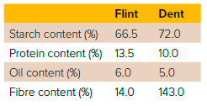
Maize is the third most important cereal crop species in the world (after wheat
and rice) and is grown across a wide range of climates, but mainly in the warmer temperate regions and humid subtropics. Maize has multiple uses, including human foods, animal feeds, and the manufacture of pharmaceutical and industrial products.
It is the staple food source for people in many countries. Maize is highly desirable as an animal feed because of the high energy and feed value of the kernel, leaf and stem. It is increasingly important in many countries for industrial and pharmaceutical applications. It can be used to produce starch, ethanol and plastics and as a base for antibiotic production. Over the past 40 years, the total global area sown to maize has increased by about 40% and production has doubled. Maize is a C4 (tropical) plant. It uses carbon dioxide, solar radiation, water and nitrogen more efficiently during photosynthesis than C3 (temperate) crops. The Water Use Efficiency of maize is approximately double that of C3 crops grown at the same sites. The transpiration ratio of maize (molecules of water lost per molecule of carbon dioxide fixed) is 388, whereas that of wheat is 613 and soybean 704. Most plants are C3 plants, including wheat, barley and oats. C4 plants have a specialised type of photosynthesis whereby carbon dioxide is first incorporated into a 4-carbon compound. C4 plants carry out photosynthesis faster than C3 plants under high light intensity and high temperatures. This gives better Water Use Efficiency than that of C3 plants at the same location, because the stomata (pores) are open for a shorter period.
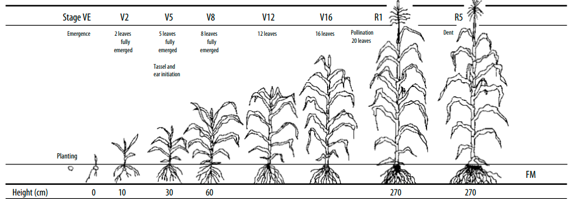
Defining maize growth stages
Crop managers need to be able to identify the different stages of growth. The most common system used for defining maize growth stages divides the growth cycle into two parts: vegetative growth and reproductive development.
Vegetative growth stages
Vegetative growth stages are determined using the Leaf Collar method. A plant is assigned a growth stage depending on the number of visible leaf collars present. Vegetative stages defined by this method are named ‘V’ stages. For example, a plant with seven visible leaf collars (see Figure v) would be at ‘V7’.
As the maize plant progresses through growth stages V4 and V5, some of the earlier leaves may have fallen off because of stem expansion and aging. To determine the vegetative growth stage, split the stem and locate the fifth leaf node. The fifth leaf node is located above the first visibly elongated node at the base of the stem.
From this point, the V-stage is determined by counting the nodes upwards until the highest leaf node is identified. The final V-stage is VT. This is when all the branches of the tassel are fully
Reproductive development stages
Reproductive stages are defined by using an ‘R-stage’ instead of the V used for vegetative growth stages. Growth stage ‘R1’ is defined as silking – the emergence of silks beyond the tip of the ear husk (Figure v). The rest of the R stages relate to the development of the kernels on the ear. The husk needs to be removed to enable the identification of these next stages.
Seeds start developing as soon as they have been fertilised. The first ones to be fertilised are at the base of the ear, and the last seeds to be fertilised are at the ear tip. In assessing the reproductive growth stage, only the seeds in the middle section of the ear are assessed.
The maize kernel
The kernel or seed of the maize plant has three main parts: the pericarp or seed coat, the starchy endosperm, and the germ or embryo (Figure vii). The pericarp protects the kernel before and after planting against entry by fungi and bacteria. The endosperm provides energy for the young plant until its roots and leaves are well established. The embryo contains the parts that will first develop in a new seedling, including the growing point, the first five to six leaves, and the initial root.
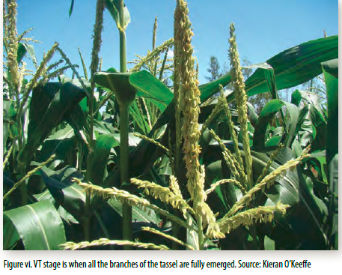
The maize plant
The main structures of the plant are the coleoptile, leaves, stalk, roots, ear and tassel. Unlike all other major grain crops, the maize plant has separate male and female flowering structures – the tassel and the ear. When both flowering structures are located on the same plant, as they are in maize, the plant is called monoecious.
Coleoptile
The coleoptile is a pointed, modified leaf that surrounds and protects the plumule (four or five leaves rolled up, one inside the other) during germination. Such protection is valuable as the coleoptile elongates, pushing the plumule through the covering of the kernel (pericarp) and then through the soil to the surface.
Leaves
The leaf (Figure viii) consists of the leaf blade, leaf midrib and leaf collar and sheath. Leaves are produced in a set order on alternate sides of the stem.
The leaf blade is the nearly flat part of the leaf where the process of photosynthesis occurs. The leaf midrib extends the length of the middle of the leaf blade from the base to the tip. It provides structural support. The collar is the area on the inner surface of the leaf where the leaf blade and leaf sheath join. The sheath is the leaf portion (below the collar) that wraps around a stalk and attaches the leaf to a stalk node.
The stalk
The stem is made up of nodes and internodes and provides structural support for the leaves to intercept sunlight.
The roots
The root system consists of lateral seminal roots, nodal roots and brace roots. The lateral roots grow directly from the kernel. These roots provide anchorage for seedlings until about V3, when the nodal roots have developed sufficiently. The nodal roots extend directly from each node of the first six to eight stalk nodes below the ground. The brace or crown roots form later in the season at nodes just above the soil surface.
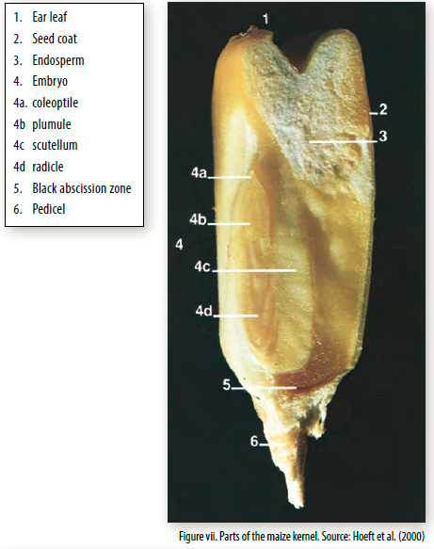

The ear
The ‘ear’ of the maize plant is a central cob with a cylindrically arranged group of flowers, each consisting of an ovary that has an attached silk (actually a very elongated style) and is capable of producing a kernel if fertilised successfully. On a well developed ear there are 700 to 1000 potential kernels, or ovules, arranged on the cob, with typically about 50 per row long and 12 to 24 rows round (Figure ix).

The tassel
The tassel is the male flowering structure of the maize plant (Figure x). Unlike all other major grain crops, the maize plant has separate male and female flowers. The only function of the male flower (the tassel) is to produce pollen to fertilise the female flower (the ear). The number of pollen grains produced by a tassel is usually between 2 million and 5 million. If there are 1000 silks per ear, then there are 2000 to 5000 pollen grains produced per silk. Maize is a wind-pollinated plant and therefore produces copious quantities of pollen; this increases the chance of a pollen grain landing on each silk and thus the chances of fertilisation occurring.

Lentil
Plant and growth physiology
•The lentil plant is hypogeal meaning the cotyledons of the germinating seed remain below the ground and inside the seed coat.
• Lentil germination requires a minimum soil temperature of 5°C.
• The lentil plant is a slender, semi-erect, bushy annual with compound leaves with a tendril at each tip.
• Lentil roots are highly sensitive to saline, boron and sodic soils.
• Flowering begins on the lowest branches, gradually moving up the plant and continuing until near maturity.
• Lentil has an indeterminate growth habit meaning it is possible to find flowers, immature pods and mature pods on a plant at the same time.
Introduction
The lentil plant experiences hypogeal emergence, like field pea (Figure 1), which means the cotyledons of the germinating seed remain below the ground and inside the seed coat. Seedlings with hypogeal emergence are less likely to be killed by frost, wind erosion, or insect attack. This is because new stems can develop from buds at nodes at, or below, ground level. Their growth may, however, be slowed considerably. The lentil plant is a slender, semi-erect, bushy annual with compound leaves (4–7 pairs of leaflets), similar to vetch leaves, with a tendril at each tip. Plants can have single stems or many branches, depending upon the population in the paddock. The many stems of a lentil plant originate from near the ground and are better supported when the crop is sown inter-row, which means between the rows of last season’s cereal stubble. Plants normally range from 30–50 cm in height. Plants generally grow taller when the growing season temperatures are cool, and there is good moisture and soil fertility. Despite their relatively short plant height, many crops lodge late in spring due to their weak stems, particularly if well grown with high crop biomass and high yields. Flowering begins on the lowest branches, gradually moving up the plant and continuing until harvest. Flowers can be white, lilac, or pale blue in colour and are self-pollinated. Lentil plants flower profusely over a short period and set many pods, with each pod containing one or two seeds depending on the growing season conditions. Due to its indeterminate growth habit it is possible to find flowers, immature pods and mature pods on a plant at the same time. This means that crop desiccation may be required, as an aid to harvest, in order to create more even maturity. Seeds are small in comparison with other pulses and are a characteristic lens shape.
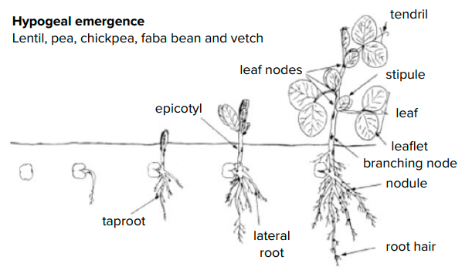
Stages of growth
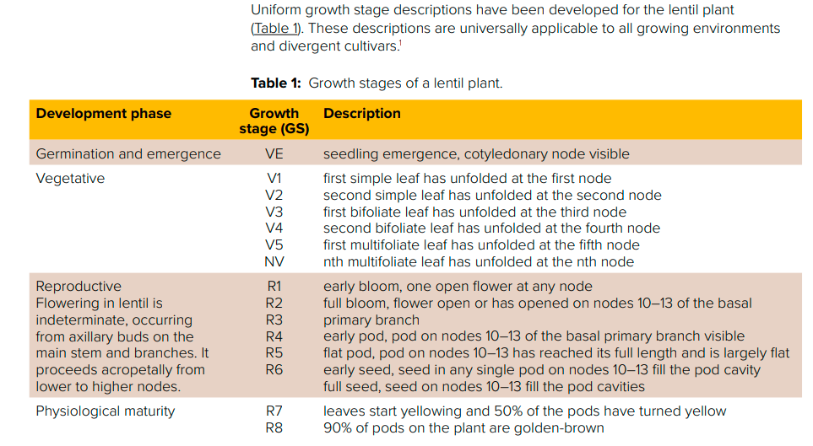
Root
Roots Lentil has a slender taproot with a mass of lateral fibrous roots. Plant roots are important in the capture of moisture and inorganic nutrients, particularly on soils with low fertility or low water-holding capacity. Positive associations have been reported between rate, and amount of, root surface development with grain yield.3 4 Lentil varieties that are adapted to differing soil types have either shallow, intermediate or deep root systems (Figure 3). Soil texture, depth, and whether the soil cracks or not can determine which variety suits a particular soil.
Nodulation
Nodules might start appearing as early as 15 days after emergence. The taproot and lateral roots near the soil surface carry the small round or oblong shaped nodules, if the correct strain of rhizobia is present. Nodulation by nitrogen-fixing bacteria begins at the third and fourth node stage. Peak nodule growth and development occurs at peak vegetative production, and starts to decline at the commencement of flowering, or later if adequate soil moisture is available. Nodules eventually form slightly flattened, fan-like lobes and are, nearly all, confined to the top 30 cm of soil, with 90% being within 15 cm of the surface. When cut open, healthy nodules, that are actively fixing nitrogen, have a pink centre (Photo 2). Nitrogen fixation is highly sensitive to waterlogging and hence, lentil needs well aerated soils.
Stem and branches
Primary branches, starting from ground level, grow from buds at the lowest nodes, or plumular shoot, as well as the lateral branches of the seedling. These branches are relatively thin, and determine the general appearance and erectness of the plant. Height achieved by the main stem and branches depends on soil moisture or rainfall conditions, length of growing season, and variety. Unlike lupin and some other pulses like chickpea, lentil does not have secondary or tertiary branches that develop from the main stem or branches. Australian lentil varieties are indeterminate, which means vegetative growth continues initially after the plant switches to reproductive mode and flowering begins, but can terminate before moisture becomes limiting. Current Australian green lentil varieties are later maturing than red lentil varieties. Plants normally range from 30–50 cm tall; the taller plants are a result of cool growing season temperatures, good moisture and good fertility. Plants can have single stems or many branches depending upon the population in the field.
Flowering and pod development
The beginning of the reproductive stage is marked by flowers opening at any node. In early maturing varieties, flowers will open at about the 10th to 11th nodes, while flowers of later-maturing varieties will open at the 13th or 14th nodes.6 Flowering begins on the lowest branches, gradually moving up the plant, and continuing until desiccation or harvest.
The node of the first flower, and the interval between successive nodes, vary depending on the month, season, variety and seeding time. Duration between nodes is particularly slow during vegetative and early reproductive stages during winter, but shorter during spring. Each flower produces a short pod containing one or two lens-shaped seeds. Flowers can be white, lilac or pale blue in colour and are self-pollinated. At maturity, plants tend to lodge because of their weak stems. Flowers are self-pollinated. Pods are less than 2.5 cm in length and contain one or two seeds. Most of the seed is produced on branches that form on the middle and lower nodes of the main stem, depending on variety and growing conditions. If moisture and temperature conditions are favourable, additional crop growth, node production, flowering and, therefore, crop height occurs until flowering ceases. It is hot conditions (maximum temperatures >30°C) or lack of moisture that cause flowering and consequently, additional crop growth to cease.

