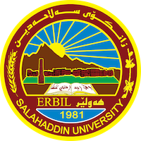
Academic Curriculum Vitae
Personal Information:
Full Name: Shalaw Najat Ghani
Academic Title: Assistant Lecturer
Email: Shalaw.Ghani@su.edu.krd
Mobile: 009647504632237

Education:
MA TESOL, 2015, Valparaiso University, Indiana, USA
BA English Language, 2011, Salahaddin University, Erbil, Iraq

Employment:
I was employed in 2015 by MHE-KRG and was stationed in College of Education - Shaqlawa Districr since then I have been teaching

Qualifications
- Teaching Methods course
- Toefl
- E learning 2013/ Salahaddin University/ College of Education/ Iraq
- Legal translator license
Teaching experience:
- -English, Psychology, and Computer since 2015
Research and publications
- The standardization of Kurmanji Saru Dialect: obstacles and worldview
- A comparative Study between Arabic and English proverbs based on cross cultural differences (Selected Examples)

Conferences and courses attended
NA
Funding and academic awards
- HCDP-KRG Scholarship 2012

Professional memberships
NA
Professional Social Network Accounts:
- https://www.linkedin.com/in/shalaw-ghani-783820b6/
- https://scholar.google.com/citations?user=w6uG6-8AAAAJ&hl=en
- https://www.researchgate.net/profile/Shalaw-Ghani
https://orcid.org/my-orcid?orcid=0000-0002-8199-550X

