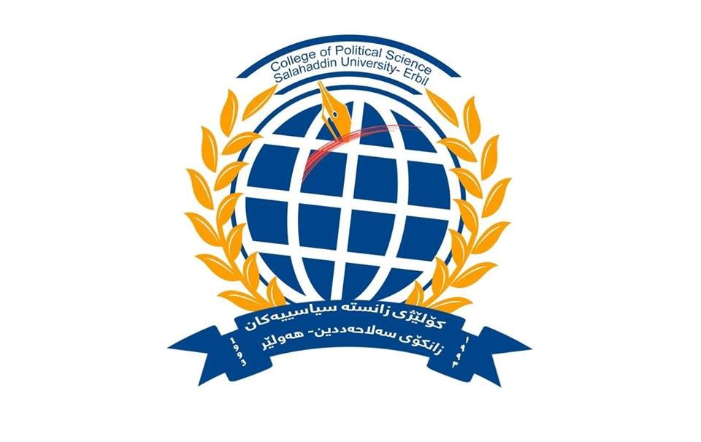
Department of International Relations& Diplomacy
College of Political Science
Salahaddin- University

Subject: Foreign policy of European Union

Course Book - (Third year)

Instructor: Dr. Shallaw A Mohammed

Academic year: 2022-2021
Foreign policy of European Union |  | 1-Course Name
Dr. Shallaw A Mohammed |  | 2-Lecturer in charge
International Relations & Diplomacy |  | 3-Department/ College
E-Mail: shallaw.mohammed@su.edu.krd  Personal E-Mail: shallaw.1980@gmail.com  Mobile: 07504644874 |  | 4-Contact
Practices : 1 Every Tuesday  Theory : 2 Every Thursday |  | 5-Time(In hours) per week
Every Monday & Tuesday from 12:30 to 1:30 PM |  | 6-Office Hours:
A54o2Ib |  | 7- Course Code
Doctoral of philosophy in: Politics and International Relations  Soran University (2020)  (The Role of Energy Diplomacy in Drawing the Security Equations in the Middle East)  Master Degree: Political Science/ University of Cincinnati/  Ohio-USA (2015)  (The Role of Energy Power in Reshaping Iraqi Kurdistan)  Bachelor Degree: Political science/ Salahaddin University  Erbil/Iraq (2008) |  | 8- Teacher's academic profile
9- Course Overview: Given the important role of the European Union in bringing together the policies of most European countries (there are now 27 member states), this course will examine the question of European foreign policy through the lens of integration with the European Union. To what extent have EU member states built a coherent foreign security policy? Hence the discussions will also relate to relations between the European Union, states and non-member organizations, supranational organization theory and practice, and leadership relations, both conceptually and through experience.
This course provides a broad introduction to the historical process of European integration, the evolution of the European Union (EU) as an international actor, and to the most relevant current internal and external challenges faced by the European Union.
In addition, this course will deal with the substantive debate surrounding Europe's rise as a major player in the international system, with particular attention to the transatlantic relationship. As a background, we will begin with an overview of the evolution of the European Union's foreign policy, and how its institutions operate today. With 27 voices to be heard around the table, how are decisions about joint approaches made? What are the policy areas governed at the supranational level that require the unanimous consent of member states? What happens when member states are deadlocked, and how do EU institutions ensure democratic accountability going side by side with the EU foreign policy? So, during the semester, we will demonstrate the main intuitions of EU, and analyze the EU foreign policy on international stage.
10- Course Objective:
By the end of the course, students should have...
- • Understand the development and functioning of Europe's foreign policy and the main debates surrounding it.
- • Ability to explain and evaluate European institutions.
- • The ability to argue for or against the idea that the European Union is or will become a superpower in various dimensions.
- • A completed research project focusing on an area of EU foreign policy of particular interest to each student
11- Forms Of Teaching: This lecture is delivering through a program of weekly lectures and activities.
Lectures will provide the outline and introduction to the subject. The introductory lectures are very important in setting the EU foreign policy in context and ensuring that you have a sound base from which to develop your understanding of the subject.
Activity classes are aimed to engage students in class and train them to use the knowledge they achieved in class and advance it in a way to be able to use them in real life situations like professional analyzer.
Each activity class is specially designed to meet the needs of the students and are designed based on weekly needs assessment of the students. Students are carefully and closely studied by the instructor and based on that class activities and homework are designed by the instructor. Besides that, the classes are made student centered.
Finally, we use (PowerPoint, Word, documents, videos ...etc.) to explain the lessons.
12- Assessment scheme:

The assignments for this class are designed to help students meet the goals of this course. Students will develop their writing and analytical skills and deepen their knowledge of the EU foreign policy by writing a short primary source paper and one power point presentation so as the final Exam during the semester. In addition, students will have an opportunity to develop their oral communication skills through regular in-class discussions especially through the group project.
So, grading Policy will be depending on: 1-Class participation, Short Paper, One presentation, and Group work: 10% +-Midterm Exam: 40% 3-Final examination: (60%)
13- Course Reading list and References:
- Laïdi, Zaki, ed. EU foreign policy in a globalized world: normative power and social preferences. Vol. 1. Routledge, 2008.
- Keukeleire, Stephan, and Tom Delreux. The foreign policy of the European Union. Macmillan International Higher Education, 2014.‏
- Bindi, Federiga, ed. The foreign policy of the European Union: assessing Europe's role in the world. Brookings Institution Press, 2010.‏
- Kazmi, Sarah Syed. "European Union Foreign Policy in a Changing World." Journal of European Studies 32.1 (2016).
Lecture's Name | 14- Tim& Topics
Dr. Shallaw | Introduction to the Course |  | Week1
 | The partition of Europe and the new European order after WW2. |  | Session1 | Week2
 | Historical evolution of the European Union |  | Session2
 | Treaties of the beginning of the European Union |  | Session1 | Week3
 | The Marshall Plan (1947), containment and the role of Germany inside the Western bloc |  | Session2
 | Creation and evolution of the Atlantic Alliance during the Cold War |  | Session1 | Week4
 | Background facts: from the Dunkirk Pact to the Brussels Treaty. |  | Session2
 | The American commitment with European security and integration |  | Session1 | Week5
 | Crisis and solidarity inside the Western bloc between the 1960s and the 1980s. |  | Session2
 | The road to European foreign policy |  | Seesion1 | Week6
 | How European Foreign Policy is Made |  | Session2
 | Creation and consolidation of the Soviet Union sphere of influence |  | Session1 | Week7
 | Creation and institutionalization of the communist bloc |  | Session2
 | The EU and its decision-making process in external relations |  | Session1 | Week8
 | Europe in a bipolar world: tensions and cooperation |  | Session2
 | Osteolytic: the new relations between West and East |  | Session1 | Week9
 | Transformations in the USSR during the 1980s and its impact in the East West relations |  | Session2
 | Europe after the end of the cold war world |  | Session1 | Week10
 | The challenges of EU enlargement: political and institutional factors |  | Session2
 | New regional and international security environments: continuity and change |  | Session1 | Week11
 | The impact of economic globalization on the EU |  | Session2
 | The evolution of European integration |  | Session1 | Week12
 | The creation of European Communities |  | Session2
 | The European Coal and Steel Community (ECSC), and the Treaties of Rome |  | Session1 | Week13
 | Creation and evolution of the Foreign Policy of the EU |  | Session2
 | Background: European Political Cooperation (EPC) |  | Session1 | Week14
 | The Foreign and Security Policy of the EU after Brexit |  | Session2
 | - Hint: 1- Final exams and tests according to the time board. 2- Questions, exercises and problems listed at the end of each chapter (problems solved in class and housework).

