**Curriculum Vitae**

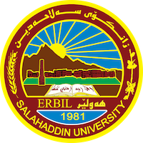

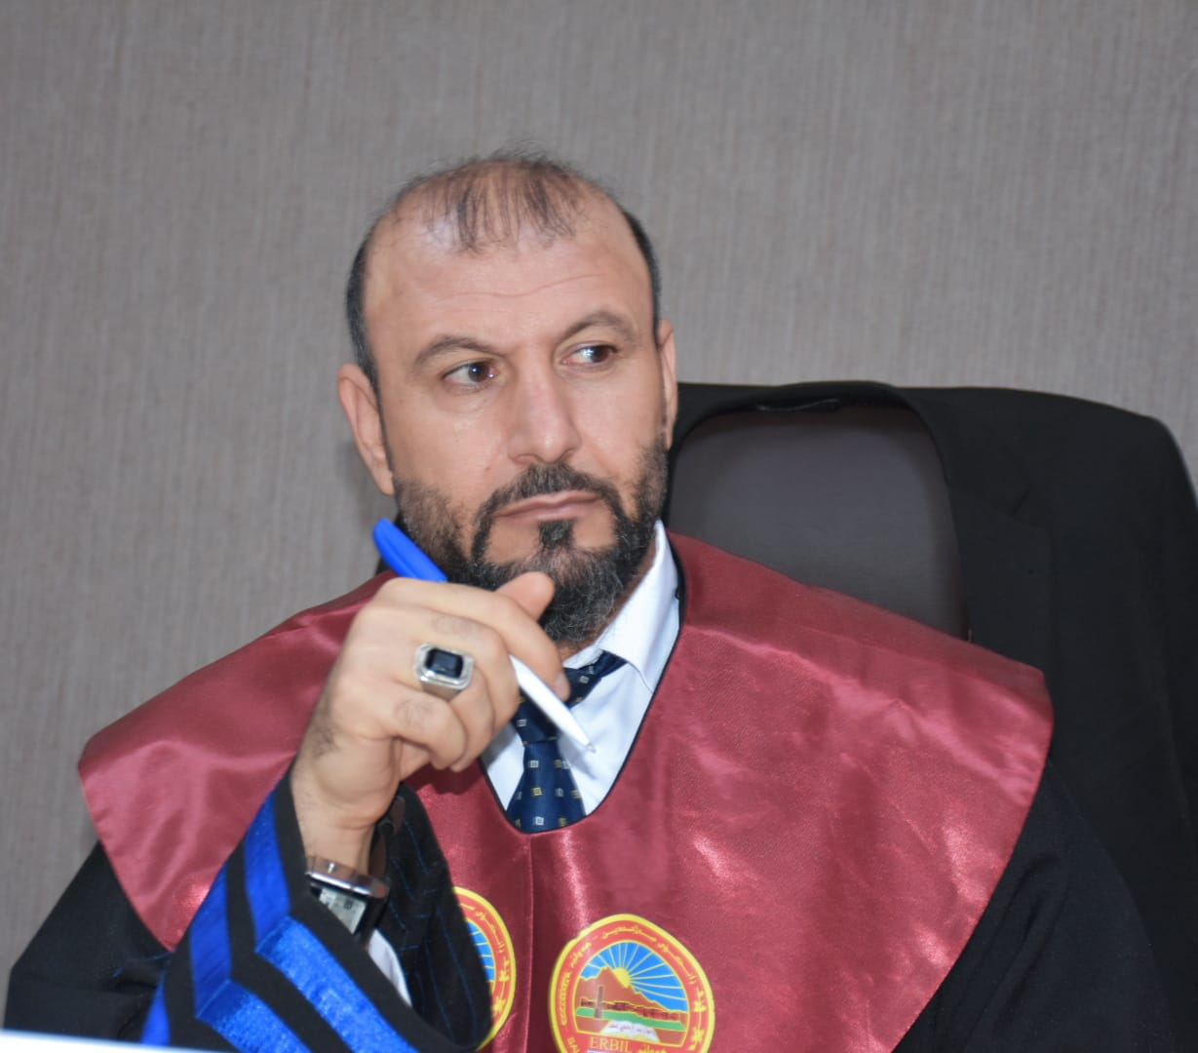

**I. Personal Information**

Full name: Dr. Shamal Husain Mustafa

Place & date of birth: Iraq – 1st April 1981

Gender & marital status: Male, married

Address: Iraqi Kurdistan Region, Erbil city

Mobile phone No: +964(0) 750 470 9992

Email address: [shamal.mustafa@su.edu.krd](mailto:shamal.mustafa@su.edu.krd)

Shamal.mustafa@neu.edu.tr

**II. Education**

* **Academic Certificates**
* Bachelor of Arts (B.A.) in Political Sciences (Salahaddin University – Erbil, Iraq) (2004).
* Master of Arts (M.A.) in Foreign Policy and International Relations; Salahaddin University – Erbil, Iraq. (2008).
* Doctorate of Philosophy (PhD) in World Politics and International Relations; Salahaddin University – Erbil, Iraq. (2014).
* **Academic Specialisation**
* General specialisation: Political Sciences.
* Specific specialisation: International Relations and Foreign Policy.
* Fields of interest: International Relations, Diplomacy and Foreign Policy.
* **Academic rank**
* Assist. Prof.

**III. Professional Skills**

* **Language Skills**
* Kurdish (Native)
* Arabic (Advance)
* English (Intermediate)
* **Computer and IT Skills**
* Good in Mac. and Windows programmes, and typing skills.

**IV. Posts and Activities**

* **Jobs:**
* Lecturer: Teaching as a guest lecturer in College of Education at Salahaddin University-Erbil, 2008-2009; Modules: Human Rights, Public International Law, Methodology in Politics; Supervising and examining several graduate researches.
* Lecturer: Teaching as a lecturer in College of Law and Politics at Soran University, from 2009 to 2013; Modules: History and Theories of International Relations, An Introduction to International Relations, Global Contemporary Issues.
* Lecturer: Teaching as a guest lecturer in College of Law and Politics at Nawroz University-Dahuk, 2014-2018; Modules: Foreign Policy, International relations, Diplomatic Relations, Supervising and examining several graduate researches.
* Lecturer: Teaching as a lecturer in College of Politics and International Relations at University of Salahaddin-Erbil, from 2008 to Now; Modules: Foreign Policy,Theores of International relations, Diplomatic Relations. and a member of academic staff.
* **Trainings and Activities**
* Participating in various academic trainings and workshops on qualitative and quantitative methods of research.

**V. Examples of the Published works**

* **Journal Articles:**
* The Nature and Principles of International system after The 11 september, Law and Politics Journal, Erbil, 2014
* US Foreign Policy towards Iran after Nuclear Deal, Qallat Journal, 2019
* The Necessity of UN Reform under the Light of Contemporary Issues: Syrian Case as an example; Nawroz Journal, 2019
* Russian Strategy under Putin’s Rule, Twejer Journal, 2019
* **Books:**
* Power and US Foreign Policy after 11/9, Khani Publisher, Dahuk, 2017
* Glibal Politics between Chaos and Order, Wafa Publisher, Egypt, 2018
* Priniciples of Foreign Policy, Tafseer Publisher, Erbil, 2017
* *Foreign Policy: US, Russia, Iran and Turkey as examples, Tafseer Publisher, Erbil, 2018*
* *International Relations: history concepts and principles, Tafseer Publisher, Erbil, 2018*
* The Rules of Diplomacy: an introduction to diplomacy, protocol and etiquette, hevey Publisher, Erbil, 2020
* *International Relations: concept an- history- Events- Theoris, Tafseer publisher,Erbil, 2020.*
* **Newspaper and magazine articles:**
* Writing and translating various articles on socio-political and international affairs in different magazines, newspapers and websites.

**VI. Attachments**

* All related documents would be sent, when they were required.

**Shamal Husain Mustafa**

July 2024